Conrad Horton

CSC203 Jun 2016

Control Statements Part 1 Lab 3

20160620

**Part I**

Answer the following questions. Your answers should be concise; aim for two or three sentences.

1. Explain the purpose of a selection statement.
   1. To execute statements based on a certain conditions being met.
2. Use pseudocode or a UML activity diagram to give an example of sequence control statements.

if the car goes fast = true

apply brakes

1. Describe the term “algorithm” and why pseudocode can help programmers develop algorithms.
   1. Algorithms are a set of specific instructions created to complete a task. Pseudo code helps programmers to write algorithms that are in a generic syntax, and can easily be interpreted into other programming languages.
2. Use pseudocode or a UML activity diagram to give an example of an if...else selection statement.

if the car goes fast = true

apply brakes

else

apply accelerator

1. Explain the difference between the if selection statement and the if...else selection statement.
   1. If statements perform a task when a specific condition is met. If...else performs a task regardless if the condition has been met or not.
2. Use pseudocode to give an example of a looping construct in which the number of repetitions is known in advance.

for card = 0 to 52

if card is on the ground = true

pick up the card

**Part II**

For each of the given program segments, read the code and write the output in the space provided below each program. [Note: Do not execute these programs on a computer.]

For questions 1-3 assume the following class definition: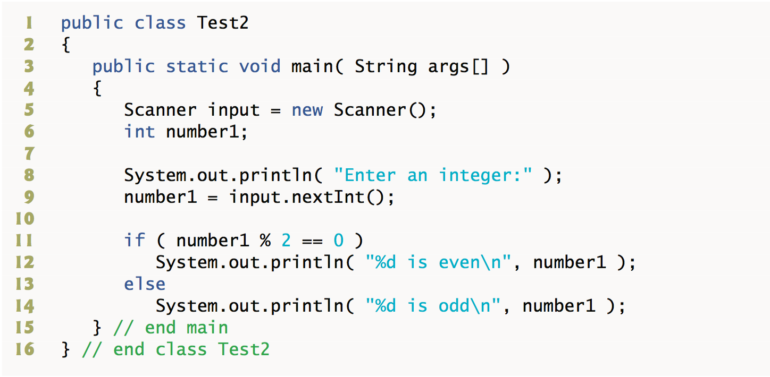

1. What will be output by lines 11–14 if the user enters the integer 3 at line 9?
   1. 3 is odd.
2. What will be output by lines 11–14 if the user enters the integer 2 at line 9?
   1. 2 is even.
3. What will be the output if the following code is placed at line 10 of the preceding class definition? Assume that the user enters 5.
   1. ??? What code ???
4. What is output by the following program?

Passed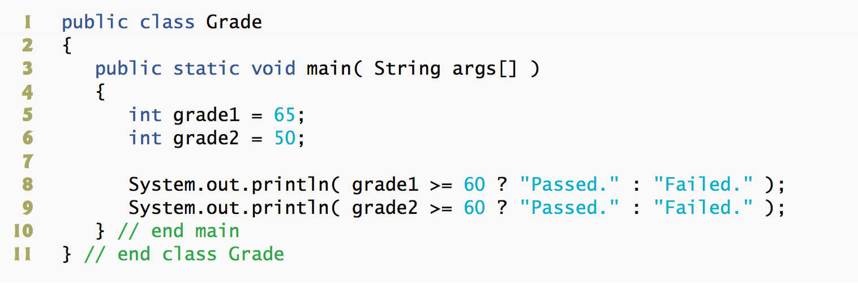

Failed

**Part III**

The problem is divided into six parts:

1. Lab Objectives

2. Description of the Problem

3. Sample Output

4. Program Template (Fig. L 4.1 and Fig. L 4.2)

5. Problem-Solving Tips

**Lab Objectives**

This lab was designed to reinforce programming concepts from Chapter 4 of Java How to Program: 8/e. In this lab, you will practice:

* Writing pseudocode.
* Using selection statements.
* The follow-up questions and activities also will give you practice:
* Using counter-controlled repetition.

Description of the Problem

Develop a Java application that will determine whether any of several department-store customers has exceeded the credit limit on a charge account. For each customer, the following facts are available:

1. account number
2. balance at the beginning of the month
3. total of all items charged by the customer this month
4. total of all credits applied to the customer’s account this month
5. allowed credit limit.

The program should input all of these facts as integers, calculate the new balance (= beginning balance + charges – credits), display the new balance and determine whether the new balance exceeds the customer’s credit limit. For those customers whose credit limit is exceeded, the program should display the message "Credit limit exceeded".

**Problem-Solving Tips**

1. There are five input values required. But the account number must be input before the loop in order to test whether it is equal to the sentinel value. So there should be six input statements, five in the loop and one before it.
2. Use the formula given in the problem description to compute the new balance.
3. UseanifstatementtodeterminewhethernewBalanceislargerthanthecustomer’screditLimit.Ifso,
4. indicate that the credit limit was exceeded.
5. Write out your algorithms in pseudocode before writing any code.
6. Be sure to follow the spacing and indentation conventions mentioned in the text.

