Hypothesis Testing

Rahul Sharma  
500091839

R2142210619

B.Tech. CSE AIML Batch-2 Non-hons.

# Applying Z-Test T-Test and ANOVA on house price dataset.

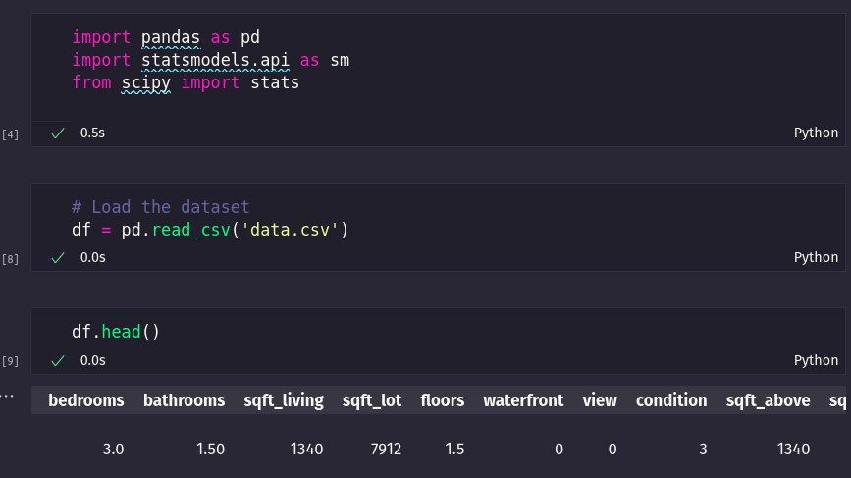

Got the dataset from [Kaggle](https://www.kaggle.com/datasets/shree1992/housedata?select=data.csv).  
The real estate markets, like those in Sydney and Melbourne, present an interesting opportunity for data analysts to analyze and predict where property prices are moving towards. Prediction of property prices is becoming increasingly important and beneficial. Property prices are a good indicator of both the overall market condition and the economic health of a country. Considering the data provided, we are wrangling a large set of property sales records stored in an unknown format and with unknown data quality issues.

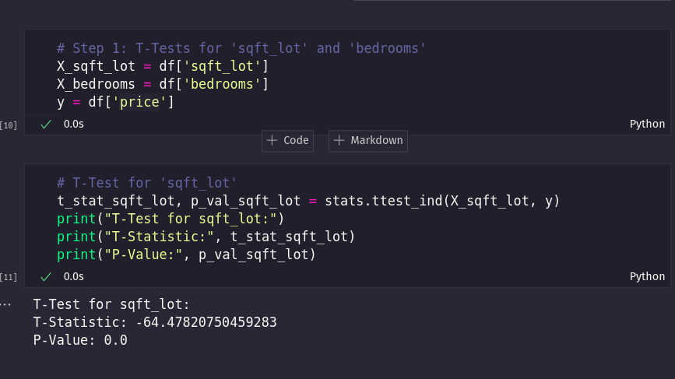

### Conclusion:

With a p-value effectively at 0.0, it suggests strong evidence against the null hypothesis. Here's how you'd interpret this result:

* Conclusion:
  + We reject the null hypothesis. There is strong evidence to suggest that sqft_lot has a statistically significant effect on the Property_Price.
* In Practical Terms:
  + The negative t-statistic indicates that, on average, as sqft_lot increases, the Property_Price tends to decrease. This suggests a relationship where larger lot sizes might lead to lower property prices.

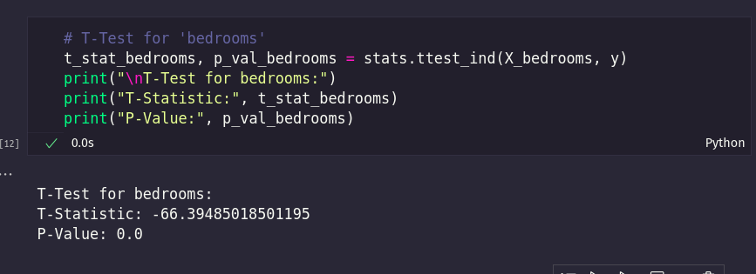

### Conclusion:

With a p-value effectively at 0.0, it suggests strong evidence against the null hypothesis. Here's how you'd interpret this result:

* Conclusion:
  + We reject the null hypothesis. There is strong evidence to suggest that the bedrooms variable has a statistically significant effect on Property_Price.
* In Practical Terms:
  + The negative t-statistic indicates that, on average, as the number of bedrooms increases, the Property_Price tends to decrease. This suggests a relationship where properties with more bedrooms might have lower prices.

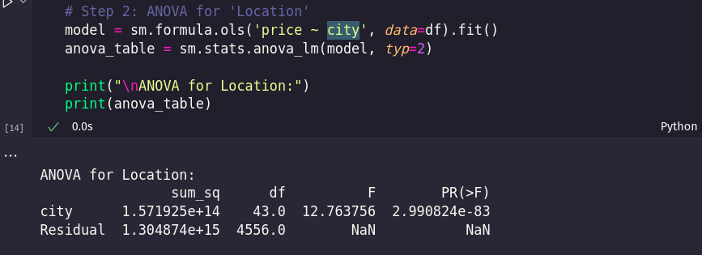

### Conclusion:

Based on the ANOVA results:

* Conclusion:
  + We reject the null hypothesis. There is strong evidence to suggest that the Location (city) variable has a statistically significant effect on Property_Price.
* In Practical Terms:
  + This means that the Location (city) where a property is located is likely to have a significant impact on its Property_Price. Different cities tend to have different average property prices.