How to use the program expense tracker

\*\*\*\*\*\*\*\*\*\*\*\*\*\*\*\*\*\*\*\*\*\*\*\*\*\*\*\*\*\*\*\*\*\*

1) Run the program in IDE (VS-code) or you can use others.

2) After you run, it will display in the terminal and shows the 5 options to choose (1, 2, 3, 4 and 0).

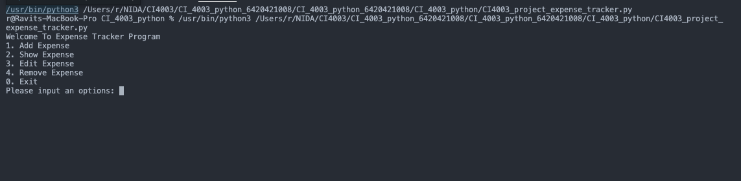

3) Basically, when you start the program, it doesn’t have any data in the database. So, first you must choose option 1 to add expense. Btw you can choose other options but there is no data to show, edit or remove so that is make you choose option 1.

4) You have to input order by categories of expense, name of expenses, prices and date (format yyyy/mm/dd; example 2022/11/11).

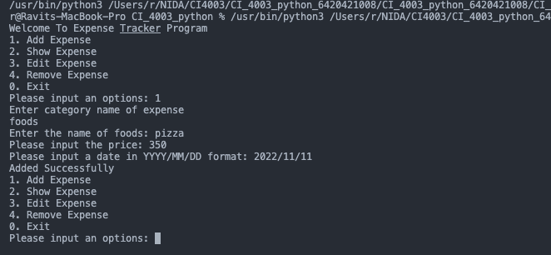

5) The program will repeat again until you haven't data to add, or you want to do other options.

6) If you choose option 2 to show expense. It will display the date in the database that you added before.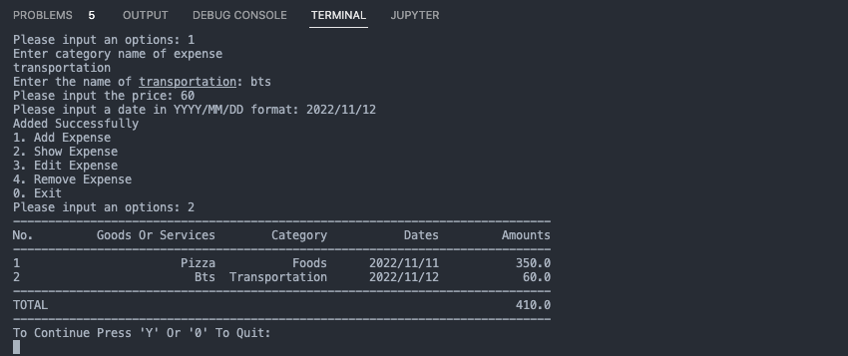

7) Next, if you want to update or remove data in the database, you must following this step carefully.

Press “y” or “Y” to continue to choose next command.

Or

Press “0” to quit.

8) If you choose option 3 and 4, It will almost same display (input name of expenses, date (format yyyy/mm/dd; example 2022/11/11) but the option 3, you must input one more price to update the data in database.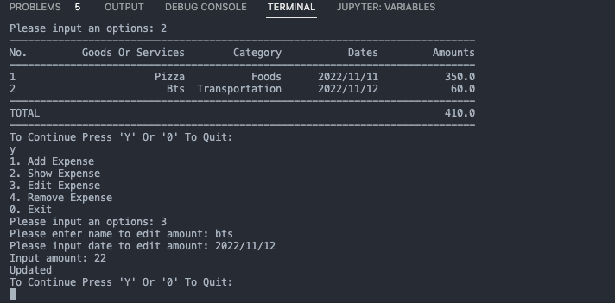

9) The last option is remove expense, you can do it easily.

Just input name of expenses, date (format yyyy/mm/dd; example 2022/11/11).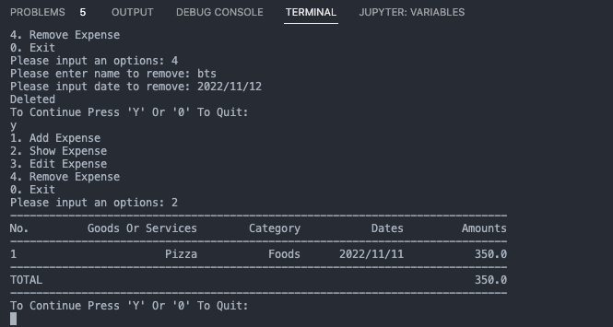

10) You can press “0” to exit the program any time after you finished any command.