**Instructions**

Download the BUSINFO Folder.

Navigate to the app folder. BUSINFOAPP/fla/App or BUSINFOAPP\fla\App

Start the application

1. Using the script for windows run for linux/mac run
2. Alternatively use the following commands to manually run

**Linux/Max**

pip install -r requirements.txt

export FLASK_APP=app.py

flask run

**Windows**

pip install -r requirements.txt

set FLASK_APP=app.py

flask run

Using the browser navigate to : <http://127.0.0.1:5000/index>

**See Bus Arrival Times**

A list of the 5 most recent Bus Arrivals times will be displayed. To refresh this list press the BUS Arrivals Button.

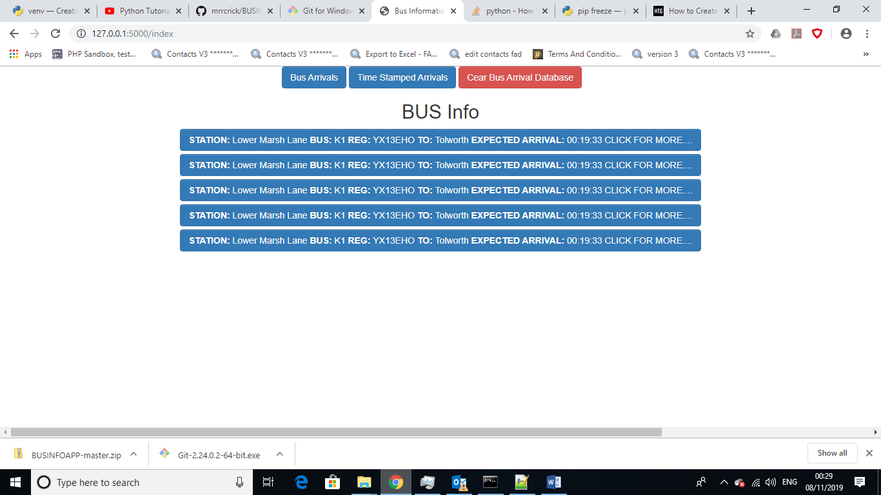

For More information click on the bus information header.

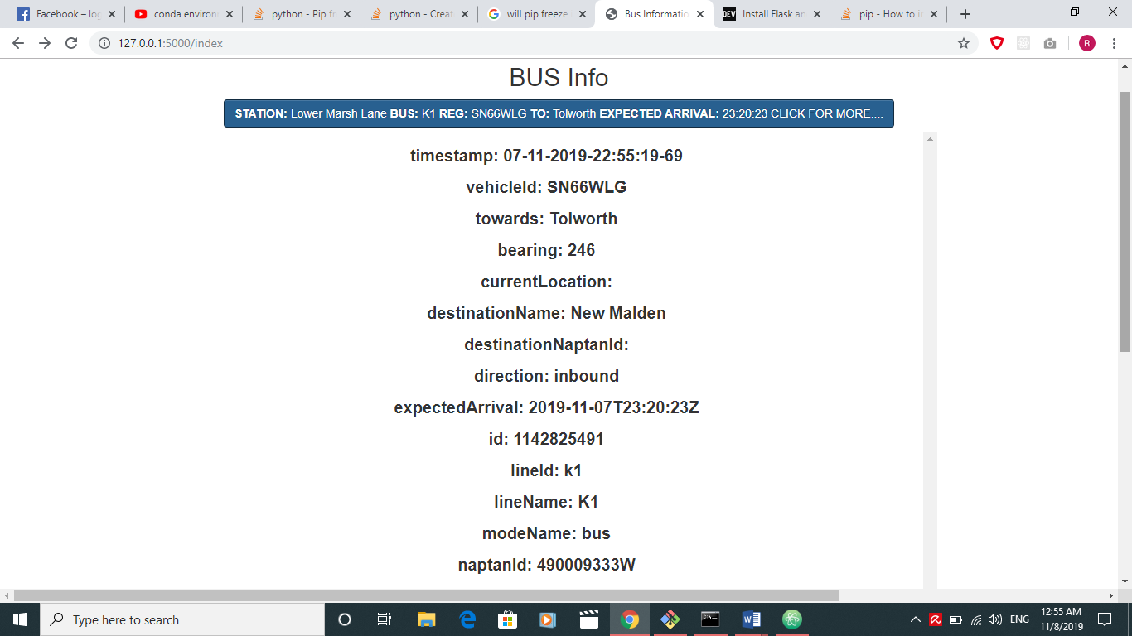

**List the history of Bus Arrival Times**

To view a list of **All** the Bus Arrival API Call data sorted by Timestamp Click the **Time Stamped Arrivals Button.** This will display a list of all the data retrieved from the API and the Time Stamp.

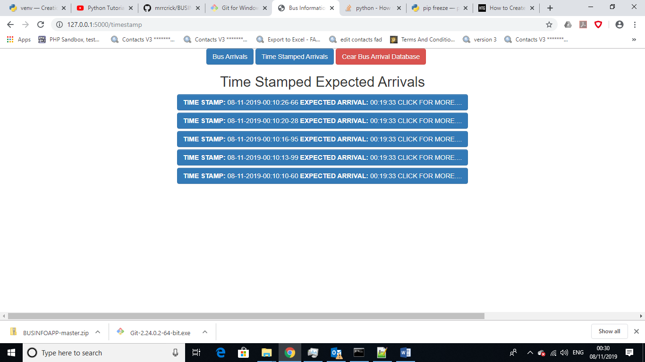

For more information click on the Time Stamp header

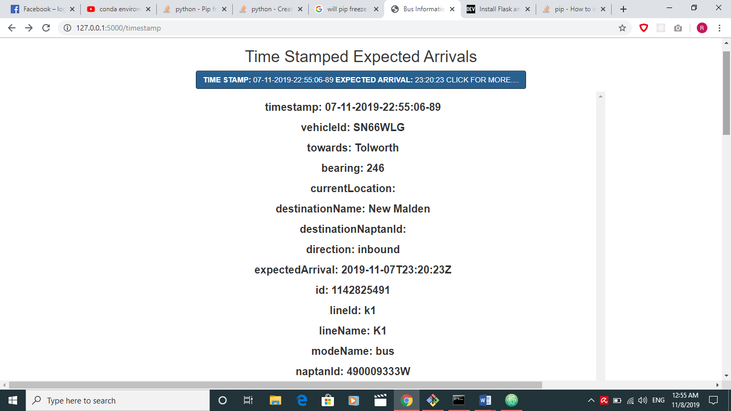

**Clearing the Database**

To Clear the Database, click the Clear Bus Arrival Database Button. All of the data in the database will be removed.

