PFB2073 Well Test Analysis Assignment 2

Muhammad Radhi bin Mohd Riadh
Department of Petroleum Engineering, Universiti Teknologi PETRONAS
PFB2073: Well Test Analysis
Dr. Shiferaw Regassa Jufar
31 July 2026

Table of Contents

Abstract 3
Introduction 4
Methodology 4
Problem 1: Drawdown Test 4
Problem 2: Buildup Test 5
Results 5
Problem 1: Drawdown Test Results 5
Problem 2: Buildup Test Results 6
Discussion 7
Drawdown Test Interpretation 7
Buildup Test Interpretation, Model Identification, and MBH Correction 7
Conclusion 8
References 9

Abstract
This report presents the well test analysis for two problems: a drawdown test (Problem 1) and a buildup test (Problem 2) in a petroleum reservoir. The Bourdet pressure derivative method was employed as the primary diagnostic tool to identify flow regimes and determine reservoir parameters. For the drawdown test, the analysis yielded a permeability of $k=14.16mD$, a skin factor of $s=2.51$, and a wellbore storage coefficient of $C=0.00105bbl/psi$ ($C_{D}=111.6$). For the buildup test, the computed permeability was $k=30.09mD$ with a skin factor of $s=−1.86$, a wellbore storage coefficient of $C=0.00158bbl/psi$ ($C_{D}=351.3$), and a true average reservoir pressure of $\overline{p}=1340.2psia$ derived via the Matthews-Brons-Hazebroek (MBH) method using the Dietz shape factor approach. The radius of investigation during the $72hr$ shut-in period for the buildup test was $r_{inv}=359ft$. A comparison with the boundaries of the $80acre$, 2:1 rectangular reservoir was conducted to evaluate whether boundary effects were felt during shut-in versus prior production.
Keywords: well test analysis, drawdown test, buildup test, Bourdet derivative, type curve matching, permeability, skin factor, wellbore storage, MBH method, Dietz shape factor

Introduction
Well test analysis is a fundamental technique in reservoir engineering used to determine reservoir parameters such as permeability, skin factor, and wellbore storage coefficient. These parameters are essential for reservoir characterization, production optimization, and field development planning (Ahmed & McKinney, 2005).
The Bourdet pressure derivative, introduced by Bourdet et al. (1983), revolutionized well test interpretation by providing a diagnostic tool more sensitive to flow regime changes than pressure data alone.

Methodology

Problem 1: Drawdown Test
The drawdown test was conducted at a constant flow rate of $q=50STB/day$ from an initial reservoir pressure of $p_{i}=1326.6psia$. Reservoir parameters: $h=25ft$, $ϕ=0.276$, $r_{w}=0.36ft$, $B=1.099RB/STB$, $c_{t}=9.4e−06{psi}^{−1}$, $μ=5.28cP$.

Pressure Change Calculation
$$Δp=p_{i}−p_{wf}$$

Bourdet Pressure Derivative
$$t·Δp^{′}=\frac{\frac{Δp_{L}}{Δln(t_{L})}·Δln(t_{R})+\frac{Δp_{R}}{Δln(t_{R})}·Δln(t_{L})}{Δln(t_{L})+Δln(t_{R})}$$
*(where subscripts $L$ and $R$ denote the left and right adjacent data points in log-time, respectively).*

Permeability, Skin Factor, and Wellbore Storage
$$k=\frac{162.6qBμ}{mh}$$
$$s=1.1513\left[\frac{Δp_{1hr}}{m}−\log_{10}\left(\frac{k}{ϕμc_{t}r_{w}^{2}}\right)+3.2275\right]$$
$$s=1.1513\left[\frac{737.20}{133.26}−\log_{10}\left(\frac{14.16}{\left(0.276)(5.28)(9.4×{10}^{−6})({0.36}^{2}\right)}\right)+3.2275\right]=2.51$$

Dimensional Wellbore Storage ($C$)
The dimensional wellbore storage coefficient was estimated using a data coordinate ($t,Δp$) located on the early-time unit-slope line of the log-log diagnostic plot:
$$C=\frac{qBt}{24Δp}\left[bbl / psi\right]$$
$$C=\frac{\left(50)(1.099)(0.100\right)}{24(217.6)}=0.00105bbl/psi$$
$$C_{D}=\frac{0.8936C}{ϕc_{t}hr_{w}^{2}}$$
$$C_{D}=\frac{0.8936(0.00105)}{\left(0.276)(9.4×{10}^{−6})(25)({0.36}^{2}\right)}=111.6$$

Problem 2: Buildup Test
Reservoir and Fluid Properties (Problem 2): The buildup test was conducted after $t_{p}=960hrs$ at $q=10STB/day$ in an $A=80acres$ 2:1 rectangular reservoir ($h=10ft$, $ϕ=0.319$, $r_{w}=0.34ft$, $B=1.098RB/STB$, $c_{t}=10.9×{10}^{−6}{psi}^{−1}$, $μ=5.11cP$).
$$Δt_{e}=\frac{t_{p}Δt}{t_{p}+Δt}$$

Permeability Calculation
$$k=\frac{162.6qBμ}{mh}$$
$$k=\frac{162.6(10)(1.098)(5.11)}{\left(30.29)(10\right)}=30.09mD$$

Horner Skin Factor ($s$)
Because buildup tests utilize the Horner time ratio, the skin factor evaluates the flowing pressure immediately prior to shut-in ($p_{wf(Δt=0)}$) and the idealized 1-hour shut-in pressure ($p_{ws,1hr}$) extrapolated from the Horner straight line:
$$s=1.1513\left[\frac{p_{ws,1hr}−p_{wf(Δt=0)}}{m}−\log_{10}\left(\frac{k}{ϕμc_{t}r_{w}^{2}}\right)+3.2275\right]$$
$$s=1.1513\left[\frac{1262.87−1192.45}{30.29}−\log_{10}\left(\frac{30.09}{\left(0.319)(5.11)(10.9×{10}^{−6})({0.34}^{2}\right)}\right)+3.2275\right]=−1.86$$

Wellbore Storage Coefficient ($C$ and $C_{D}$)
$$C=\frac{\left(10)(1.098)(0.050\right)}{24(14.47)}=0.00158bbl/psi$$
$$C_{D}=\frac{0.8936(0.00158)}{\left(0.319)(10.9×{10}^{−6})(10)({0.34}^{2}\right)}=351.3$$

Radius of Investigation
$$r_{inv}=\sqrt{\frac{kt}{948ϕμc_{t}}}$$

Results
*Note: The analytical type-curve models generated by the software (shown in the legends of Figure 1 and Figure 3) yield slightly different parameters than the manual semi-log analysis due to the software's non-linear regression algorithms. Following standard engineering practice, the manually derived semi-log parameters are reported as the primary definitive results in the summary tables.*

Problem 1: Drawdown Test Results
Permeability $k=14.16mD$, skin factor $s=2.51$, wellbore storage coefficient $C=0.00105bbl/psi$ ($C_{D}=111.6$), and semi-log slope $m=133.26psi/cycle$. The complete calculated reservoir parameters for the drawdown test are summarized in Table 1. The corresponding log-log diagnostic plot and semi-log plot are presented in Figure 1 and Figure 2, respectively.

Problem 2: Buildup Test Results
Permeability $k=30.09mD$, skin factor $s=−1.86$, wellbore storage coefficient $C=0.00158bbl/psi$ ($C_{D}=351.3$), semi-log slope $m=30.29psi/cycle$, radius of investigation $r_{inv}=359ft$, and true average pressure $\overline{p}=1340.2psia$. The complete calculated reservoir parameters for the buildup test are summarized in Table 2. The corresponding log-log diagnostic plot and Horner plot are presented in Figure 3 and Figure 4, respectively.

Discussion

Drawdown Test Interpretation
Extrapolating the IARF semi-log straight line to $t=1hr$ yields $p_{wf,1hr}=546.2psia$. The true skin factor is $s=2.51$, indicating formation damage near the wellbore.

Buildup Test Interpretation, Model Identification, and MBH Correction

Model Identification
The diagnostic log-log plot for the buildup test exhibits three distinct flow regimes. In the Early Time Region (ETR), wellbore storage dominates the response with a characteristic unit slope ($m=1$) on both pressure change and derivative curves, yielding a wellbore storage coefficient of $C=0.00158bbl/psi$ ($C_{D}=351.3$) and a skin factor hump indicating stimulus ($s=−1.86$). This is followed by a Transition Region as wellbore storage effects decline and transient flow expands into the formation. In the Middle Time Region (MTR), Infinite-Acting Radial Flow (IARF) is clearly established, marked by a horizontal derivative plateau of $t_{e}·Δp^{′}≈13.15psi$ and a corresponding Horner straight line with a slope of $m=30.29psi/cycle$.
For Problem 2, the radius of investigation during the $72hr$ shut-in period only reached $r_{inv}=359ft$, which does not exceed the distance to the nearest boundary ($660ft$). Thus, boundary effects are not visible on the buildup log-log derivative.
However, over the total production time ($t_{p}=960hr$), the radius of investigation vastly exceeded the boundaries of the $80−acre$ reservoir ($A=3,484,800{ft}^{2}$). The dimensionless production time based on area is calculated to evaluate the flow regime prior to shut-in:
$$t_{pDA}=\frac{0.0002637kt_{p}}{ϕμc_{t}A}=\frac{0.0002637(30.09)(960)}{0.319(5.11)(10.9×{10}^{−6})(3,484,800)}=0.1231$$
Because $t_{pDA}>0.1$, the reservoir reached Pseudo-Steady State prior to shut-in. Consequently, the extrapolated Horner pressure ($p^{*}=1353.22psia$) is a false pressure, and the Matthews-Brons-Hazebroek (MBH) method is required to compute the true average reservoir pressure ($\overline{p}$).
Utilizing the Dietz shape factor analytical approach for the MBH correction, the true average pressure can be directly computed. For a well centered in a 2:1 rectangular reservoir, the Dietz shape factor is $C_{A}=21.8369$ (from standard reservoir engineering tables). The exact true average reservoir pressure is:
$$\overline{p}=p^{*}−m\log_{10}(C_{A}t_{pDA})$$
$$\overline{p}=1353.22−30.29\log_{10}(21.8369×0.1231)$$
$$\overline{p}=1353.22−30.29\log_{10}(2.688)$$
$$\overline{p}=1353.22−30.29(0.4294)=1340.21psia$$
Finally, extrapolating the Horner line to a Horner time ratio of 961 (which corresponds to a shut-in time of $Δt=1hr$) yields $p_{ws,1hr}=1262.87psia$. Using the flowing pressure just before shut-in ($p_{wf(Δt=0)}=1192.45psia$), this yields a skin factor of $s=−1.86$, indicating a successfully stimulated wellbore.

Conclusion
The Bourdet pressure derivative analysis successfully determined all reservoir parameters for both drawdown and buildup tests. For Problem 1, $k=14.16mD$, $s=2.51$, and $C=0.00105bbl/psi$ ($C_{D}=111.6$). For Problem 2, $k=30.09mD$, $s=−1.86$, $C=0.00158bbl/psi$ ($C_{D}=351.3$), and the MBH Dietz method yielded a true average reservoir pressure of $\overline{p}=1340.2psia$.

References
Agarwal, R. G. (1980). A new method to account for producing time effects when drawdown type curves are used. Paper SPE 9289.
Ahmed, T., & McKinney, P. D. (2005). Advanced reservoir engineering. Gulf Professional Publishing.
Bourdet, D. (2002). Well test analysis: The use of advanced interpretation models. Elsevier.
Bourdet, D., Ayoub, J. A., & Pirard, Y. M. (1989). Use of pressure derivative in well test interpretation. SPE Formation Evaluation, 4(2), 293-302.

Table 1
Drawdown Test Calculated Reservoir Parameters
Parameter | Value
Permeability, $k$ | $14.16mD$
Skin Factor, $s$ | $2.51$
Wellbore Storage Coefficient, $C$ | $0.00105bbl/psi$
Dimensionless Wellbore Storage, $C_{D}$ | $111.6$
Semilog Slope, $m$ | $133.26psi/cycle$

Table 2
Buildup Test Calculated Reservoir Parameters
Parameter | Value
Permeability, $k$ | $30.09mD$
Skin Factor, $s$ | $−1.86$
Wellbore Storage Coefficient, $C$ | $0.00158bbl/psi$
Dimensionless Wellbore Storage, $C_{D}$ | $351.3$
Semilog Slope, $m$ | $30.29psi/cycle$
Radius of Investigation at $t_{shut−in}=72hrs$ | $359ft$
Boundary Effects Detected (During Shut-in) | No
True Average Reservoir Pressure, $\overline{p}$ | $1340.2psia$

Figure 1
Log-Log Diagnostic Plot for Drawdown Test ($Δp$ and Bourdet Derivative).
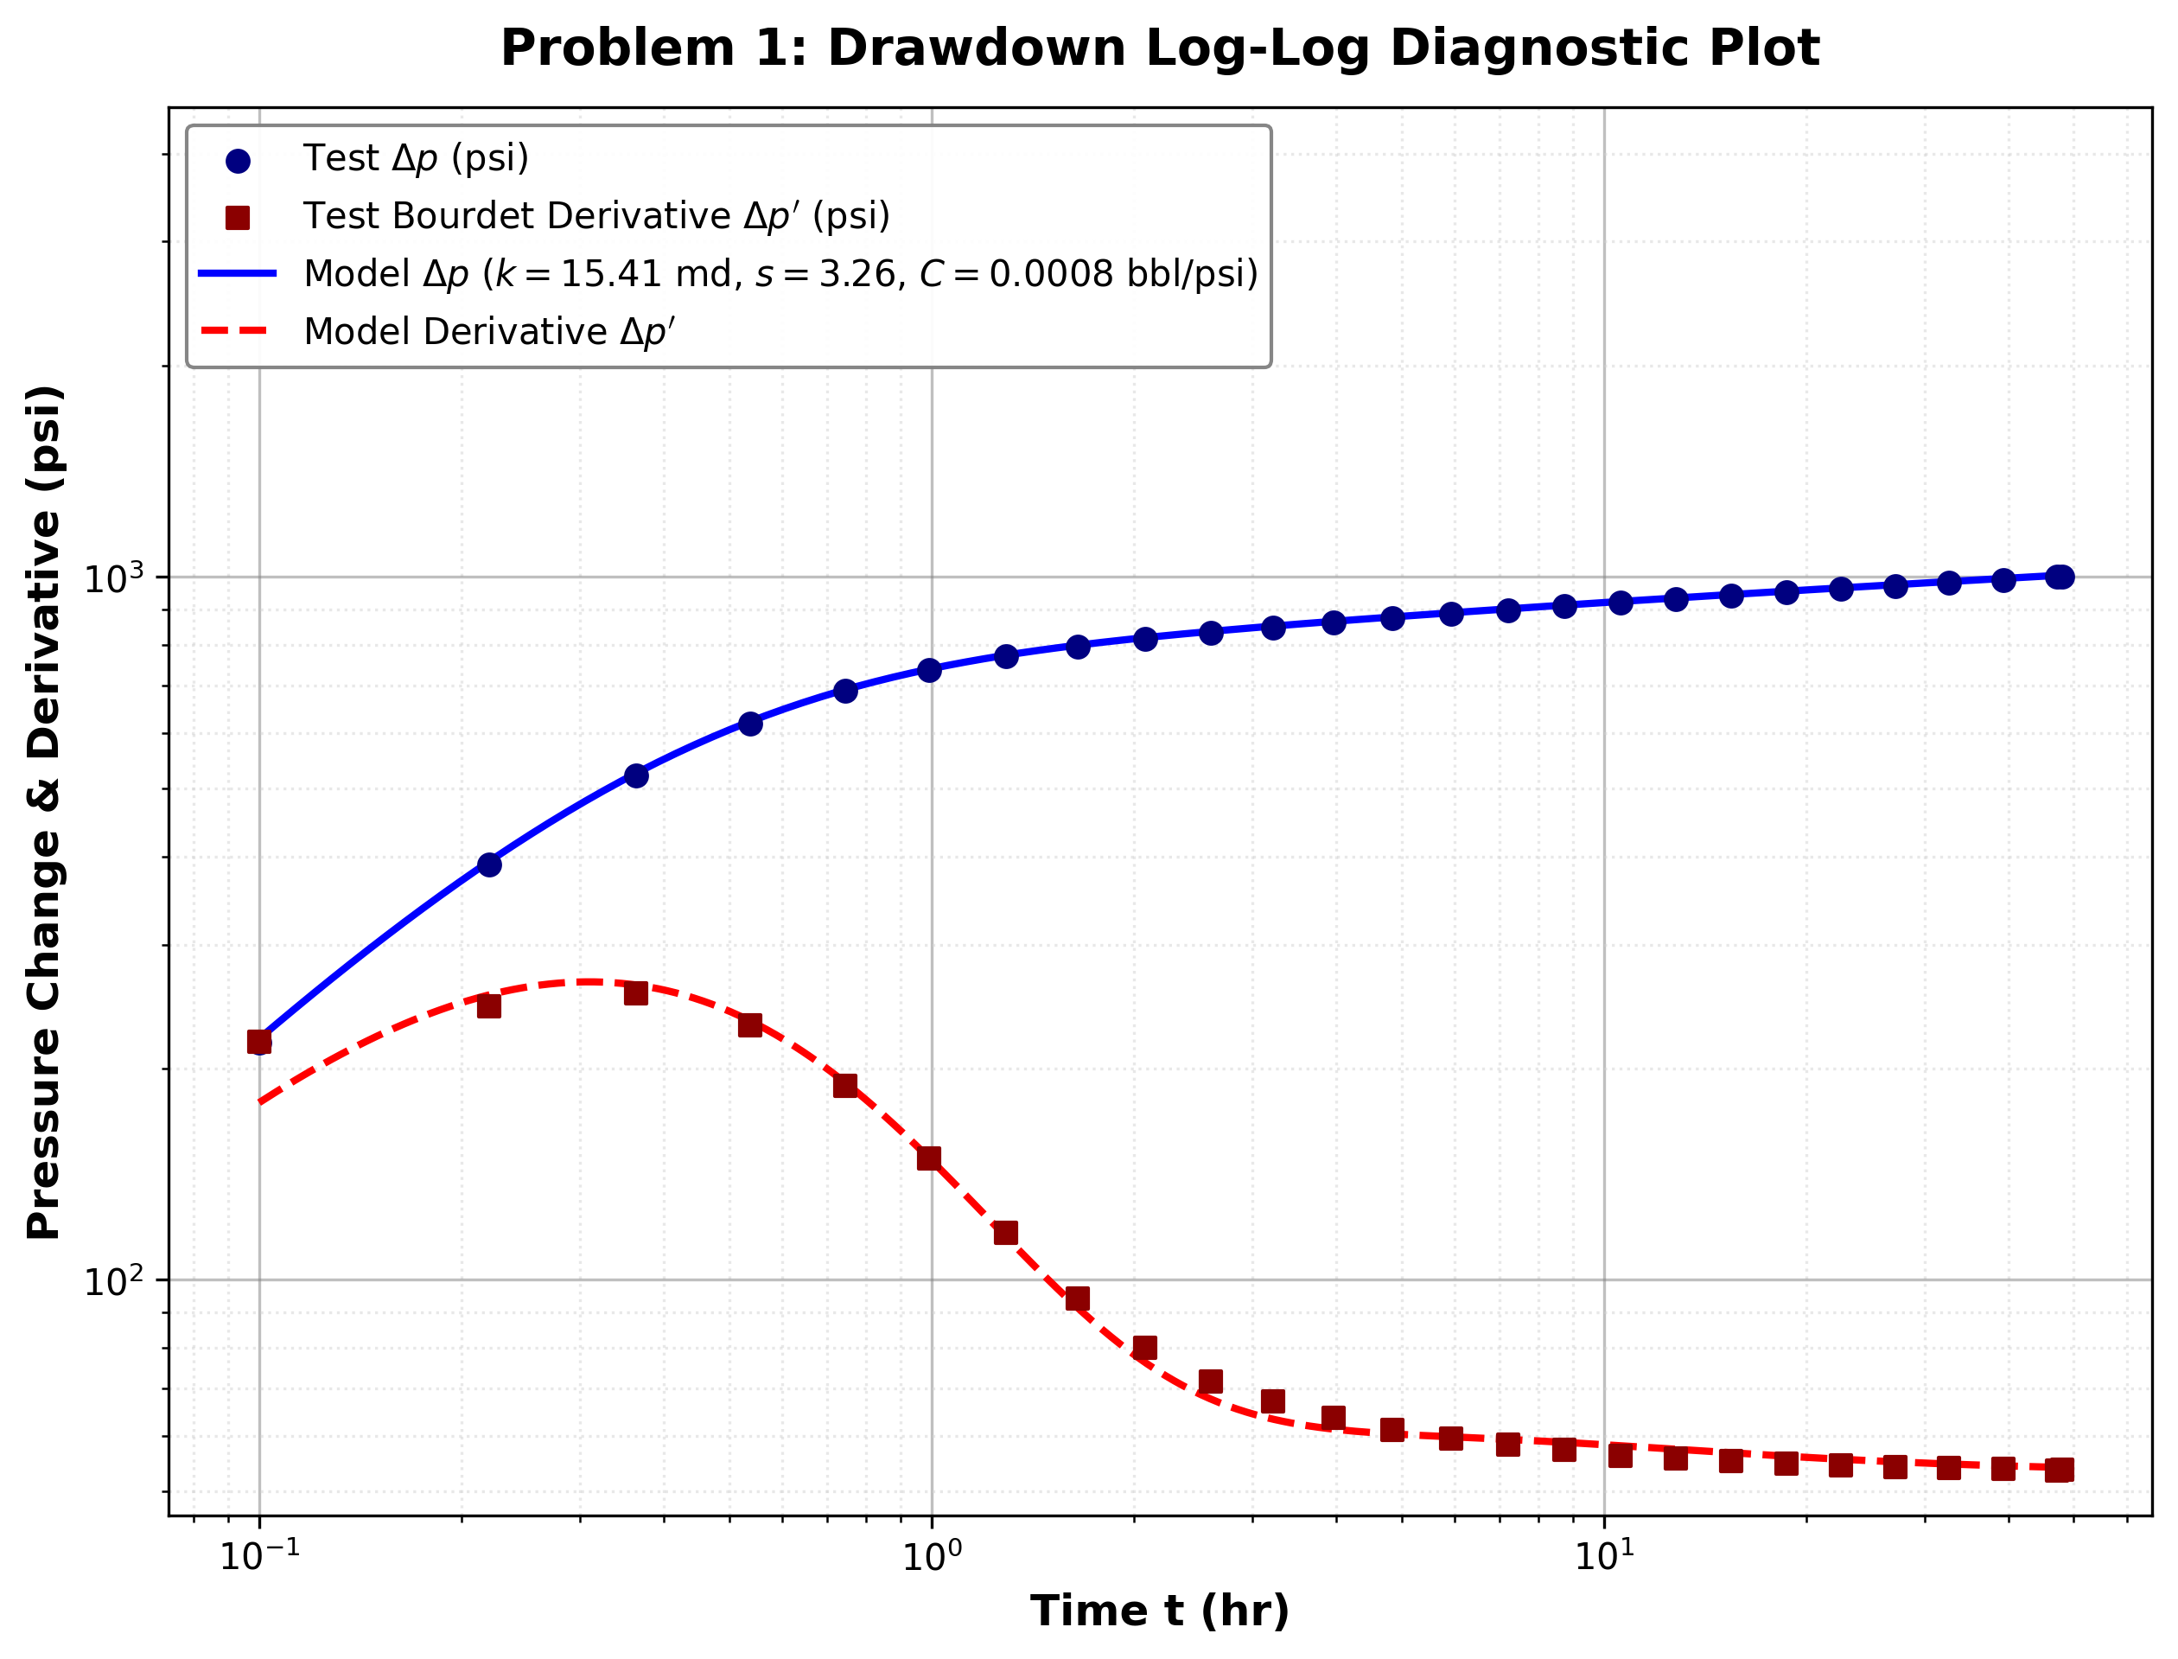

Figure 2
Semi-Log Plot for Drawdown Test ($p_{wf}$ vs Log(t)).
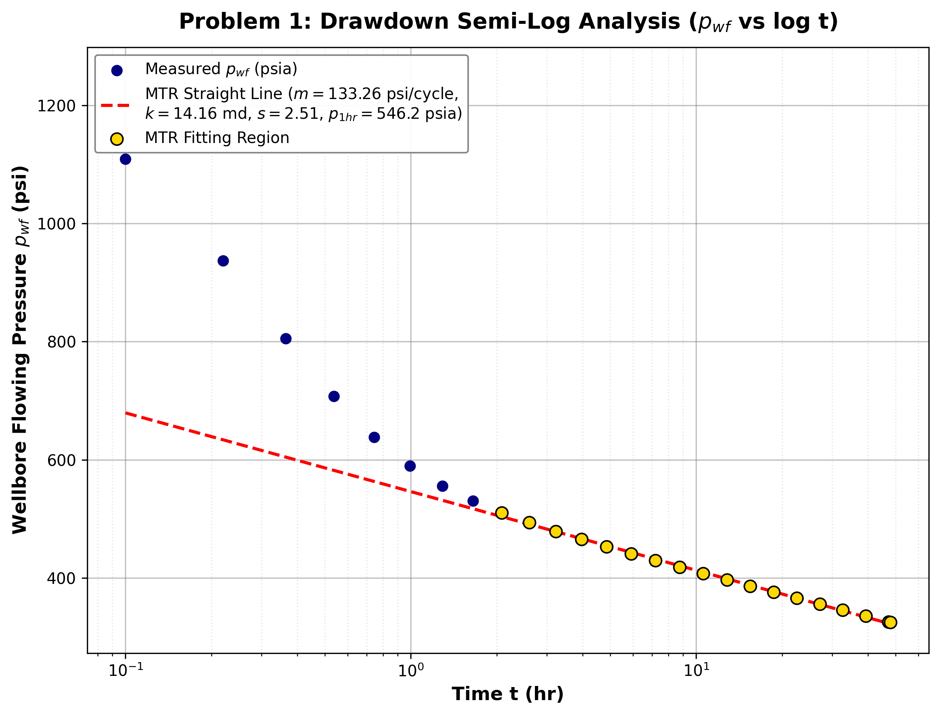

Figure 3
Log-Log Diagnostic Plot for Buildup Test (Agarwal Equivalent Time).
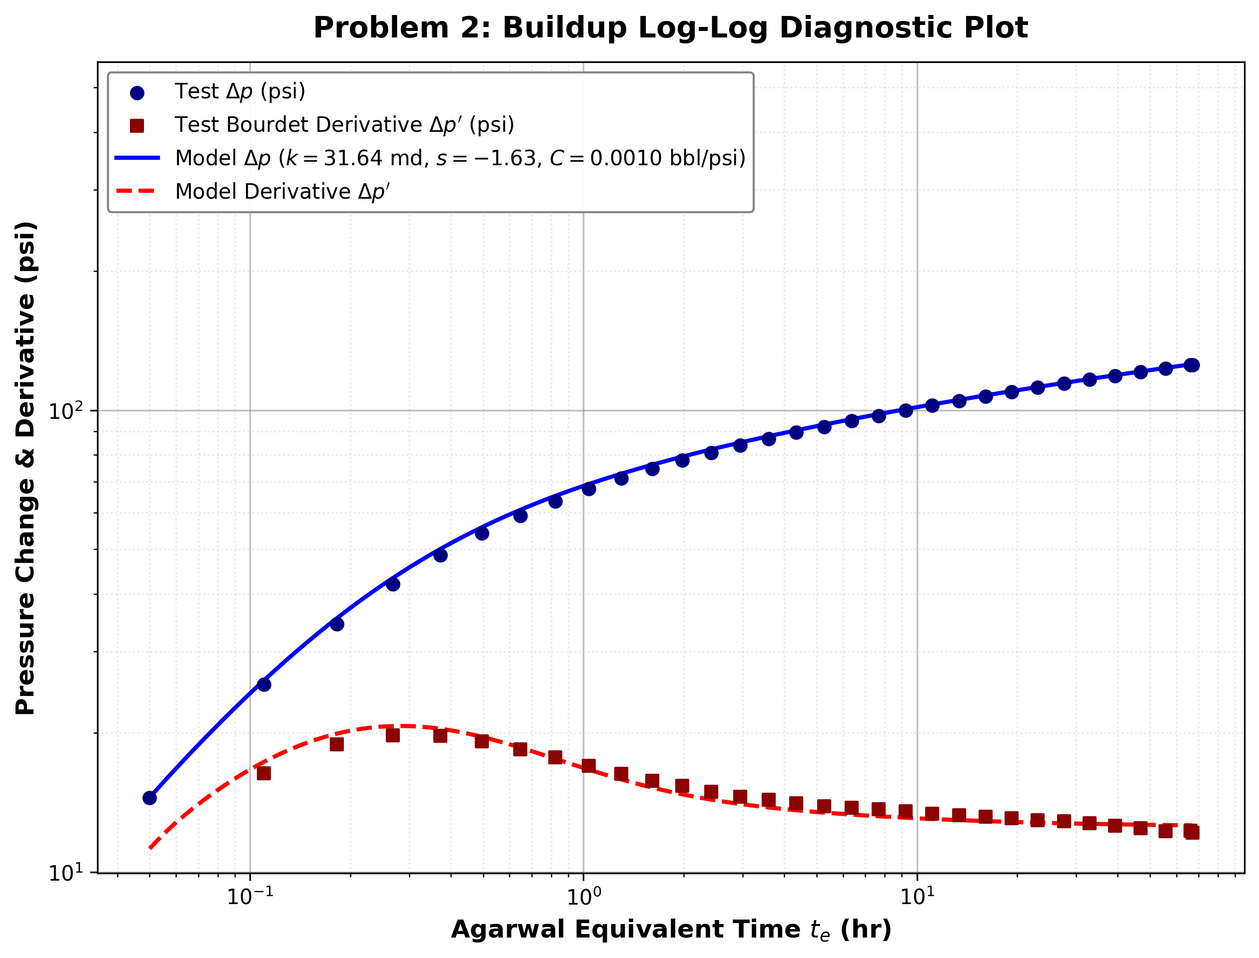

Figure 4
Horner Plot for Buildup Test ($p_{ws}$ vs Horner Ratio).
