Two Sum
原题:
Given an array of integers, return indices of the two numbers such that they add up to a specific target.
You may assume that each input would have exactly one solution, and you may not use the same element twice.
Example:
Given nums = [2, 7, 11, 15], target = 9,

Because nums[0] + nums[1] = 2 + 7 = 9,
return [0, 1].

最简单最笨的方法:
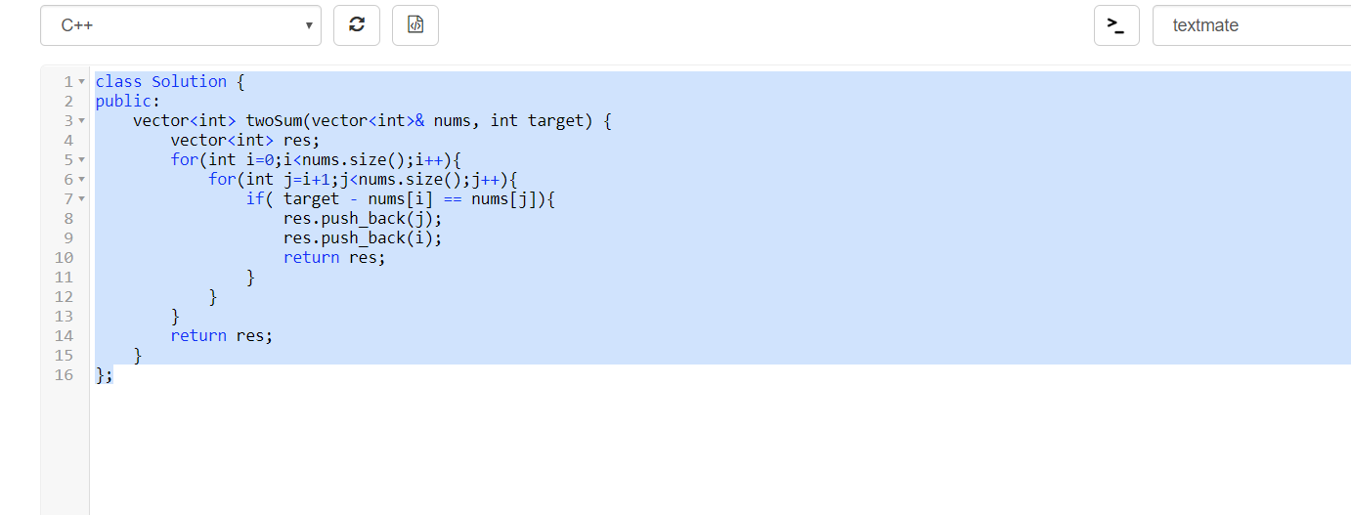
两层for循环，T(n)=O(n**2)

第二种方法:
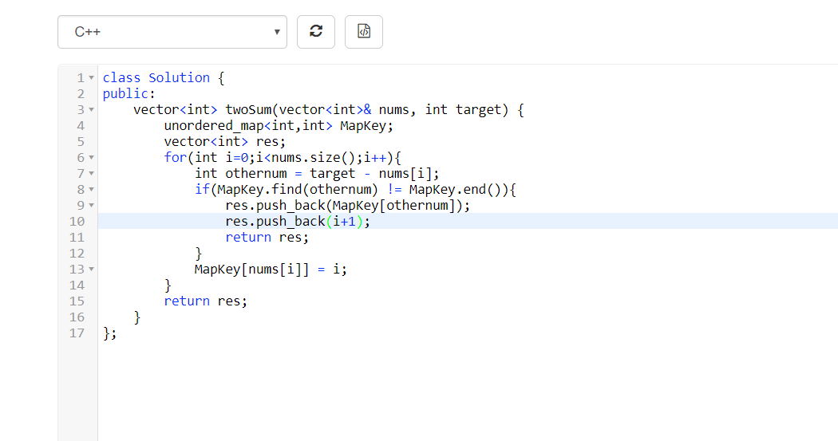
因为用的STL库，find操作假设为1，则其T(n) = O(n).

