Министерство образования Республики Беларусь

Учреждение образования

«Брестский государственный технический университет»

Кафедра ИИТ

**Лабораторная работа №4**

По дисциплине: «Современные платформы программирования»

Выполнила:

Студентка 3 курса

Группы ПО-6

Юсковец М.А.

Проверил:

Монтик Н.С.

Брест, 2023

**Цель работы:** освоить приемы тестирования кода на примере использования библиотеки JUnit.

Ход работы:

**Задание:**

Вариант 25

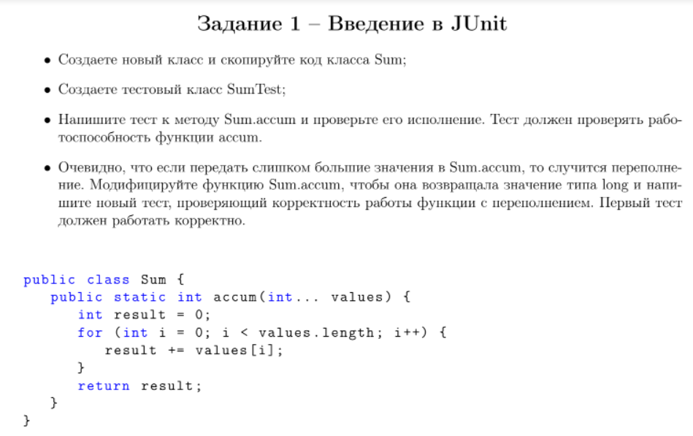

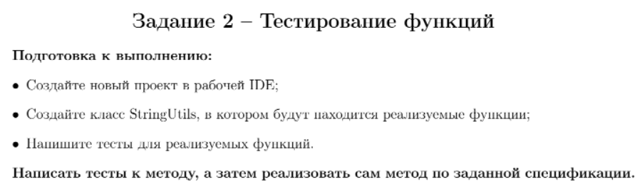

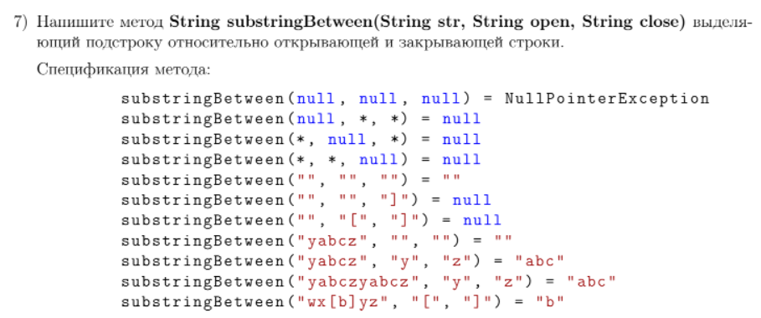

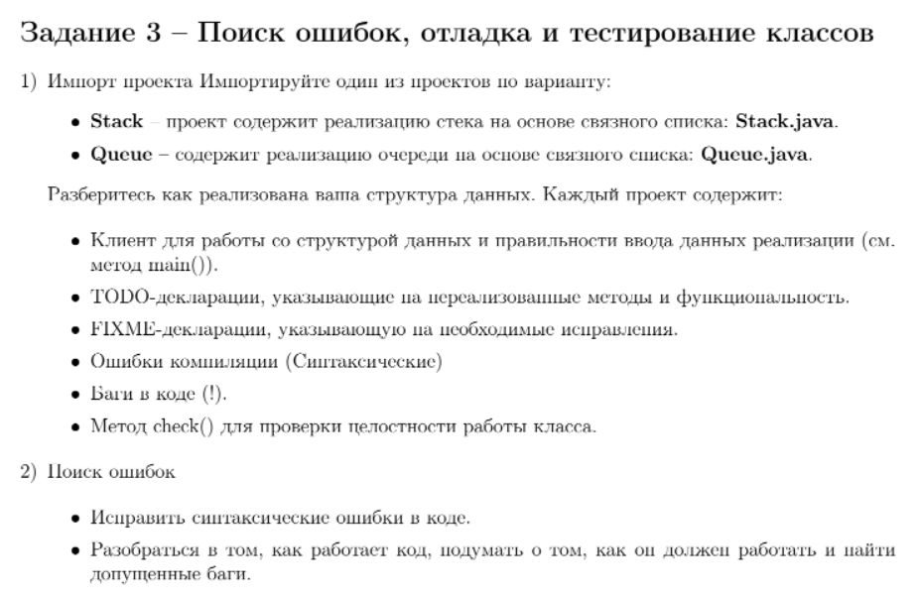

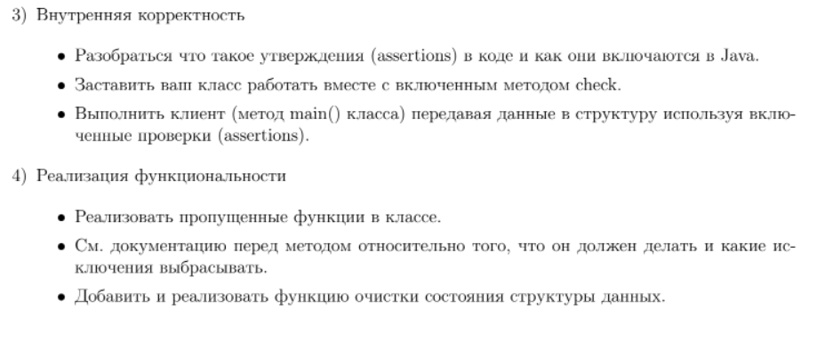

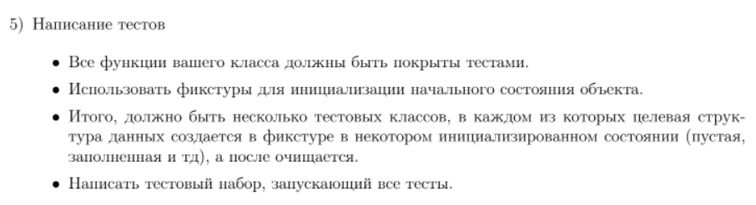

Задание 1:

Текст программы:

Sum.java

package com.example.spp_lab4;  
  
public class Sum {  
 public static int accum ( int ... values ) {  
 int result = 0;  
 for ( int i = 0; i < values.length ; i ++) {  
 result += values [ i ];  
 }  
 return result ;  
 }  
  
 public static long accumLong ( int ... values ) {  
 long result = 0;  
 for ( int i = 0; i < values.length ; i ++) {  
 result += values [ i ];  
 }  
 return result ;  
 }  
}

SumTest.java

package com.example.spp_lab4;  
  
import org.junit.jupiter.api.Test;  
  
import static org.junit.jupiter.api.Assertions.*;  
  
class SumTest {  
  
 @Test  
 public void accumTest() {  
 int[] values = {5, 6, 3};  
 int expecteds = 14;  
 int result = Sum.*accum*(values);  
 System.*out*.println("accumTest");  
 *assertEquals*(expecteds, result);  
 }  
  
  
 @Test  
 public void accumLongTest() {  
 int[] values = {599999999, 699999999, 399999999};  
 long expecteds = 1699999997L;  
 long result = Sum.*accum*(values);  
 System.*out*.println("accumLongTest");  
 *assertEquals*(expecteds, result);  
 }  
}

Результат программы:

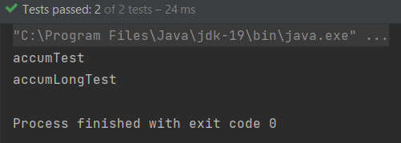

Задание 2:

Текст программы:

StringUtils.java

package com.example.spp_lab4;  
  
import java.util.Objects;  
  
public class StringUtils {  
 public static String substringBetween(String str, String open, String close) {  
 String result = null;  
  
 if (str == null && open == null && close == null)  
 throw new NullPointerException();  
 else if (str == null || open == null || close == null)  
 return null;  
 else if (!Objects.*isNull*(str) && open.equals("") && close.equals(""))  
 return "";  
  
 int openIndex = str.indexOf(open);  
 int closeIndex = str.indexOf(close);  
  
 if (openIndex < 0 || closeIndex < 0)  
 return null;  
 else if (closeIndex < openIndex)  
 return null;  
 else if (openIndex == closeIndex)  
 return "";  
  
 result = str.substring(openIndex + 1, closeIndex);  
  
 return result;  
 }  
}

StringUtilsTest.java

package com.example.spp_lab4;  
  
import org.junit.jupiter.api.Test;  
  
import static org.junit.jupiter.api.Assertions.*;  
  
class StringUtilsTest {  
  
 @Test  
 public void substringBetweenTest() throws NullPointerException {  
 System.*out*.println("substringBetweenTest");  
  
 *assertNull*(StringUtils.*substringBetween*(null , "*" , "*"));  
 *assertNull*(StringUtils.*substringBetween*("*", null, "*"));  
 *assertNull*(StringUtils.*substringBetween*("*", "*", null ));  
 *assertEquals*(StringUtils.*substringBetween*("", "", ""), "");  
 *assertNull*(StringUtils.*substringBetween*("", "", "]"));  
 *assertNull*(StringUtils.*substringBetween*("", "[", "]"));  
 *assertEquals*(StringUtils.*substringBetween*(" yabcz ", "", ""), "");  
 *assertEquals*(StringUtils.*substringBetween*(" yabcz ", "y", "z"), "abc");  
 *assertEquals*(StringUtils.*substringBetween*(" yabczyabcz ", "y", "z"), "abc");  
 *assertEquals*(StringUtils.*substringBetween*("wx[b]yz", "[", "]"), "b");  
  
 try {  
 StringUtils.*substringBetween* (null, null, null);  
 } catch (NullPointerException ex) {  
 System.*out*.println("NullPointerException thrown");  
 }  
 }  
}

Результат программы:

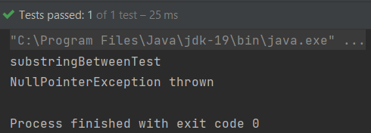

Задание 3:

Текст программы:

Stack.java

package com.example.spp_lab4;  
  
import java.util.NoSuchElementException;  
  
*/**  
 * The <tt>Stack</tt> class represents a last-in-first-out (LIFO) stack of  
 * generic items. It supports the usual <em>push</em> and <em>pop</em>  
 * operations, along with methods for peeking at the top item, testing if the  
 * stack is empty, and iterating through the items in LIFO order.  
 * <p>  
 */*//*TODO FIXME Find Bugs & Write Tests*public class Stack<Item> {  
 private int N; // size of the stack  
 private Node first; // top of stack  
 private Node last;  
  
 // helper linked list class  
 private class Node {  
 private Item item;  
 private Node next;  
 }  
  
 */**  
 * Create an empty stack.  
 */* public Stack() {  
 clear();  
 }  
  
 public void clear() {  
 first = null;  
 last = null;  
 N = 0;  
 assert check();  
 }  
  
 */**  
 * Is the stack empty?  
 */* public boolean isEmpty() {  
 // *TODO Implement method* return N == 0;  
 }  
  
 */**  
 * Return the number of items in the stack.  
 */* public int size() {  
 return N;  
 }  
  
 */**  
 * Add the item to the stack.  
 */* public void push(Item item) {  
 Node oldfirst = first;  
 first = new Node();  
 first.item = item;  
 first.next = oldfirst;  
 last = first;  
 N++;  
 assert check();  
 }  
  
 */**  
 * Delete and return the item most recently added to the stack.  
 *  
 \** ***@throws*** *java.util.NoSuchElementException if stack is empty.  
 */* public Item pop() {  
 // *FIXME throw exception if stack is Empty.* if (isEmpty())  
 throw new NoSuchElementException();  
  
 Item item = first.item; // save item to return  
 first = first.next; // delete first node  
 N--;  
 assert check();  
 return item; // return the saved item  
 }  
  
 */**  
 * Return the item most recently added to the stack without deletion.  
 *  
 \** ***@throws*** *java.util.NoSuchElementException if stack is empty.  
 */* public Item peek() {  
 // *TODO implement function* // *FIXME throw exception if stack is Empty.* if (isEmpty())  
 throw new NoSuchElementException();  
  
 return first.item;  
 }  
  
 public int search(Item searchItem) {  
 if (isEmpty())  
 return -1;  
  
 int counter = 0;  
 Node item = first;  
  
 while (item != null) {  
 if (item.item.equals(searchItem)) {  
 return counter;  
 }  
  
 counter++;  
 item = item.next;  
 }  
  
 return -1;  
 }  
  
 */**  
 * Return string representation.  
 */* public String toString() {  
 StringBuilder s = new StringBuilder();  
 for (Node current = first; current != null; current = current.next) {  
 Item item = current.item;  
 s.append(item).append(" ");  
 }  
 return s.toString();  
 }  
  
 // check internal invariants  
 private boolean check() {  
 if (N == 0) {  
 if (first != null || last != null) {  
 return false;  
 }  
 }  
 else if (N == 1) {  
 if (first == null || last == null) {  
 return false;  
 }  
 if (first.next != null) {  
 return false;  
 }  
 }  
 else {  
 if (first.next == null) {  
 return false;  
 }  
 if (first == null || last == null) {  
 return false;  
 }  
 }  
  
 // check internal consistency of instance variable N  
 int numberOfNodes = 0;  
  
 for (Node x = first; x != null; x = x.next) {  
 numberOfNodes++;  
 }  
  
 if (numberOfNodes != N) {  
 return false;  
 }  
  
 return true;  
 }  
}

StackClient.java

package com.example.spp_lab4;  
  
import java.util.Scanner;  
  
  
*/**  
 * A test client.  
 */*public class StackClient {  
 public static void main(String[] args) {  
 Stack<String> s = new Stack<String>();  
  
 Scanner scanner = new Scanner(System.*in*);  
  
 while (scanner.hasNext()) {  
 String item = scanner.next();  
 if (item.equals("stop"))  
 break;  
 else if (!item.equals("-")) {  
 s.push(item);  
 } else if (!s.isEmpty()) {  
 System.*out*.println("Deleted element: " + s.pop());  
 }  
 }  
  
 System.*out*.println("Size: " + s.size());  
 }  
}

EmptyStackTest.java

package com.example.spp_lab4;  
  
import java.util.NoSuchElementException;  
import org.junit.*;  
import org.junit.Test;  
  
import static org.junit.jupiter.api.Assertions.*;  
  
public class EmptyStackTest {  
 Stack<String> s = new Stack<String>();  
  
 @Before  
 public void initBefore() {  
 s.clear();  
 }  
  
 @After  
 public void initAfter() {  
  
 }  
  
 */**  
 * Test of clear method, of class Stack.  
 */* @Test  
 public void clearTest() {  
 System.*out*.println("clearTest");  
  
 s.clear();  
  
 *assertTrue*(s.isEmpty());  
 *assertEquals*(s.size(), 0);  
 }  
  
 */**  
 * Test of isEmpty method, of class Stack.  
 */* @Test  
 public void isEmptyTest() {  
 System.*out*.println("isEmptyTest");  
  
 *assertTrue*(s.isEmpty());  
 }  
  
 */**  
 * Test of size method, of class Stack.  
 */* @Test  
 public void sizeTest() {  
 System.*out*.println("sizeTest");  
  
 *assertEquals*(s.size(), 0);  
 }  
  
 */**  
 * Test of push method, of class Stack.  
 */* @Test  
 public void pushTest() {  
 System.*out*.println("pushTest");  
  
 s.push("1");  
  
 *assertEquals*(s.size(), 1);  
 *assertEquals*(s.search("1"), 0);  
 *assertEquals*(s.peek(), "1");  
 }  
  
 */**  
 * Test of pop method, of class Stack.  
 */* @Test  
 public void popTest() throws NoSuchElementException {  
 System.*out*.println("popTest");  
  
 try {  
 s.pop();  
 } catch (NoSuchElementException ex) {  
 System.*out*.println("NoSuchElementException");  
 }  
 }  
  
 */**  
 * Test of peek method, of class Stack.  
 */* @Test  
 public void peekTest() throws NoSuchElementException {  
 System.*out*.println("peekTest");  
  
 try {  
 s.peek();  
 } catch (NoSuchElementException ex) {  
 System.*out*.println("NoSuchElementException");  
 }  
 }  
  
 */**  
 * Test of search method, of class Stack.  
 */* @Test  
 public void searchTest() {  
 System.*out*.println("searchTest");  
  
 *assertEquals*(s.search("1"), -1);  
 }  
  
 */**  
 * Test of toString method, of class Stack.  
 */* @Test  
 public void toStringTest() {  
 System.*out*.println("toStringTest");  
  
 *assertEquals*(s.toString(), "");  
 }  
}

NotEmptyStackTest.java

package com.example.spp_lab4;  
  
import org.junit.*;  
import org.junit.Before;  
import org.junit.Test;  
  
import static org.junit.jupiter.api.Assertions.*;  
  
public class NotEmptyStackTest {  
 Stack<String> s = new Stack<String>();  
  
 @Before  
 public void initBefore() {  
 s.clear();  
 s.push("7");  
 s.push("1");  
 s.push("4");  
 }  
  
 @After  
 public void initAfter() {  
  
 }  
  
 */**  
 * Test of clear method, of class Stack.  
 */* @Test  
 public void clearTest() {  
 System.*out*.println("clearTest");  
  
 s.clear();  
  
 *assertTrue*(s.isEmpty());  
 *assertEquals*(s.size(), 0);  
 }  
  
 */**  
 * Test of isEmpty method, of class Stack.  
 */* @Test  
 public void isEmptyTest() {  
 System.*out*.println("isEmptyTest");  
  
 *assertFalse*(s.isEmpty());  
 }  
  
 */**  
 * Test of size method, of class Stack.  
 */* @Test  
 public void sizeTest() {  
 System.*out*.println("sizeTest");  
  
 *assertEquals*(s.size(), 3);  
 }  
  
 */**  
 * Test of push method, of class Stack.  
 */* @Test  
 public void pushTest() {  
 System.*out*.println("push");  
  
 s.push("0");  
  
 *assertEquals*(s.size(), 4);  
 *assertEquals*(s.search("1"), 2);  
 *assertEquals*(s.peek(), "0");  
 }  
  
 */**  
 * Test of pop method, of class Stack.  
 */* @Test  
 public void popTest() {  
 System.*out*.println("popTest");  
  
 *assertEquals*(s.pop(), "4");  
 *assertEquals*(s.size(), 2);  
 }  
  
 */**  
 * Test of peek method, of class Stack.  
 */* @Test  
 public void peekTest() {  
 System.*out*.println("peekTest");  
  
 *assertEquals*(s.peek(), "4");  
 }  
  
 */**  
 * Test of search method, of class Stack.  
 */* @Test  
 public void searchTest() {  
 System.*out*.println("searchTest");  
  
 *assertEquals*(s.search("7"), 2);  
 *assertEquals*(s.search("1"), 1);  
 *assertEquals*(s.search("4"), 0);  
 }  
  
 */**  
 * Test of toString method, of class Stack.  
 */* @Test  
 public void toStringTest() {  
 System.*out*.println("toStringTest");  
  
 *assertEquals*(s.toString(), "4 1 7 ");  
 }  
}

StackTest.java

package com.example.spp_lab4;  
  
import org.junit.runner.RunWith;  
import org.junit.runners.Suite;  
  
  
@RunWith(Suite.class)  
@Suite.SuiteClasses({  
 EmptyStackTest.class,  
 NotEmptyStackTest.class  
})  
public class StackTest {  
  
}

Результат программы:

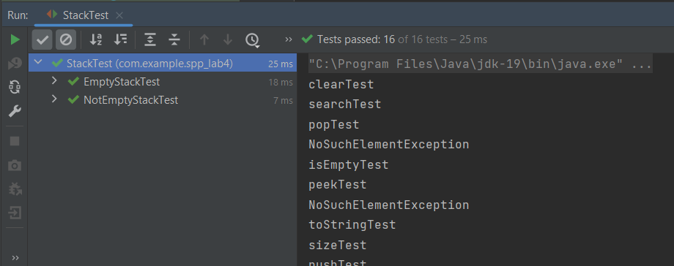

**Вывод:** освоили приемы тестирования кода на примере использования библиотеки JUnit.