**PRAKTIKUM 6 KONSEP FUNDAMENTAL CSS DAN**

FRAMEWORK

# TUJUAN PEMBELAJARAN

* 1. Mahasiswa memahami fundamental dari CSS
  2. Mahasiswa mampu menggunakan framework CSS

# DASAR TEORI

**a. CSS**

Cascading Style Sheet (CSS) merupakan aturan untuk mengendalikan beberapa komponen dalam sebuah web sehingga akan lebih terstruktur dan seragam. CSS bukan merupakan bahasa pemograman. CSS dapat mengatur beberapa style, misalnya heading, subbab, bodytext, footer, images, dan style lainnya untuk dapat digunakan bersama-sama dalam beberapa berkas (file). Pada umumnya CSS dipakai untuk memformat tampilan halaman web yang dibuat dengan bahasa HTML dan XHTML. CSS dapat mengendalikan ukuran gambar, warna bagian tubuh pada teks, warna tabel, ukuran border, warna border, warna hyperlink, warna mouse over, spasi antar paragraf, spasi antar teks, margin kiri, kanan, atas, bawah, dan parameter lainnya. CSS adalah bahasa style sheet yang digunakan untuk mengatur tampilan dokumen. Dengan adanya CSS memungkinkan kita untuk menampilkan halaman yang sama dengan format yang berbeda.

# TUGAS PENDAHULUAN

* 1. Lakukan Instalasi bootstrap terlebih dahulu!

# PERCOBAAN

* 1. Percobaan 1 : Hello World CSS

Input :

HTML :

<html lang="en">

<head>

    <meta charset="UTF-8">

    <meta name="viewport" content="width=device-width, initial-scale=1.0">

    <title>Document</title>

    <link rel="stylesheet" href="apps.css">

</head>

<body>

    <h1>HELLO WORLD</h1>

</body>

</html>

CSS :

body{

    margin: 0px;

    background-image: linear-gradient(to bottom right, #95d9f9, #ae4bc3) ;

    background-size: cover;

}

h1 {

    color: #1b95cd;

    font-family: tahoma, sans-serif;

    size: 400px;

}

Output :

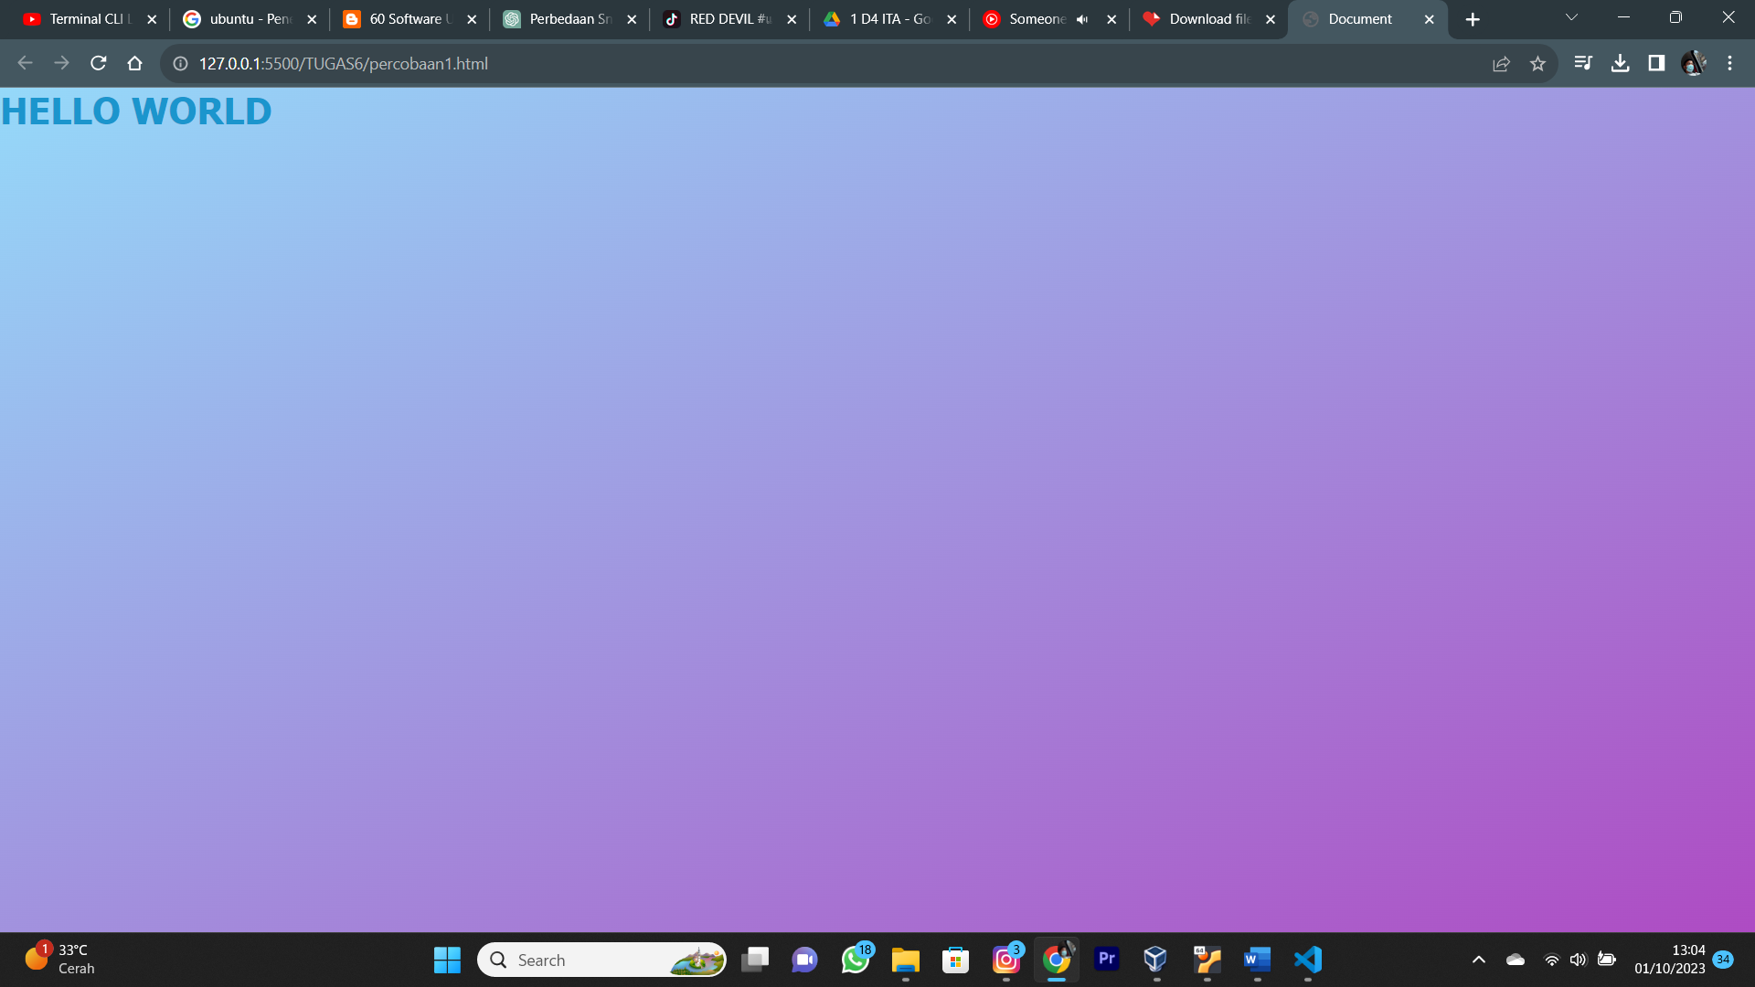

Analisa : Program berikut merupakan program html sederhana yang menampilkan web dengan tulisan hello world dan background gradasi warna yang diatur dengan css.

* 1. Percobaan 2 : CSS Background

Input ;

<!DOCTYPE html>

<html>

  <head>

    <style>

      #example1 {

        width: 40%;

        padding: 15px;

        background-image: url("https://www.w3schools.com/Jsref/img_flwr.gif"),

        url("http://www.lecturemaker.com/wp-content/uploads/2013/07/HP_paper.gif");

        background-position: right bottom, left top;

        background-repeat: no-repeat, repeat;

      }

    </style>

  </head>

  <body>

    <h1>Flower Market</h1>

    <p>the following div element has two background images</p>

    <div id="example1">

      <h1>Fresh and Beautiful Flower</h1>

      <p>We sell many kinds of flower, likes zinia, lavender, english ivi, orchid,

        jasmine, majoram, rose etc.</p>

      <p>Rose is a flower with strong scent that could gave us positive vibes</p>

    </div>

  </body>

</html>

Output :

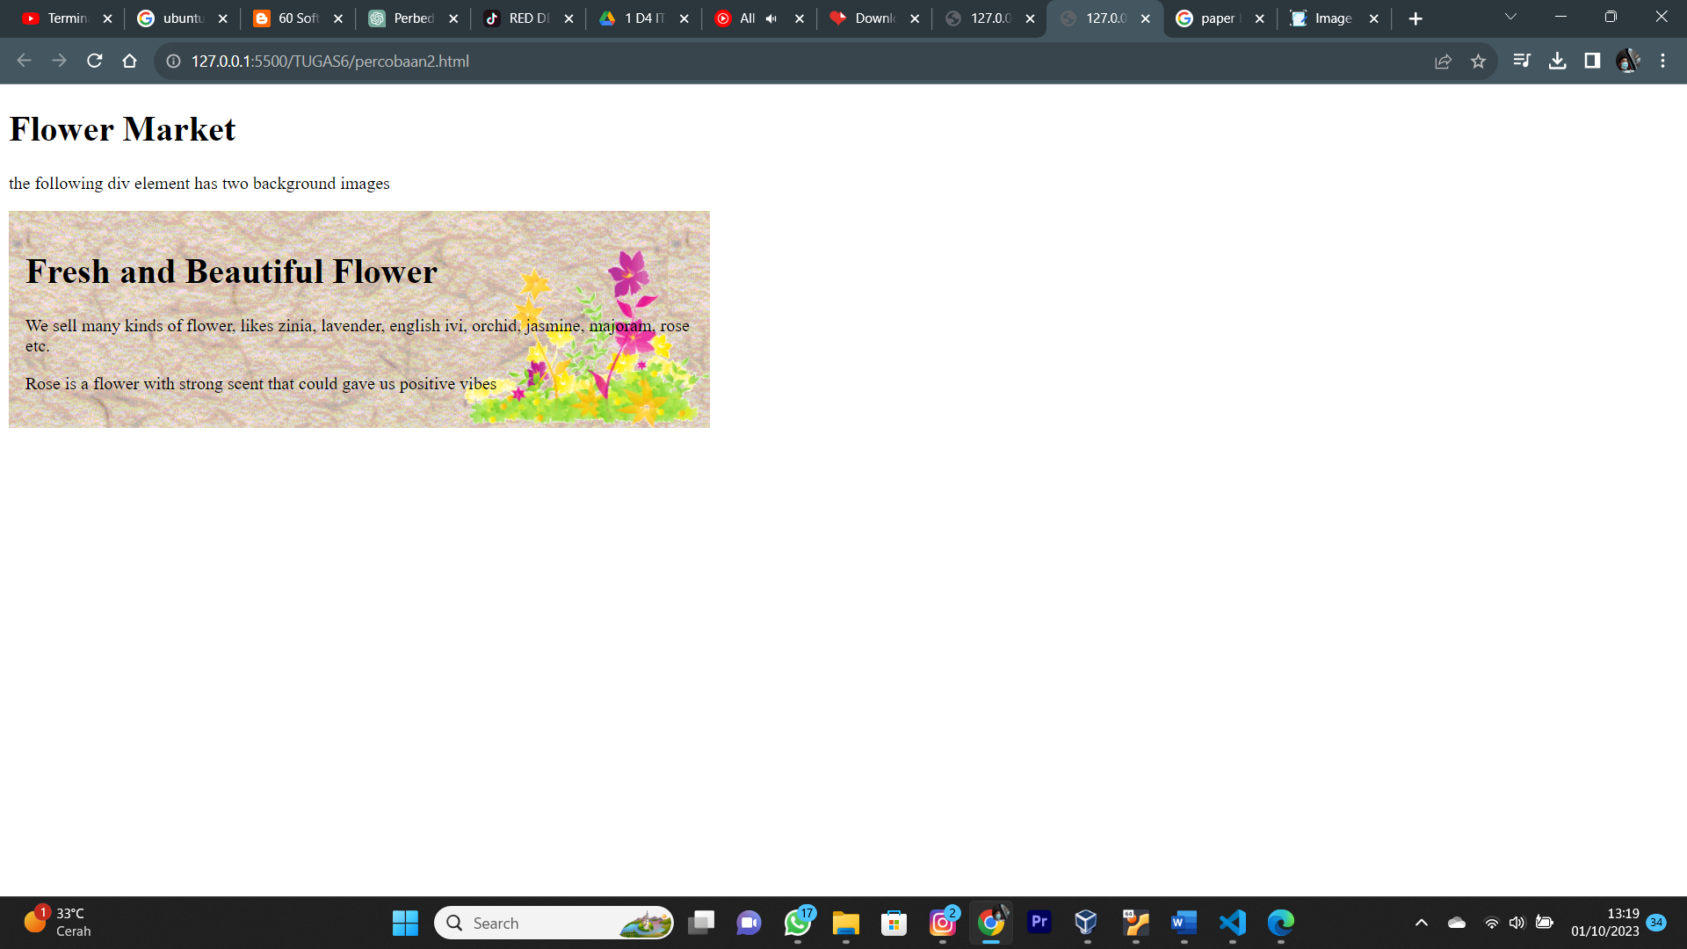

Analisa :

Program tersebut merupakan program web sederhana yang mencakup sebuah teks pendek dengan background 2 gambar dengan format css yang berbeda.

* 1. Percobaan 3 : CSS Borders

Input :

<!DOCTYPE html>

<html>

<head>

    <style>

        .dotted {

            border-style: dotted;

        }

        .dashed {

            border-style: dashed;

        }

        .solid {

            border-style: solid;

        }

        .double {

            border-style: double;

        }

        .groove {

            border-style: groove;

        }

        .ridge {

            border-style: ridge;

        }

        .inset {

            border-style: inset;

        }

        .outset {

            border-style: outset;

        }

        .none {

            border-style: none;

        }

        .hidden {

            border-style: hidden;

        }

        .mix {

            border-style: dotted dashed solid double;

        }

    </style>

</head>

<body>

    <h2>PENS</h2>

    <p>Politeknik Elektronika Negeri Surabaya</p>

    <p class="dotted">Politeknik Elektronika Negeri Surabaya</p>

    <p class="dashed">Politeknik Elektronika Negeri Surabaya</p>

    <p class="solid">Politeknik Elektronika Negeri Surabaya</p>

    <p class="double">Politeknik Elektronika Negeri Surabaya</p>

    <p class="groove">Politeknik Elektronika Negeri Surabaya</p>

    <p class="ridge">Politeknik Elektronika Negeri Surabaya</p>

    <p class="inset">Politeknik Elektronika Negeri Surabaya</p>

    <p class="outset">Politeknik Elektronika Negeri Surabaya</p>

    <p class="none">Politeknik Elektronika Negeri Surabaya</p>

    <p class="hidden">Politeknik Elektronika Negeri Surabaya</p>

    <p class="mix">Politeknik Elektronika Negeri Surabaya</p>

</body>

</html>

Output :

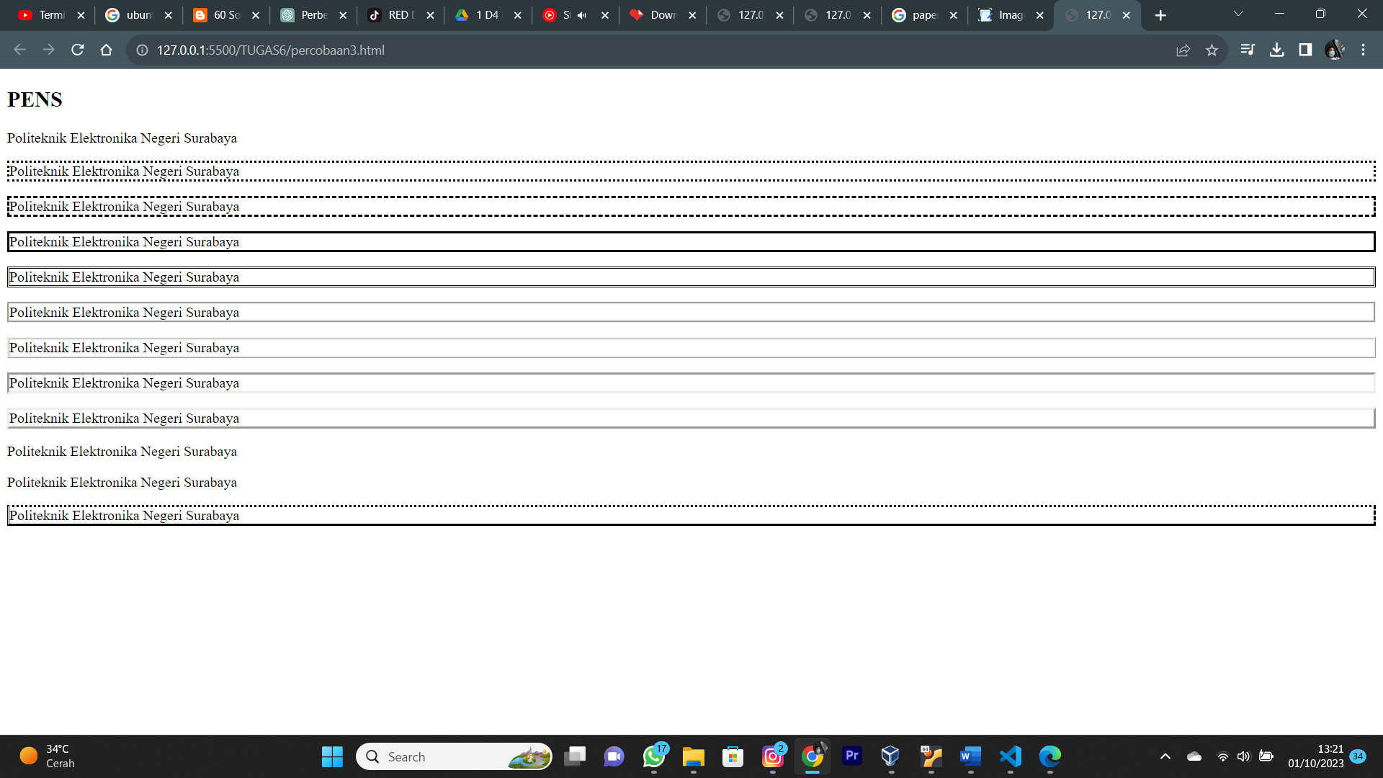

Analisa : Program tersebut program web sederhana yang terdapat tag paragraph yang dibungkus dengan border yang berbeda tiap barisnya dan ada juga border yang dikombinasikan antarjenisnya.

* 1. Percobaan 4 : Bootstrap Access

Input :

<!DOCTYPE html>

<html lang="en">

<head>

    <meta charset="utf-8">

    <meta name="viewport" content="width=device-width, initial-scale=1">

    <title>Bootstrap demo</title>

    <link href="https://cdn.jsdelivr.net/npm/bootstrap@5.3.2/dist/css/bootstrap.min.css" rel="stylesheet"

    integrity="sha384-T3c6CoIi6uLrA9TneNEoa7RxnatzjcDSCmG1MXXSR1GASXEV/Dwwykc2MPK8M2HN"

    crossorigin="anonymous">

</head>

<body>

    <h1>Hello, world!</h1>

    <script src="https://cdn.jsdelivr.net/npm/bootstrap@5.3.2/dist/js/bootstrap.bundle.min.js"

    integrity="sha384-C6RzsynM9kWDrMNeT87bh950GNyZPhc TNXj1NW7RuBCsyN/o0j lpcV8Qyq46cDfL"

    crossorigin="anonymous"></script>

</body>

</html>

Output :

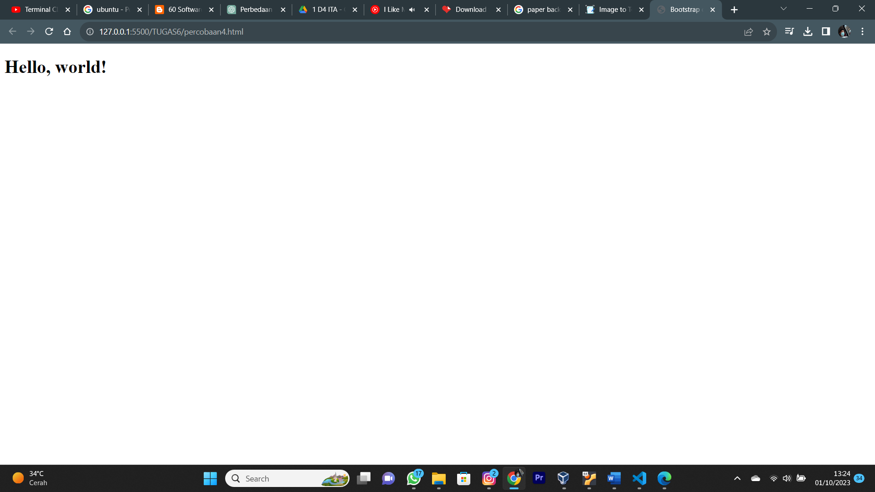

Analisa :

Program tersebut merupakan contoh program web sederhana dengan sudah dikaitkan dengan salah satu frame work CSS, Bootstrap,

* 1. Percobaan 5 : Bootstrap Containers

Input :

<!DOCTYPE html>

<html lang="en">

<head>

    <title>Bootstrap Example</title>

    <meta charset="utf-8">

    <meta name="viewport" content="width=device-width, initial-scale=1">

    <link href="https://cdn.jsdelivr.net/npm/bootstrap@5.3.1/dist/css/bootstrap.min.css" rel="stylesheet">

    <script src="https://cdn.jsdelivr.net/npm/bootstrap@5.3.1/dist/js/bootstrap.bundle.min.js"></script>

</head>

    <body>

    <div class="container">

        <h1>Bootstrap Pertamaku</h1>

        <p>Ini adalah bagian dari kelas Container</p>

        <p>The .container class provides a responsive fixed width container.</p>

        <p>Resize the browser window to see that the container width will change at different breakpoints.</p>

    </div>

    </body>

</html>

Output :

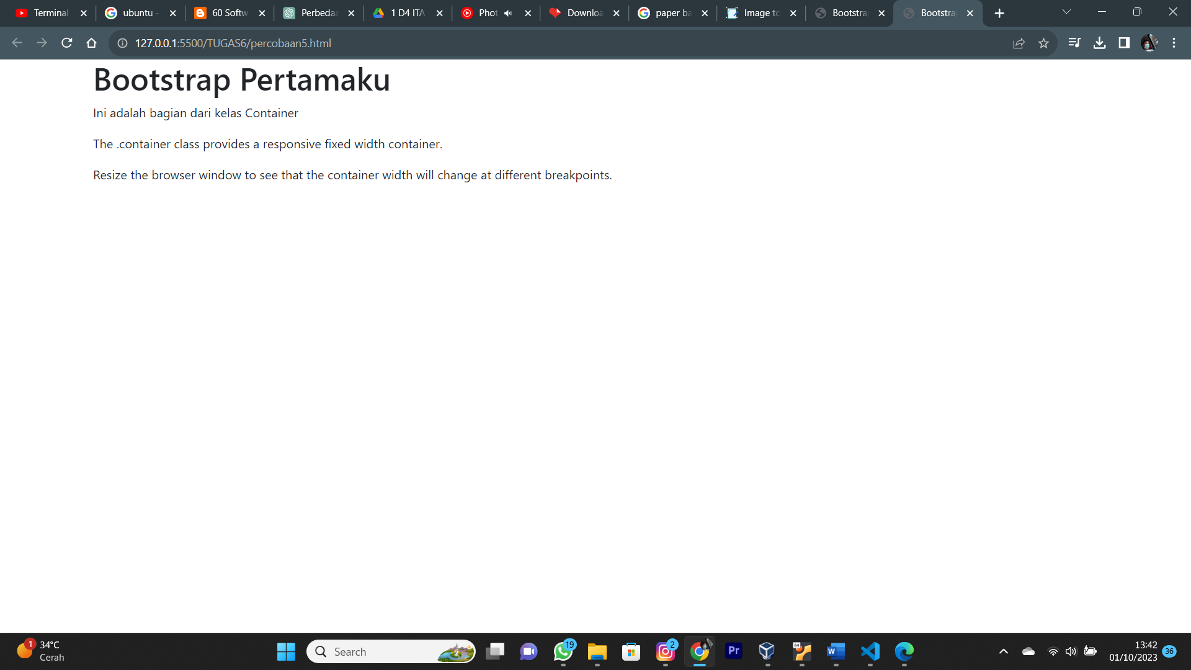

Analisa :

Program tersebut merupakan program web sederhana yang menampilkan perintah dengan framework bootstrap sebagai style nya. Container yang digunakan merupakan container biasa yang responsive terhadap ukuran layer (otomatis rapi saat dibuka di device yang berbeda)

* 1. Percobaan 6 : Bootstrap Grid

Input :

<!DOCTYPE html>

<html lang="en">

<head>

    <title>Bootstrap Example</title>

    <meta charset="utf-8">

    <meta name="viewport" content="width=device-width, initial-scale=1">

    <link href="https://cdn.jsdelivr.net/npm/bootstrap@5.3.1/dist/css/bootstrap.min.css" rel="stylesheet">

    <script src="https://cdn.jsdelivr.net/npm/bootstrap@5.3.1/dist/js/bootstrap.bundle.min.js"></script>

</head>

    <body>

    <div class="container-fluid mt-3">

        <h1>PENS</h1>

        <p>D4 Teknik Informatika</p>

        <p>The columns will automatically stack on top of each other when the screen is less than 576px wide.</p>

        <div class="row">

            <div class="col-sm-3 p-3 bg-primary text-white">Nama</div>

            <div class="col-sm-3 p-3 bg-dark text-white">NRP</div>

            <div class="col-sm-3 p-3 bg-primary text-white">Alamat</div>

            <div class="col-sm-3 p-3 bg-dark text-white">Kelas</div>

        </div>

    </div>

    </body>

</html>

Output :

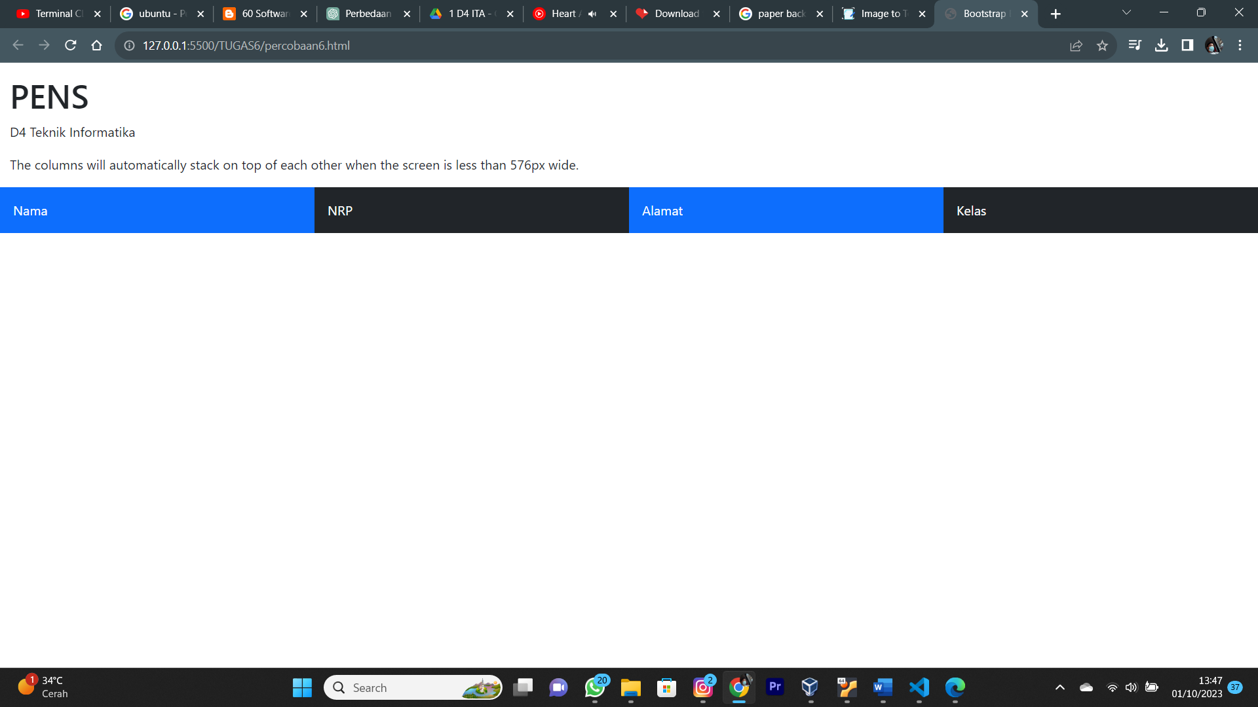

Analisa :

Program tersebut merupakan program web sederhana yang memuat tah h1sebagai header dan dibawahnya terdapat kolom kolom yang responsive terhadap layer, apabila layer kurang dari 576 pixel maka kolom tersebut akan otomatis menjadi baris.

* 1. Percobaan 7 : Bootstrap Table

Input :

<!DOCTYPE html>

<html lang="en">

  <head>

    <title>Bootstrap Example</title>

    <meta charset="utf-8" />

    <meta name="viewport" content="width=device-width, initial-scale=1" />

    <link href="https://cdn.jsdelivr.net/npm/bootstrap@5.3.1/dist/css/bootstrap.min.css" rel="stylesheet" />

    <script src="https://cdn.jsdelivr.net/npm/bootstrap@5.3.1/dist/js/bootstrap.bundle.min.js"></script>

  </head>

  <body>

    <div class="container mt-3">

      <h2>Hover Rows</h2>

      <p>Tabel akan berubah warna jika di scroll</p>

      <table class="table table-hover">

        <thead>

          <tr>

            <th>Firstname</th>

            <th>Lastname</th>

            <th>Email</th>

          </tr>

        </thead>

        <tbody>

          <tr>

            <td>Yesta</td>

            <td>Medya</td>

            <td>yesta@example.com</td>

          </tr>

          <tr>

            <td>Prasetyo</td>

            <td>Wibowo</td>

            <td>pras@example.com</td>

          </tr>

          <tr>

            <td>Ailyn</td>

            <td>Maria</td>

            <td>maria@example.com</td>

          </tr>

        </tbody>

      </table>

    </div>

  </body>

</html>

Output :

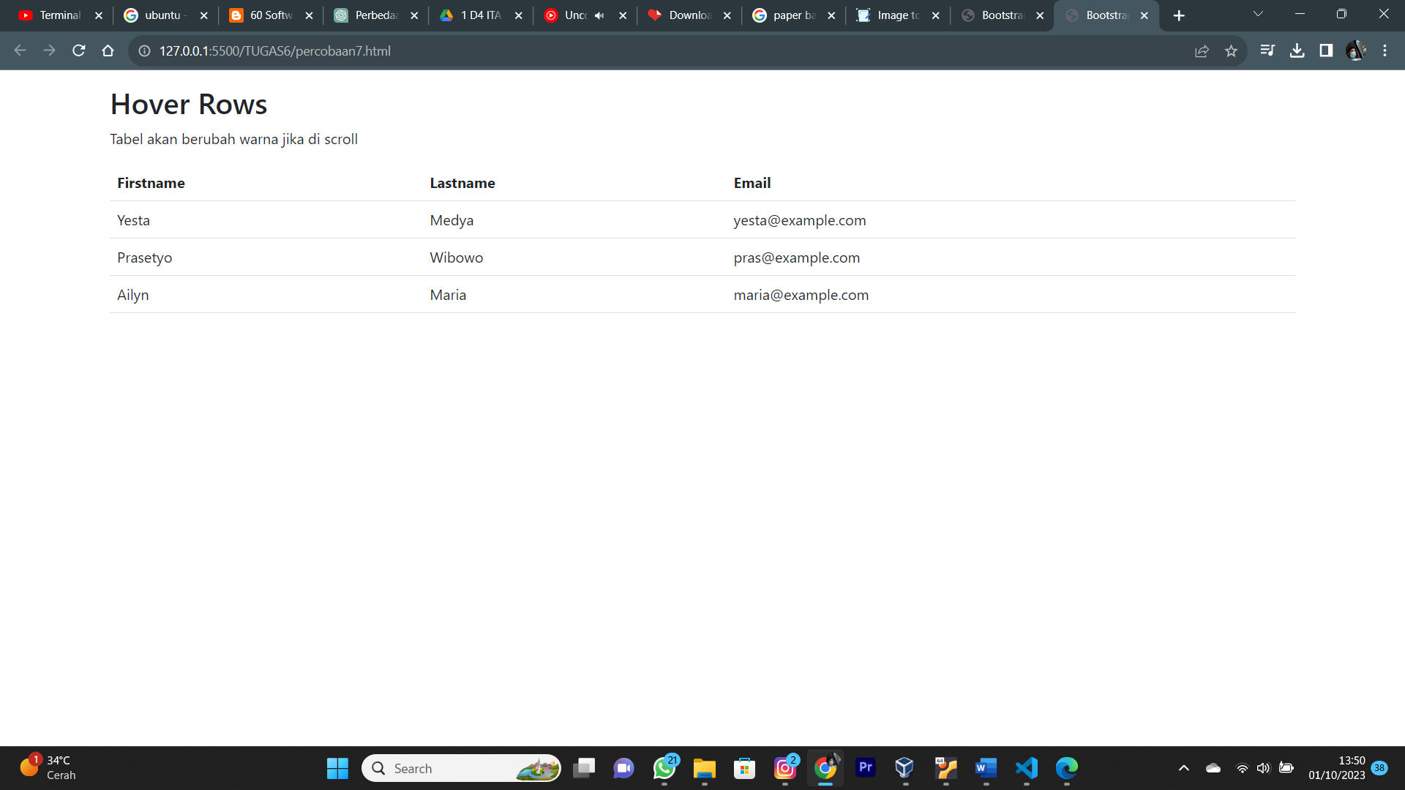

Analisa :

Program tersebut merupakan program web sederhana yang menggunakan framework bootstrap sebagai CSS nya. Program menampilkan tabel dengan salah satu pseudocode nya (hover) diberi style sendiri.

* 1. Percobaan 8 : Bootstrap Jumbotron

Input :

<!DOCTYPE html>

<html>

<head>

    <meta name="viewport" content="width=device-width, initial-scale=1">

    <link href="https://cdn.jsdelivr.net/npm/bootstrap@5.3.1/dist/css/bootstrap.min.css" rel="stylesheet">

    <script src="https://cdn.jsdelivr.net/npm/bootstrap@5.3.1/dist/js/bootstrap.bundle.min.js"></script>

</head>

<body>

    <div class="container mt-3">

        <h2>Example of Jumbotron</h2>

        <div class="mt-4 p-5 bg-primary text-white rounded">

            <h1>Politeknik Elektronika Negeri Surabaya</h1>

            <p>The early history of PENS began in 1984. The Japan International Cooperation Agency (JICA), an

                international cooperation

                agency established by the Japanese government in 1974 to assist the development of developing countries,

                plans to build polytechnic education in Indonesia and provide grants for polytechnic development.</p>

        </div>

    </div>

</body>

</html>

Output :

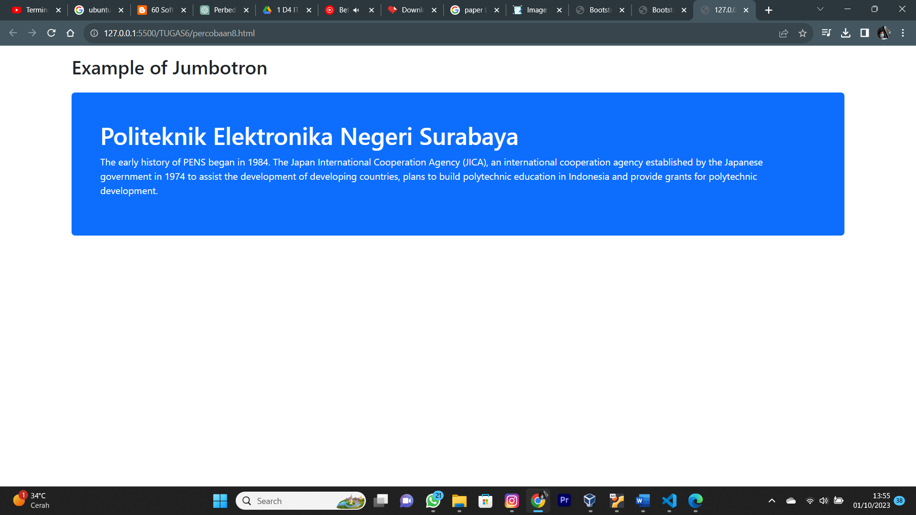

Analisa :

Program tersebut merupakan program web HTML sederhana dengan framework CSS bootstrap yang menampilkan sebuah jumbotron dengan tag h1 dan paragraf sebagai kontennya, serta diberi background primary (biru) , teks berwarna putih, dan ujung sudut kontainer nya tumpul.

* 1. Percobaan 9 : Bootstrap Alert

Input :

<!DOCTYPE html>

<html lang="en">

<head>

    <title>Bootstrap Example</title>

    <meta charset="utf-8">

    <meta name="viewport" content="width=device-width, initial-scale=1">

    <link href="https://cdn.jsdelivr.net/npm/bootstrap@5.3.1/dist/css/bootstrap.min.css" rel="stylesheet">

    <script src="https://cdn.jsdelivr.net/npm/bootstrap@5.3.1/dist/js/bootstrap.bundle.min.js"></script>

</head>

<body>

    <div class="container mt-3">

        <h2>Alerts</h2>

        <p>Alerts are created with the .alert class, followed by a contextual color classes:</p>

        <div class="alert alert-success">

            <strong>Success!</strong> This alert box could indicate a successful or positive action. <div

                class="alert alert-info">

            </div>

            <strong>Info!</strong> This alert box could indicate a neutral informative change or action.

        </div>

        <div class="alert alert-warning">

            <strong>Warning!</strong> This alert box could indicate a warning that might need attention.

        </div>

        <div class="alert alert-danger">

            <strong>Danger!</strong> This alert box could indicate a dangerous or potentially negative action.

        </div>

        <div class="alert alert-primary">

            <strong>Primary!</strong> Indicates an important action.

        </div>

        <div class="alert alert-secondary">

            <strong>Secondary!</strong> Indicates a slightly less important action.

        </div>

        <div class="alert alert-dark">

            <strong>Dark!</strong> Dark grey alert.

        </div>

        <div class="alert alert-light">

            <strong>Light!</strong> Light grey alert.

        </div>

    </div>

</body>

</html>

Output :

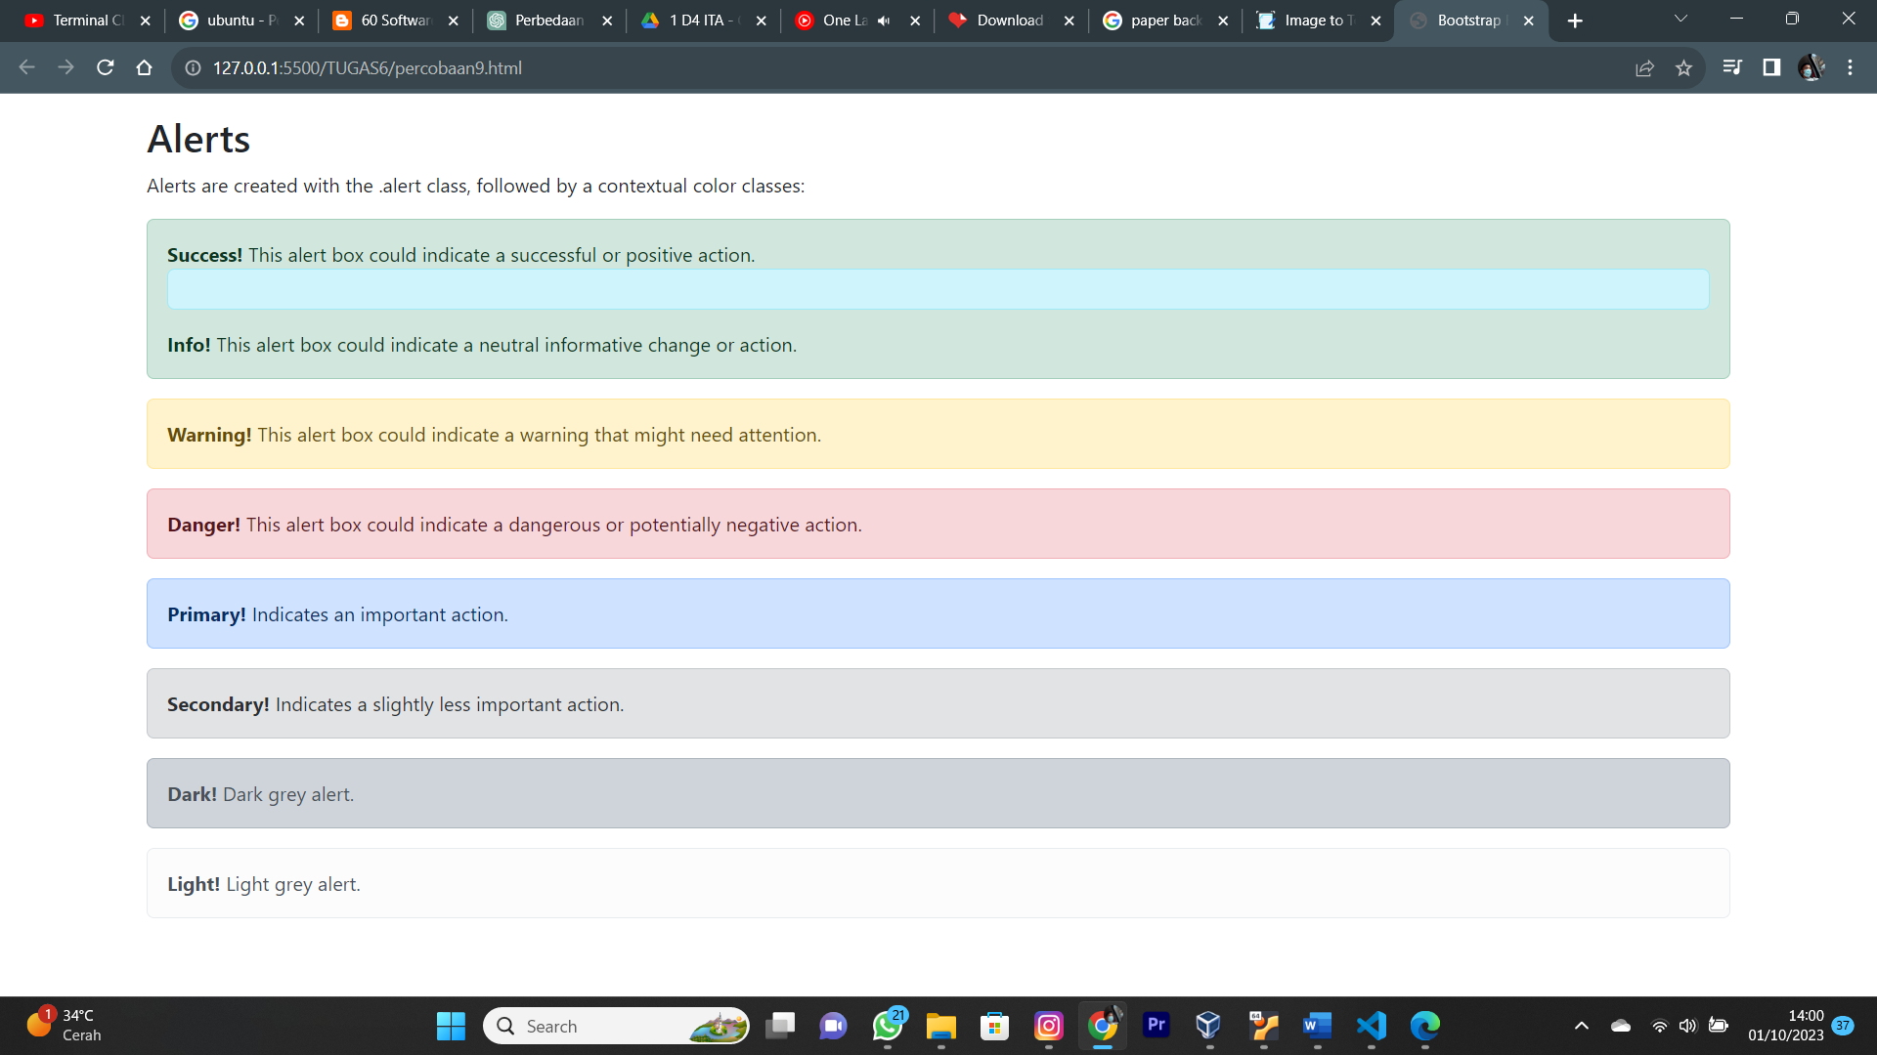

Analisa :

Program tersebut merupakan program web HTML sederhana yang menggunakan bootstrap sebagai framework css nya. Program menampilkan macam macam warna utama pada bootstrap yang direpresentasikan dengan perintah tertentu.

* 1. Percobaan 10 : Bootstrap Button

Input :

<!DOCTYPE html>

<html lang="en">

<head>

    <title>Bootstrap Example</title>

    <meta charset="utf-8">

    <meta name="viewport" content="width=device-width, initial-scale=1">

    <link href="https://cdn.jsdelivr.net/npm/bootstrap@5.3.1/dist/css/bootstrap.min.css" rel="stylesheet">

    <script src="https://cdn.jsdelivr.net/npm/bootstrap@5.3.1/dist/js/bootstrap.bundle.min.js"></script>

</head>

<body>

    <div class="container mt-3">

        <h2>Button Elements</h2>

        <a href="#" class="btn btn-success">Link Button</a>

        <button type="button" class="btn btn-success">Button</button>

        <input type="button" class="btn btn-success" value="Input Button"> <input type="submit" class="btn btn-success"

            value="Submit Button"> <input type="reset" class="btn btn-success" value="Reset Button">

    </div>

</body>

</html>

Output :

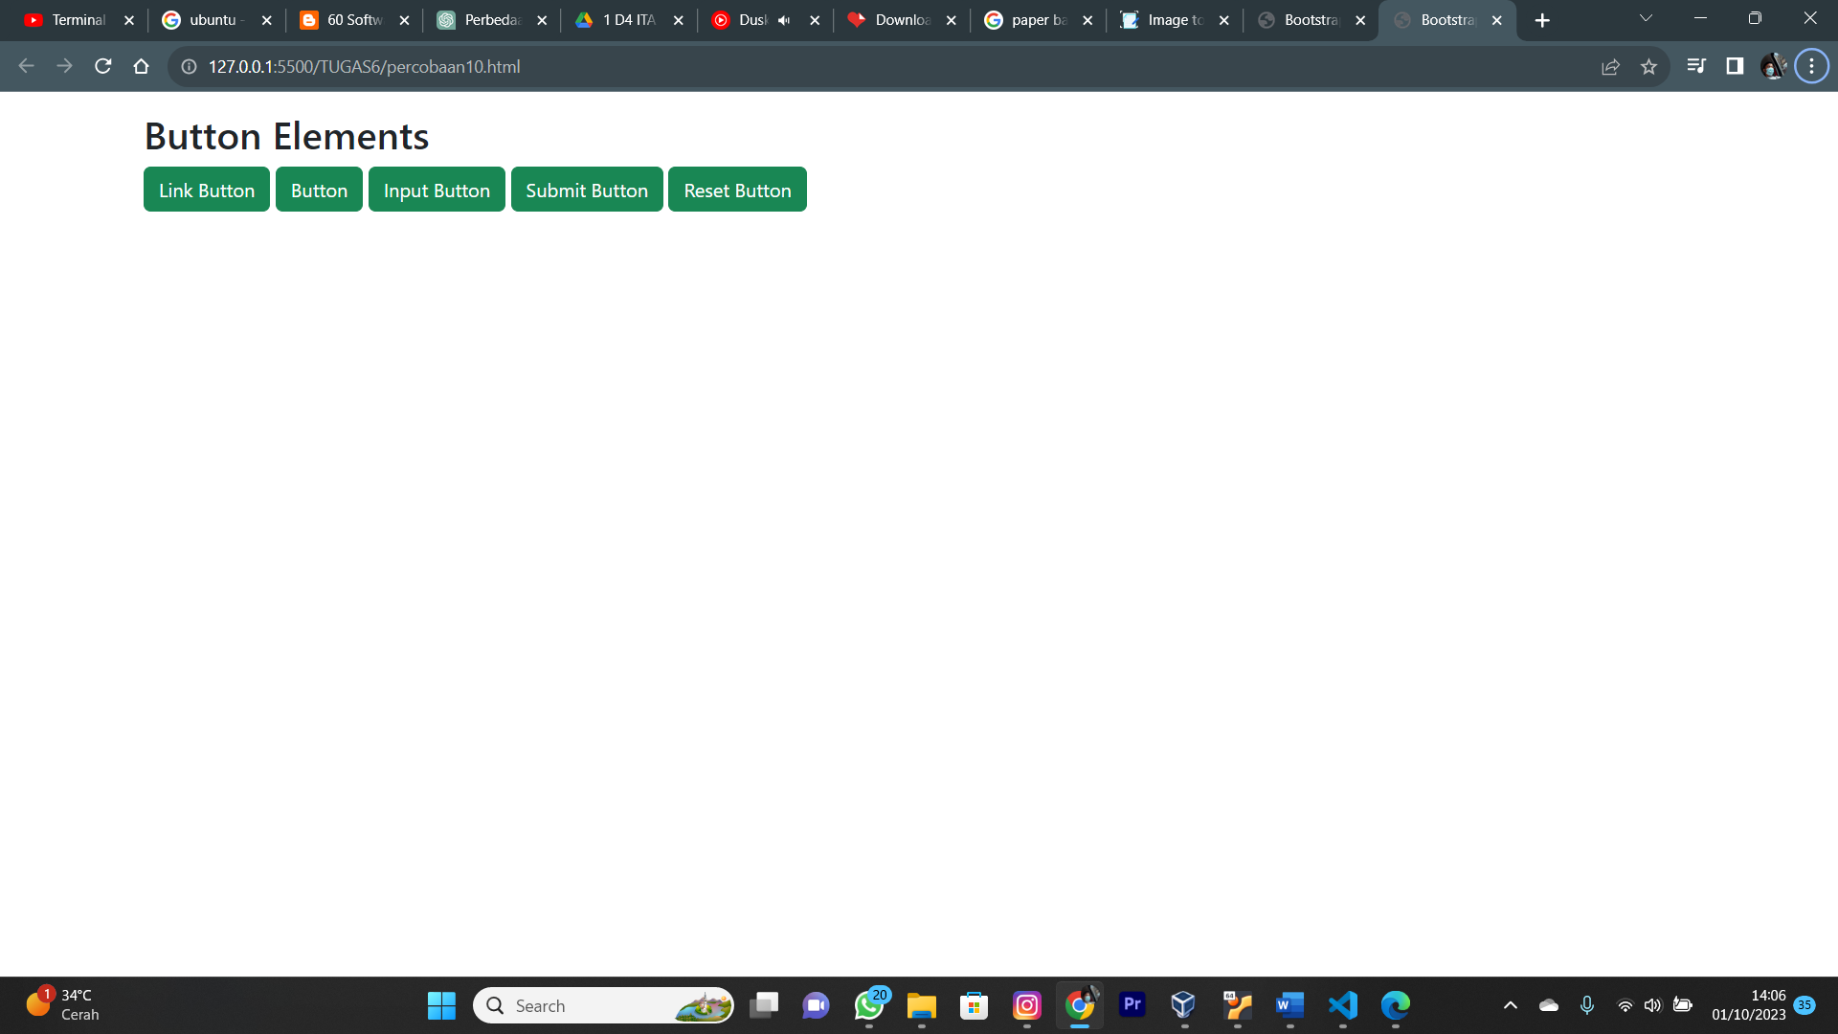

Analisa :

Program tersebut merupakan program web HTML sederhana yang menggunakan bootstrap sebagai framework css nya. Program menampilkan salah satu tag pada HTML dengan bootstrap yaitu button.

**TUGAS :**

Input :

<!DOCTYPE html>

<html lang="en">

  <head>

    <meta charset="UTF-8" />

    <meta name="viewport" content="width=device-width, initial-scale=1.0" />

    <title>Document</title>

    <link href="https://cdn.jsdelivr.net/npm/bootstrap@5.3.1/dist/css/bootstrap.min.css" rel="stylesheet" />

    <link href="https://unpkg.com/boxicons@2.1.4/css/boxicons.min.css" rel="stylesheet" />

    <script src="https://cdn.jsdelivr.net/npm/bootstrap@5.3.1/dist/js/bootstrap.bundle.min.js"></script>

    <style>

      .jumbotron {

        padding: 5rem;

      }

      footer {

        height: 50px;

      }

    </style>

  </head>

  <body>

    <section id="navbar">

      <nav class="navbar navbar-expand-lg bg-success text-white navbar-dark fixed-top">

        <div class="container">

          <a class="navbar-brand" href="#">PERSONAL PROFILE</a>

          <button class="navbar-toggler" type="button" data-bs-toggle="collapse" data-bs-target="#navbarNav" aria-controls="navbarNav" aria-expanded="false" aria-label="Toggle navigation">

            <span class="navbar-toggler-icon"></span>

          </button>

          <div class="collapse navbar-collapse" id="navbarNav">

            <ul class="navbar-nav ms-auto">

              <li class="nav-item mx-2">

                <a class="nav-link active" aria-current="page" href="#">Main</a>

              </li>

              <li class="nav-item mx-2">

                <a class="nav-link" href="#about">About Me</a>

              </li>

              <li class="nav-item mx-2">

                <a class="nav-link" href="#contact">Contact</a>

              </li>

            </ul>

          </div>

        </div>

      </nav>

    </section>

    <!-- MAIN -->

    <section id="main">

      <div class="jumbotron" style="background-color: rgb(208, 237, 207)">

        <div class="row">

          <p class="fs-1 text-center fw-bold pb-3 text-success">

            FIRST, LET ME INTRODUCE MY SELF

            <svg xmlns="http://www.w3.org/2000/svg" width="16" height="16" fill="currentColor" class="bi bi-hand-thumbs-up" viewBox="0 0 16 16">

              <path

                d="M8.864.046C7.908-.193 7.02.53 6.956 1.466c-.072 1.051-.23 2.016-.428 2.59-.125.36-.479 1.013-1.04 1.639-.557.623-1.282 1.178-2.131 1.41C2.685 7.288 2 7.87 2 8.72v4.001c0 .845.682 1.464 1.448 1.545 1.07.114 1.564.415 2.068.723l.048.03c.272.165.578.348.97.484.397.136.861.217 1.466.217h3.5c.937 0 1.599-.477 1.934-1.064a1.86 1.86 0 0 0 .254-.912c0-.152-.023-.312-.077-.464.201-.263.38-.578.488-.901.11-.33.172-.762.004-1.149.069-.13.12-.269.159-.403.077-.27.113-.568.113-.857 0-.288-.036-.585-.113-.856a2.144 2.144 0 0 0-.138-.362 1.9 1.9 0 0 0 .234-1.734c-.206-.592-.682-1.1-1.2-1.272-.847-.282-1.803-.276-2.516-.211a9.84 9.84 0 0 0-.443.05 9.365 9.365 0 0 0-.062-4.509A1.38 1.38 0 0 0 9.125.111L8.864.046zM11.5 14.721H8c-.51 0-.863-.069-1.14-.164-.281-.097-.506-.228-.776-.393l-.04-.024c-.555-.339-1.198-.731-2.49-.868-.333-.036-.554-.29-.554-.55V8.72c0-.254.226-.543.62-.65 1.095-.3 1.977-.996 2.614-1.708.635-.71 1.064-1.475 1.238-1.978.243-.7.407-1.768.482-2.85.025-.362.36-.594.667-.518l.262.066c.16.04.258.143.288.255a8.34 8.34 0 0 1-.145 4.725.5.5 0 0 0 .595.644l.003-.001.014-.003.058-.014a8.908 8.908 0 0 1 1.036-.157c.663-.06 1.457-.054 2.11.164.175.058.45.3.57.65.107.308.087.67-.266 1.022l-.353.353.353.354c.043.043.105.141.154.315.048.167.075.37.075.581 0 .212-.027.414-.075.582-.05.174-.111.272-.154.315l-.353.353.353.354c.047.047.109.177.005.488a2.224 2.224 0 0 1-.505.805l-.353.353.353.354c.006.005.041.05.041.17a.866.866 0 0 1-.121.416c-.165.288-.503.56-1.066.56z"

              />

            </svg>

          </p>

          <hr class="mb-4" />

        </div>

        <div class="row">

          <div class="col-md-4">

            <img src="aku.jpg" class="rounded-circle" width="380" alt="" />

          </div>

          <div class="col-md-7 me-4 p-5">

            <h1 class="display-4 fw-bolder mb-3">MUHAMMAD RAFI RIZALDI</h1>

            <p class="lead">Student | IT Enthusiast</p>

            <hr class="my-4" />

            <p>

              My name is Muhammad Rafi Rizaldi. I was born in Surabaya on Wednesday, 23rd of August 2006. Now, i am a student at Electronic Engineering Polytechnic Institute of Surabaya in period of

              2023. i'm taking computer science on my major just because i used to think mathematically and i like to solve numerical problem. i hope i can enjoy and finish my collage as well as i

              wish. Thank You

              <svg xmlns="http://www.w3.org/2000/svg" width="16" height="16" fill="currentColor" class="bi bi-heart" viewBox="0 0 16 16">

                <path

                  d="m8 2.748-.717-.737C5.6.281 2.514.878 1.4 3.053c-.523 1.023-.641 2.5.314 4.385.92 1.815 2.834 3.989 6.286 6.357 3.452-2.368 5.365-4.542 6.286-6.357.955-1.886.838-3.362.314-4.385C13.486.878 10.4.28 8.717 2.01L8 2.748zM8 15C-7.333 4.868 3.279-3.04 7.824 1.143c.06.055.119.112.176.171a3.12 3.12 0 0 1 .176-.17C12.72-3.042 23.333 4.867 8 15z"

                />

              </svg>

            </p>

          </div>

        </div>

      </div>

    </section>

    <!-- ABOUT -->

    <section id="about">

      <div class="row pt-5 pb-4">

        <p class="fw-semibold fs-2 text-center">About Me</p>

      </div>

      <div class="row justify-content-evenly mx-3">

        <div class="col-4">

          <p class="fs-4">Education</p>

          <ol class="list-group list-group-numbered fs-5">

            <li class="list-group-item">SD GELURAN 2 (2012-2018)</li>

            <li class="list-group-item">SMPN 1 TAMAN (2018-2020)</li>

            <li class="list-group-item">MBI AMANATUL UMMAH (2020-2023)</li>

            <li class="list-group-item">Electronic Engineering Polytechnic Institute of Surabaya (2020-Now)</li>

          </ol>

        </div>

        <div class="col-4">

          <p class="fs-4">Interest</p>

          <ul class="list-group fs-5">

            <li class="list-group-item">Information and Technology Issues</li>

            <li class="list-group-item">Football</li>

            <li class="list-group-item">Gaming</li>

            <li class="list-group-item">Religion Issue</li>

            <li class="list-group-item">

              She who is always remain

              <svg xmlns="http://www.w3.org/2000/svg" width="16" height="16" fill="currentColor" class="bi bi-heart" viewBox="0 0 16 16">

                <path

                  d="m8 2.748-.717-.737C5.6.281 2.514.878 1.4 3.053c-.523 1.023-.641 2.5.314 4.385.92 1.815 2.834 3.989 6.286 6.357 3.452-2.368 5.365-4.542 6.286-6.357.955-1.886.838-3.362.314-4.385C13.486.878 10.4.28 8.717 2.01L8 2.748zM8 15C-7.333 4.868 3.279-3.04 7.824 1.143c.06.055.119.112.176.171a3.12 3.12 0 0 1 .176-.17C12.72-3.042 23.333 4.867 8 15z"

                />

              </svg>

            </li>

          </ul>

        </div>

        <div class="col-4 mb-4">

          <p class="fs-4">Experience</p>

          <ul class="list-group-item fs-5">

            <p>Academic</p>

            <ol class="list-group list-group-numbered fs-6">

              <li class="list-group-item">2nd Runner Up Diponegoro Logic and Informatics Competition (2022)</li>

              <li class="list-group-item">Finalist on Karbora Paper Competition (2022)</li>

            </ol>

            <p class="mt-3">Organization</p>

            <ol class="list-group list-group-numbered fs-6">

              <li class="list-group-item">Staff of Education Divison in High School Council</li>

              <li class="list-group-item">Committee of MBI Big Fair as Competition Event Administrator</li>

            </ol>

          </ul>

        </div>

      </div>

    </section>

    <!-- CONTACT -->

    <section id="contact" class="pb-5" style="background-color: rgb(208, 237, 207)">

      <div class="row pt-5 pb-4">

        <p class="fs-2 fw-semibold text-center">Contact Me!</p>

      </div>

      <div class="row justify-content-between">

        <div class="col-5">

          <form class="fw-regular ms-5 mb-3">

            <div class="mb-3">

              <label for="exampleInputEmail1" class="form-label">Email address</label>

              <input type="email" class="form-control" id="exampleInputEmail1" aria-describedby="emailHelp" />

            </div>

            <div class="mb-3">

              <label for="exampleInputPassword1" class="form-label">Password</label>

              <input type="password" class="form-control" id="exampleInputPassword1" />

            </div>

            <div class="mb-3">

              <label for="exampleFormControlTextarea1" class="form-label">Give some criticism and suggestion</label>

              <textarea class="form-control" id="exampleFormControlTextarea1" rows="3"></textarea>

            </div>

            <button type="submit" class="btn btn-primary">Submit</button>

          </form>

        </div>

        <div class="col-5 text-dark">

          <p class="fs-4">Follow Me</p>

          <a class="fs-5 text-dark" href="https://wa.me/6282245168715"><i class="bx bxl-whatsapp fs-3"></i> +6282245168715</a>

          <br /><br />

          <a class="fs-5 text-dark" href="https://www.instagram.com/mrzld0/"><i class="bx bxl-instagram fs-3"></i> mrzld0</a>

        </div>

      </div>

    </section>

    <footer class="bg-success text-white text-center fw-bolder pt-2">

      <p>&copy;  This assignment was made by my whole  <svg xmlns="http://www.w3.org/2000/svg" width="16" height="16" fill="currentColor" class="bi bi-heart-fill" viewBox="0 0 16 16">

        <path fill-rule="evenodd" d="M8 1.314C12.438-3.248 23.534 4.735 8 15-7.534 4.736 3.562-3.248 8 1.314z"/>

      </svg>

  </body>

</html>

Output :

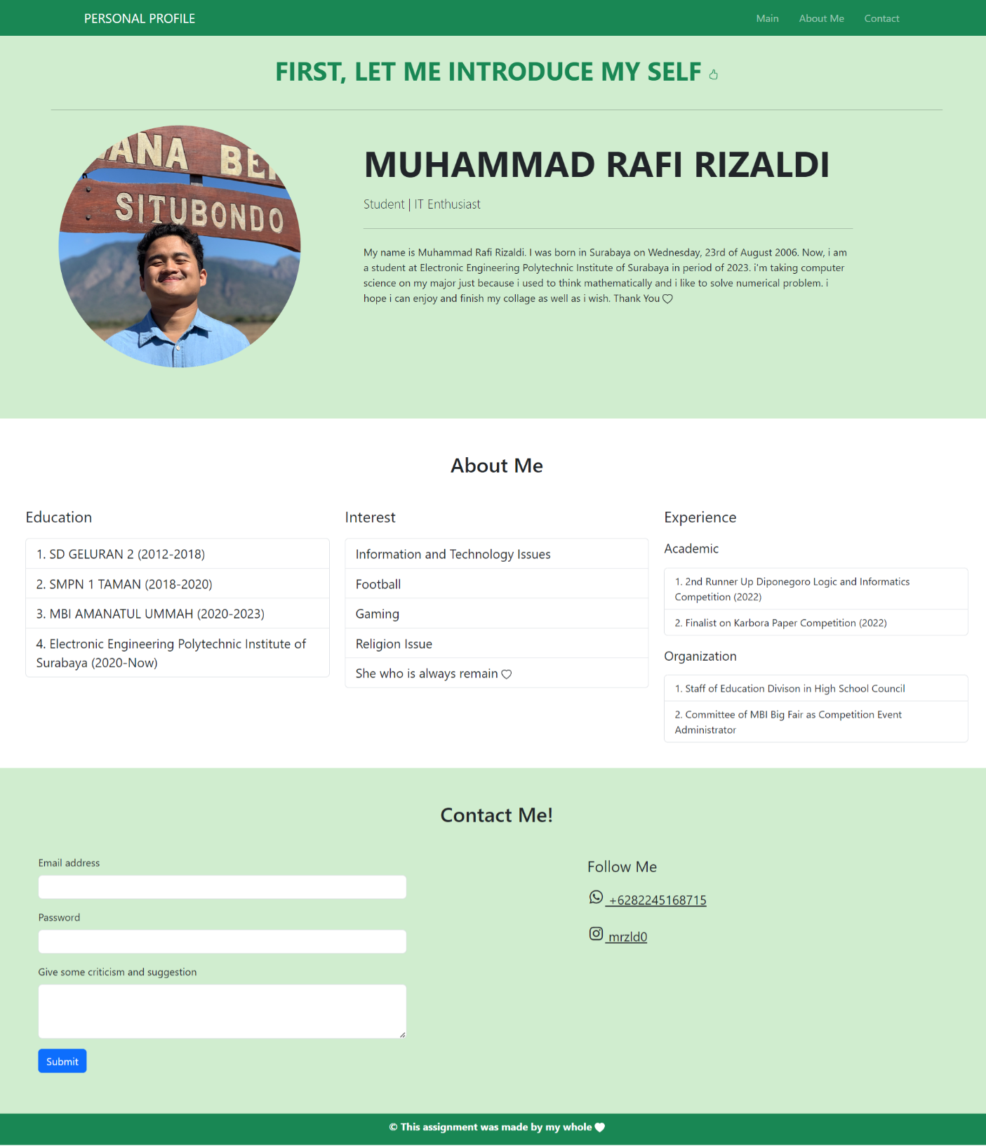

Analisa :

Program tersebut merupakan web portofolio sederhana yang dibuat dengan HTML dan CSS dari bootstrap. Kami mengimplementasikan perintah perintah yang terdapat dalam percobaan percobaan sebelumnya dan menambahkan sedikit perintah baru untuk memperindah web kami.

Untuk semua source code bisa diakses [disini](https://drive.google.com/drive/folders/1vZ_UUPTEUidx5hLQQD1S6AZJqtZq8VmK?usp=drive_link)

# REFERENSI

* [Referensi HTML](https://www.w3schools.com/html/)
* [Referensi CSS](https://www.w3schools.com/css/)
* Lakukan proyek di [Codecademy website](https://www.codecademy.com/catalog/subject/web-development)