Introduction

This is the capstone project for IBM Data Science Professional Certificate.In this project i am developing model that will tell us whic is the safe area in Washington. When people move to washington they need to know which is the safe neighborhood to rend or buy new house.keeping this in mind finding the location to buy new house is most ikmportant decision for family. I am designing this project t help families to find suitable location.

BUSINESS PROBLEM

The objective of this capstone project is to find the most suitsble locaton for the family to buy new house in washington.By using data science methods and tools along with machien learning alorithms such as clustering, this project aims to provode solution to answer the question
in washington ,if family wants to buy house,where should the consider buying it?

TARGET AUDIENCE

Families who wants to find the the location to buy new house’

DATA

To solve this problem, we will need below data:
● List of neighborhoods in Washington DC
● Latitude and Longitude of these neighborhoods
● Data related to the crime incidents. This will help us find the
neighborhoods that are more suitable to buy new house

.
EXTRACTING THE DATA

● Scrapping of Washington neighborhoods via Wikipedia
● Getting Latitude and Longitude data of these neighborhoods via
Geocoder package
● Using Foursquare API to

EXTRACTING THE DATA

● The scrapping of Toronto neighborhoods via Wikipedia
● Getting Latitude and Longitude data of these neighborhoods via
Geocoder package
● Using Foursquare API to get venue data related to these
neighborhoods

Methodology

first i need to get the list of neighborhoods inthe Wasington,this is possible by extracting the list of neighborhoods from Wikipedia.

But i used csv file containing crimes,locations and addresses.i needed to find where crieme rate is low .so i first visualised less crime area in the different regions of the city,using folium library. Next i used foursquare to pull the list of top 100 venues within 500 meters radius. I have createda Foursquare developer account in order to obtain account ID and API key to pull the data. From Foursquare, I am able to pull the names, categories, latitude, and longitude of the venues. With this data, I can
also check how many unique categories that I can get from these venues.Then, I analyze each neighborhood by grouping the rows by neighborhood and taking the mean on the frequency of occurrence of each venue category. I used foursqare data to analize neighborhoods of the safest places i have descoved before.
Then i ploted neighborhoods on the map to check which neighborhood is better and have more places nearby.
Then i used clustering again to visualise similar places.

Result

1) places with less crime rate.

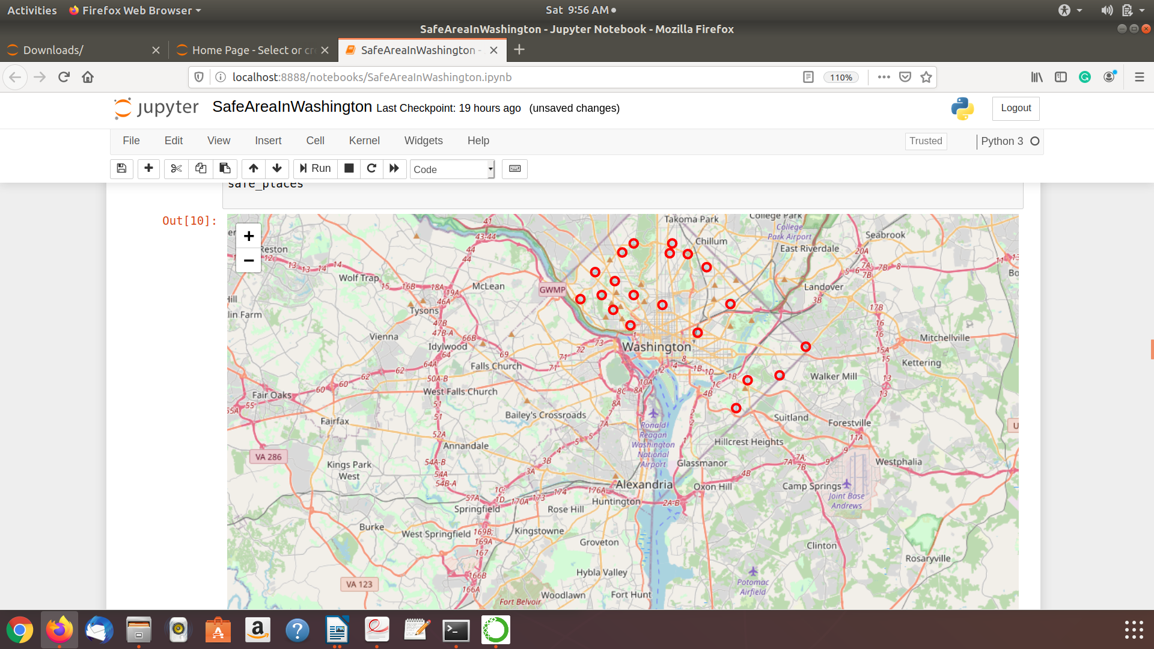

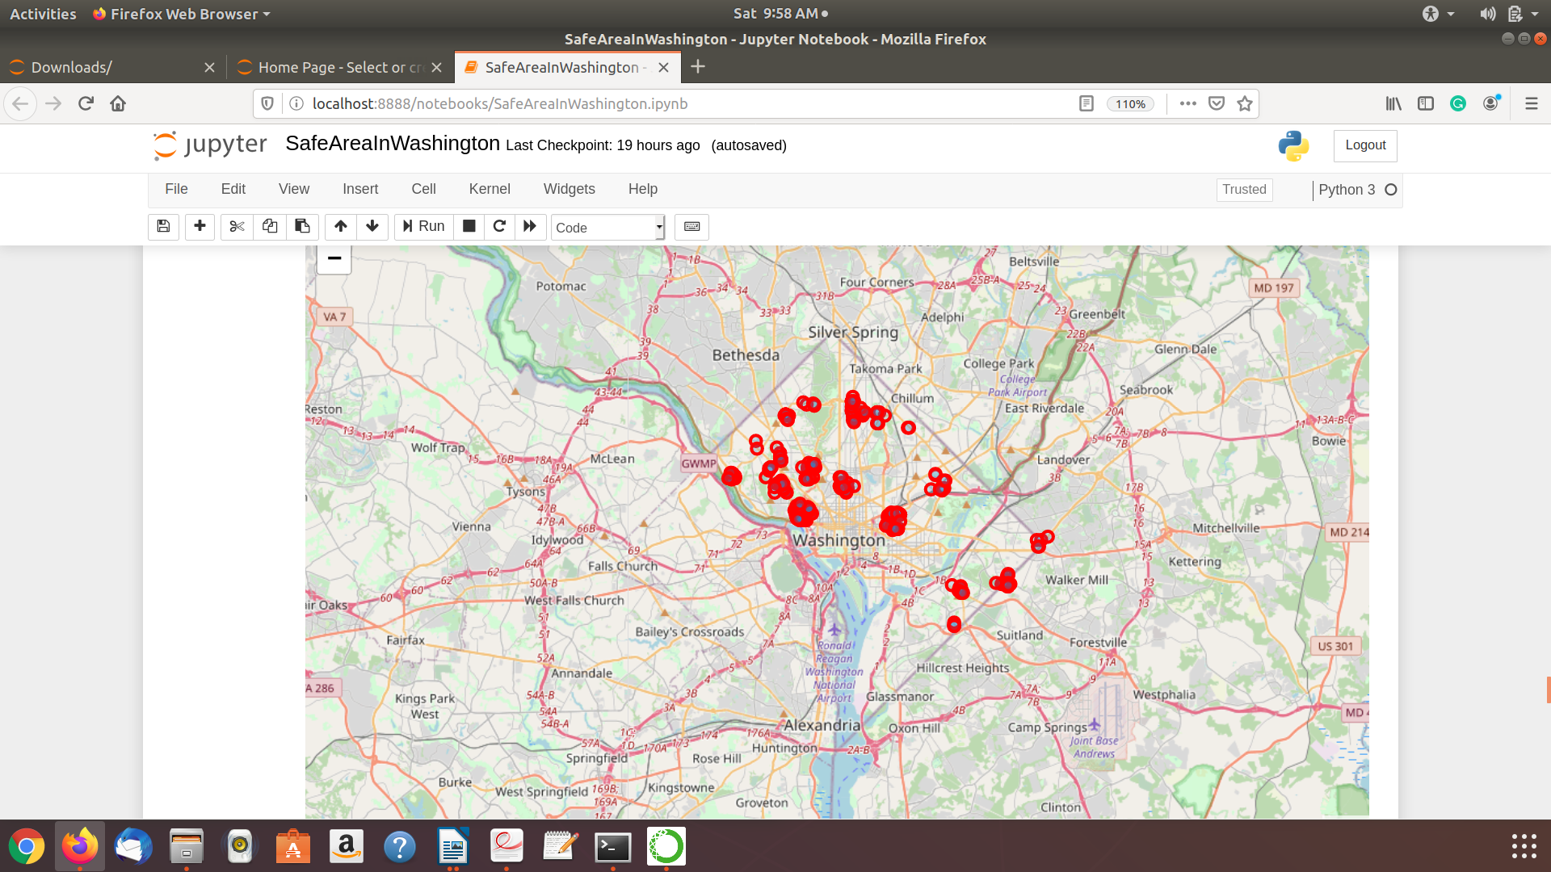

2) neighborhoods of the safe places .

3)result is the clusters of similar neighborhoods in Washington.



