# Chegg Subject Matter Expert Assessment Submission

* Author: Roger Campbell II
* Contact:
  + Roger@gemstack.io
  + [LinkedIn](https://www.linkedin.com/in/mrrogercampbell/)
  + [GitHub](https://github.com/mrrogercampbell)

## Table of Content

* Chegg Subject Matter Expert Assessment Submission
  + Table of Content
  + Part 1: New Writing
  + Part 2: Visual Asset Creation
  + Part 3: Previous Work
    - C
    - JavaScript
      * React
    - APIs
    - Misc.

## Part 1: New Writing

For this part of the assessment, I developed a script that meets the criteria for **Option 1**: * **Audience**: Adults learning Software Engineering for professional development. * **Learning objective**: By the end of this lesson, students will be able to explain what an array is.  
* **Scope of video script**: This video script would briefly introduce Arrays. It would include examples to help the student understand the concept.

**Submission**: [What is an Array?](https://github.com/mrrogercampbell/what-is-an-array) repo

## Part 2: Visual Asset Creation

For part 2 of the assessment, I **created an annotated diagram that illustrates control flow**.

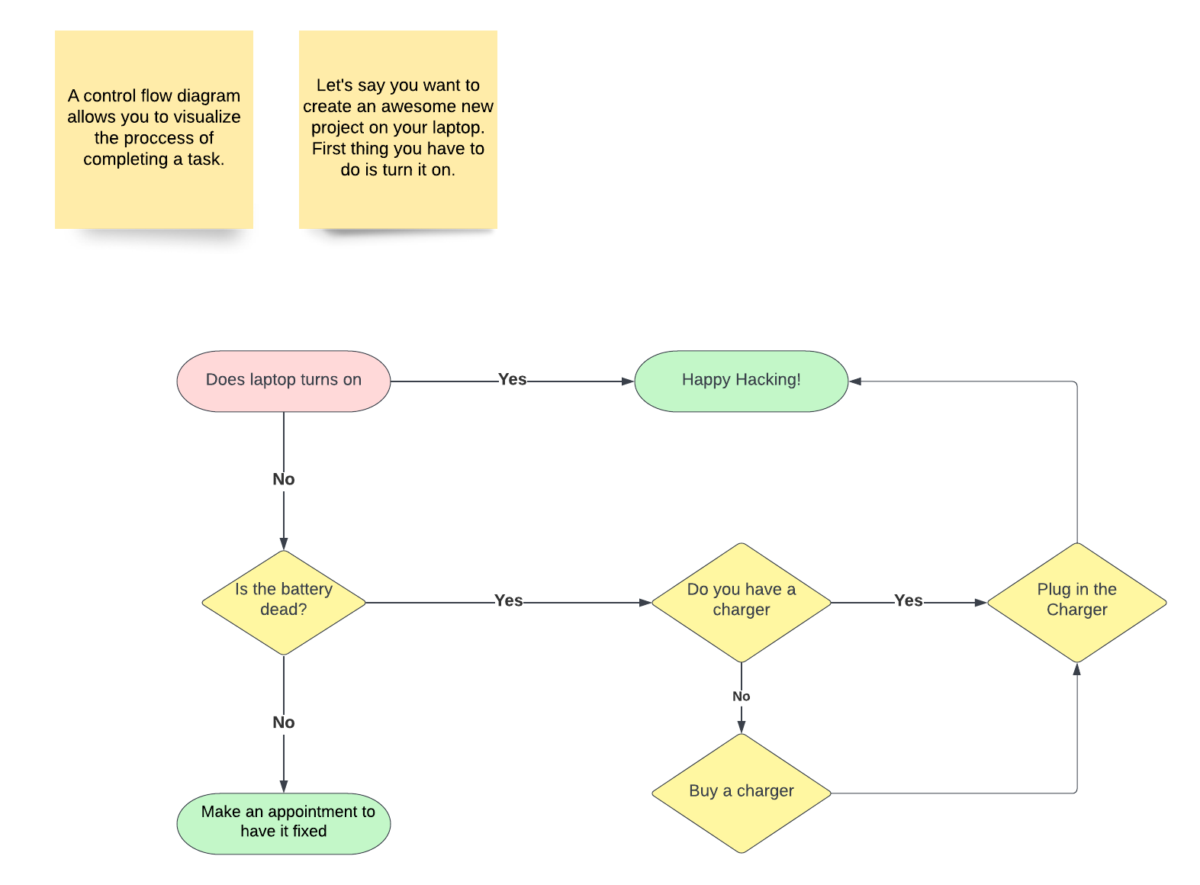

control flow diagram

I have also added a **PDF version**: [Control Flow Diagram](./pdfs/control-flow-diagram.pdf)

## Part 3: Previous Work

Below you will find a list of various courses, lesson plans, and other writing I have done in the past.

### C

* [Microsoft CodeCamp Lecture Notes](https://github.com/mrrogercampbell/microsoft-codecamp-lecture-notes):
  + **Target Learner**: transitioning TS/SCI cleared military personnel and veterans enrolled in an 18-week full-time virtual Code Camp.
  + **Description**: This repo houses the lecture notes I created to assist me as the Lead Instructor in facilitating LaunchCode in partnership with Microsoft; 2021 Transitioning Military Virtual Code Camp.
    - More details [here](https://www.launchcode.org/training/microsoft-codecamp-2021).

### JavaScript

* [Nested For Loops](https://github.com/mrrogercampbell/nested-loops-lesson)
  + **Target Learner**: Adult learner.
  + **Description**: A 5 min lesson I created for a client to demonstrate my ability to develop and execute a lecture rapidly.
* [Intro-to-js-lesson](https://github.com/mrrogercampbell/intro-to-js-lesson)
  + **Target Learner**: Adult learner enrolled in a full-time software engineering Bootcamp.
  + **Description**: I gave some of my students in a previous cohort a quick JavaScript live demo crash course lesson.
    - You will find notes within the script.js file.
* [js-array-lesson](https://github.com/mrrogercampbell/js-array-lesson)
  + **Target Learner**: Adult learner.
  + **Description**: A lesson developed for a client to demonstrate my ability to create a lecture and teach it.

#### React

* [Intro-to-react-lesson-plan](https://github.com/mrrogercampbell/intro-to-react-lesson-plan)
  + **Target Learner**: Adult learner.
  + **Description**: This was designed for a client to showcase my skills in developing a lesson plan.
* [Learning React: Props, State, and Hooks](https://github.com/mrrogercampbell/intro-to-react-lesson)
  + **Target Learner**: Adult learner.
  + **Description**: A intro lecture created for students to learn about React.
* [Learning React: Prompts](https://github.com/mrrogercampbell/intro-to-react-lesson/tree/main/Prompts)
  + **Target Learner**: Adult learner.
  + **Description**: I created a set of prompts to test students’ knowledge of React after teaching the **Learning React: Props, State, and Hooks** lesson above.
  + The empty react project was started code provided to the students.
* [Learning React: Prompt Solutions](https://github.com/mrrogercampbell/lesson-1-prompts)
  + **Target Learner**: Adult learner.
  + **Description**: Solution code to the prompts provided in the above repo.

### APIs

* [Intro to GraphQL & Gatsby](https://github.com/mrrogercampbell/graphql-gastby-lesson)
  + **Target Learner**: Adult learner.
  + **Description**: A course that I developed for a cohort that expressed interest in learning GraphQL.
* [Graphql-curriculum](https://github.com/mrrogercampbell/graphql-curriculum)
  + **Target Learner**: Adult learner.
  + **Description**: A shell of a course I wanted to write, got busy and never finished it.

### Misc.

* [Technical Interview Workshop](https://github.com/mrrogercampbell/technical-interview-workshop)
  + **Target Learner**: An adult learner who has just completed a full-time software engineering Bootcamp.
  + **Description**: A workshop that I developed and taught a few times a year for a client.
* [Technical Interview Workshop Slide Deck](https://docs.google.com/presentation/d/1zsId1oIYn7-mflEBfqzl10e2xXtUODp9sdUlbhEOHWw/edit?usp=sharing)
  + **Target Learner**: Adult learner.
  + **Description**: The accompanying slide deck for the repo listed above.