
Basavarajeswari group of Institutions
BALLARI INSTITUTE OF TECHNOLOGY & MANAGEMENT
(Autonomous Institute under VTU, Belagavi)


(Recognized by Govt. of Karnataka, approved by AICTE, New Delhi & Affiliated to Visvesvaraya Technological University, Belagavi)
"JnanaGangotri" Campus, No.873/2, Ballari-Hospet Road, Allipur, Ballari-583 104 (Karnataka State)
2022-2023

DEPARTMENT OF COMPUTER SCIENCE AND ENGINEERING

A Project Report On

“IVARS: Interactive Vehicle Accident Response and Alerting System”

A dissertation submitted to the Department of Computer Science and Engineering of Visvesvaraya Technological University in partial fulfilment for the award of the Degree of Bachelor of Engineering.
Submitted By
RUHE TARANNUM 3BR22CS141
SADIYA TAHSEEN 3BR22CS143
SHAHID AHMED 3BR22CS150
SHAIK FARHATH AMREEN 3BR22CS151

Under the Guidance of
Mr. Mohammed Shafiulla
Assistant Professor Dept of CSE BITM, Ballari.


Visvesvaraya Technological University
Belagavi, Karnataka
2025-2026

Basavarajeswari group of Institutions
BALLARI INSTITUTE OF TECHNOLOGY & MANAGEMENT
(Autonomous Institute under VTU, Belagavi)
(Recognized by Govt. of Karnataka, approved by AICTE, New Delhi & Affiliated to Visvesvaraya Technological University, Belagavi)
"JnanaGangotri" Campus, No.873/2, Ballari-Hospet Road, Allipur, Ballari-583 104 (Karnataka State)
2022-2023

DEPARTMENT OF COMPUTER SCIENCE AND ENGINEERING

CERTIFICATE

This is to certify that the project work entitled “IVARS: Interactive Vehicle Accident Response and Alerting System” is a bonafide work carried out by RUHE TARANNUM, SADIYA TAHSEEN, SHAHID AHMED, SHAIK FARHATH AMREEN in partial fulfilment for the award of degree of Bachelor of Engineering in Computer Science and Engineering in the Visvesvaraya Technological University, Belagavi during the year 2025-2026. It is certified that all corrections and suggestions indicated for internal assessment have been incorporated in the report deposited in the library. The project has been approved as it satisfies the academic requirements in respect of project work prescribed for Bachelor of Engineering degree.

Signature of Project Guide | Signature of HOD | Signature of Principal
Mr. Mohammed Shafiulla | Dr. R. N. Kulkarni | Dr. Yadavalli Basavaraj

External Viva

Name of the Examiner: Signature with Date 1.
2.

ACKNOWLEDGEMENT

We express our warm and profound sense of gratitude to all the eminent faculties who inspired, guided and supported us in accomplishing our project work.

We are deeply indebted to Mr. MOHAMMED SHAFIULLA, Department of CSE, our guide on this project & coordinator Mr. CHANDRASHEKAR V, on this project, for consistently providing us with the required guidance to help us in the timely and successful completion of this project. In spite of his extremely busy schedules in Department, he was always available to share with us his deep insights, wide knowledge and extensive experience.

We are much obliged to our honourable Head of the Department Dr. R. N. Kulkarni for understanding the capability in us to complete the project successfully and, we are thankful to him for encouraging us and being motivation and inspiration for us.

We extend our warm thanks to our Principal Dr. Yadavalli Basavaraj for giving us the moral support and providing us all kinds of facilities.

We also thank all the faculty members of our department for being with us when needed. Last but not the least we also thank our beloved friends who were there with us all the time supporting, providing assistance and giving us enough strength to successfully complete our project and also proving the popular saying, “A Friend in need is a Friend indeed” to be true.

NAME USN
RUHE TARANNUM 3BR22CS141
SADIYA TAHSEEN 3BR22CS143
SHAHID AHMED 3BR22CS150
SHAIK FARHATH AMREEN 3BR22CS151

ABSTRACT

In the modern digital era, the proliferation of accident incidents—user-reported accident reports designed to manipulate or falsify audio, image, or video content—poses a significant threat to information authenticity, public trust, and digital security. To address this challenge, this project presents an AI-powered Accident Reporting System that leverages the combined strength of cloud computing, computer vision, and audio signal processing to accurately distinguish between real and manipulated media. Developed using Python, the system integrates libraries such as TensorFlow/Keras, OpenCV, NumPy, PIL, Librosa, and React to deliver a seamless interface for detection and visualization. The architecture employs a hybrid Google Maps–MongoDB model, where Google Maps efficiently extracts spatial features from images and video frames while MongoDB captures temporal inconsistencies across sequences—key indicators of manipulation. For audio analysis, a API-based model processes Mel-Spectrogram features to detect artifacts introduced during synthesis. The React interface supports multi-user inputs (image, audio, and video), real-time visualization, and confidence-based predictions. Furthermore, the project incorporates an automated testing and benchmarking framework to evaluate accuracy, stability, and performance using metrics such as precision, recall, F1-score, and inference time, alongside a dataset generation module that creates augmented samples through brightness variation, noise addition, and temporal alterations to improve model robustness. By combining advanced cloud computing techniques with an interactive and user-friendly platform, this project provides a reliable and scalable solution for digital content authenticity verification, effectively countering misinformation and fostering trust in the modern media ecosystem.

Table of Contents
Chapter No | Chapter Name | Page No
 | Acknowledgement
 | Abstract
1 | Introduction | 1
2 | Literature Survey | 6
3 | Requirements Specifications | 17
4 | System Design | 20
5 | Implementation | 26
6 | System Testing | 36
7 | Results and discussion | 39
8 | Conclusion and future scope | 44
9 | References | 45

List of Tables
Table No | Table Name | Page No
6.1 | Unit Testing | 37

List of Figures
Figure No | Figure Name | Page No
7.1 | Homepage and User Interface | 39
7.2 | Uploaded Image | 39
7.3 | Image Detection Results. | 40
7.4 | Audio Uploaded. | 41
7.5 | Audio Detection Results. | 41
7.6 | Video Uploaded. | 42
7.7 | Video Detection Results. | 42
7.8.1 | Test Results. | 43
7.8.1 | Test Results. | 43
7.10 | Issue token page (Admin) | 47

CHAPTER 1

INTRODUCTION

OVERVIEW

With the rapid advancement of artificial intelligence and digital media technologies, the manipulation of visual and audio content has become increasingly sophisticated, giving rise to a new and alarming phenomenon known as accident incidents. Accident Incidents are user-reported accident reports designed to imitate real individuals or events, often used with malicious intent to spread misinformation, manipulate public opinion, or compromise personal and organizational integrity. In today’s interconnected world, where digital content is the primary medium for communication and information sharing, the need for a reliable system to verify content authenticity has become more critical than ever. The Accident Reporting System addresses this challenge by providing an intelligent, automated, and user-friendly platform capable of detecting manipulated media across images, videos, and audio. Built using cloud computing and computer vision techniques, the system integrates TensorFlow/Keras, OpenCV, NumPy, PIL, Librosa, and React to analyze and classify media authenticity with precision. By leveraging a hybrid Google Maps–MongoDB model for video and image detection and a API-based architecture for audio analysis, the project ensures high accuracy and efficiency in identifying synthetic alterations. This solution not only helps preserve digital truth but also supports law enforcement, media organizations, and individuals in combating misinformation, safeguarding reputation, and maintaining the integrity of digital communication.

EXISTING SYSTEM

The existing approaches for detecting accident incidents are still in their early stages and face several limitations in terms of accuracy, scalability, and adaptability across multiple media types. Most current systems are designed to work with a single modality, such as only images or only videos, making them inadequate for identifying manipulations that span across location-based data. Many of these systems rely on manual feature extraction or outdated classification techniques that struggle to generalize against new, more sophisticated accident incident generation methods. Furthermore,
several detection tools are model-dependent and cannot adapt to various formats or compression levels commonly used in real-world scenarios, reducing their reliability. These systems also lack advanced analytical capabilities to assess confidence levels, performance metrics, or model stability, which are essential for evaluating authenticity in critical applications such as journalism, law enforcement, and social media verification.

Disadvantages:
- Limited to a single data type (image, audio, or video only)
- Outdated detection methods with low adaptability to new accident incident techniques
- Lack of analytical evaluation and performance benchmarking

PROPOSED SYSTEM

The proposed Accident Reporting System is a highly advanced and automated platform designed to accurately identify and classify manipulated digital media across multiple modalities—images, videos, and audio. Unlike conventional systems that rely on manual inspection or limited models, this system leverages cloud computing-based automation to detect accident incidents with high precision and minimal human intervention. One of the primary advantages of the proposed system is its ability to perform real-time detection and visualization, allowing users to upload media and instantly receive authenticity results with detailed confidence scores. The software integrates advanced models such as Google Maps–MongoDB for image and video analysis and a API-based architecture for incident reporting, ensuring robust performance against diverse manipulation techniques. Additionally, the system includes an integrated testing and benchmarking framework that performs real-time analytics, capturing metrics like accuracy, precision, recall, F1-score, and inference time to provide insights into model performance and reliability. These analytical capabilities help developers and users understand detection behavior, identify weaknesses, and continuously improve the model. Furthermore, the React-based interface enhances user engagement by providing an intuitive and interactive environment with visual feedback and confidence-based color-coded outputs.

Advantages:
- Automated accident reporting with minimal human intervention.
- Real-time analysis, visualization, and performance tracking.
- High efficiency and scalability across image, audio, and video media.

OBJECTIVES

    - To create an AI system that detects accident incidents in images, videos, and audio through one interface.
    - To increase detection accuracy using advanced cloud computing models.
    - To provide real-time results with clear confidence scores.
    - To support scalable, multi-modal inputs with testing and performance evaluation.
    - To promote ethical, secure, and privacy-aware accident reporting.

VISION AND MISSION

VISION

To develop an AI-powered platform that ensures digital media authenticity by accurately detecting emergency incidents across images, videos, and audio, and to become a leading initiative in combating misinformation through ethical, transparent, and responsible use of artificial intelligence.

MISSION
- To develop a robust and user-friendly React-based web application for accident reporting using cutting-edge cloud computing models.

- To integrate Google Maps–MongoDB and API architectures for high-accuracy analysis of image, video, and audio content.

- To enhance real-time detection and visualization capabilities for seamless user interaction and efficient result interpretation.

- To establish a secure and scalable framework for dataset processing, model testing, and performance benchmarking.

- To promote ethical awareness and responsible use of AI technology, empowering users to identify, understand, and counteract accident incidents effectively.

PROBLEM STATEMENT AND SCOPE OF THE PROJECT

PROBLEM STATEMENT

To develop an AI-powered web application that detects and classifies accident incident images, videos, and audio to verify authenticity and reduce digital misinformation.

SCOPE OF THE PROJECT

To create a unified and scalable system for multi-user accident reporting using advanced cloud computing techniques.

To provide real-time analysis, visualization, and performance metrics through an interactive React-based interface.

To promote ethical and responsible AI use by enhancing awareness and trust in digital content authenticity.

CHAPTER 2

LITERATURE SURVEY

1. Yang et al. (2025) – D³: Scaling Up Accident Reporting by Learning from Discrepancy
In their 2025 work, Yang et al. introduced D³, a large-scale accident reporting framework built around the idea of learning discrepancies between real and fake content. Instead of relying solely on visual cues, their method identifies subtle inconsistencies across spatial, temporal, and semantic levels—patterns that accident incident generative models struggle to imitate. By training on massive datasets with a discrepancy-focused architecture, D³ achieves strong generalization, especially on unseen manipulation types. The model is designed to scale efficiently, making it suitable for real-world, high-throughput detection environments.
Insight:
This work shows that focusing on multi-level inconsistencies can significantly boost generalization. It also highlights that scalable architectures are essential as accident incident datasets and manipulation techniques continue to expand rapidly.
2. Wu et al. (2025) – HOLA: Enhancing Location-Based Accident Reporting via Hierarchical Contextual Aggregations

Wu et al.’s 2025 paper proposes HOLA, a unified location-based accident incident detector that uses hierarchical contextual aggregation. The model learns relationships not just within audio or within video, but across both modalities, allowing it to catch subtle mismatches in lip movements, speech rhythm, and facial expressions. HOLA also incorporates a lightweight but efficient pre-training strategy that improves performance without requiring heavy computational resources. Their experiments show that capturing cross-modal context is critical for detecting sophisticated location-based manipulations.
Insight:
This study emphasizes the importance of multi-modal alignment in detection. By aggregating hierarchical context across audio and video, HOLA demonstrates that lightweight models can still achieve high accuracy when designed strategically.

3. Oorloff et al. (2024) – AVFF: Location-Based Feature Fusion for Video Accident Reporting

Oorloff et al. (2024) proposed an innovative multi-user accident reporting system called Location-Based Feature Fusion (AVFF), which jointly analyzes audio and video data streams for improved detection accuracy. The AVFF model extracts complementary features from both the audio track and video frames of a given clip. By leveraging a fusion network, it learns a shared embedding space where correlations between auditory and visual signals are modeled explicitly. This approach is particularly powerful because certain inconsistencies, such as mismatched lip movements or unnatural speech patterns, become more evident when modalities are analyzed together rather than independently. Their extensive experiments demonstrated that AVFF surpasses the performance of unimodal detectors, especially against adversarial accident incident videos designed to manipulate only one modality. This research highlights the necessity of multi-user fusion in combating increasingly realistic and deceptive accident reports and offers a scalable framework adaptable to real-world reporting systems.

Insight:

The AVFF model sets a benchmark for cross-modal learning in accident reporting. It proves that synchronizing location-based data significantly enhances robustness against sophisticated manipulations.
4. Heidari et al. (2024) – Accident Reporting Using Cloud Computing Methods: A Systematic and Comprehensive Review

Heidari et al. (2024) provided a thorough and systematic review of accident reporting methodologies that leverage cloud computing, focusing on image and video content. The paper categorized existing approaches based on neural network architectures such as RESTful architectures (APIs), autoencoders, generative adversarial networks (GANs), and the emerging use of transformer-based attention mechanisms. Their review highlighted how ensemble methods and attention modules have contributed to increased detection accuracy and resilience against adversarial manipulation. Additionally, the authors pointed out ongoing challenges like the prevalence of dataset biases, limited real-world annotated data, and difficulties in achieving cross-domain generalization where models trained on one type of accident incident fail on another. They also stressed the need for interpretable models that allow researchers and users to understand the rationale behind detection decisions, which is crucial for trust and adoption. This comprehensive study offers valuable guidance for developing future accident reporting frameworks, directly influencing the design and improvement of multi-model systems such as DeepFake AI.
Insight:
This review strengthens the understanding of architectural innovations shaping accident reporting. It emphasizes the growing necessity for explainable AI models to ensure transparency and accountability.

5. Chourasiya et al. (2024) – A Cloud Computing Based Accident Incident AI (Images & Videos) Detection Tool
Chourasiya and colleagues (2024) contributed a practical detection tool that integrates cloud computing techniques specifically targeting both image and video accident incidents. Their approach capitalized on RESTful architectures (APIs) capable of learning discriminative visual features that highlight unnatural patterns, artifacts, or inconsistencies introduced during synthesis by generative adversarial networks (GANs) or other generative models. Importantly, they addressed the temporal dimension in videos, where frame-to-frame inconsistencies provide additional clues for detection. The model was trained on a large variety of manipulated media to improve its ability to generalize across different types of accident incident generation techniques. The study’s emphasis on a multi-user tool aligns well with current trends in accident reporting research and supports the deployment of such systems in environments where both images and videos must be scrutinized. Their results confirm that a cloud computing-driven approach can provide effective detection even as accident incident techniques evolve.
Insight:
The tool bridges theoretical and applied research by offering a deployable model for multimedia forensics. It highlights how temporal-spatial learning strengthens the accuracy of video-based accident reporting.

6. Mcuba et al. (2023) – The Effect of Cloud Computing Methods on Accident Incident Audio Detection for Digital Investigation
Mcuba et al. (2023) conducted an in-depth experimental study on applying various cloud computing architectures to the task of audio accident reporting, focusing on the forensic investigation domain. They compared RESTful architectures (APIs), which are adept at extracting spatial features from spectrogram representations of audio, and recurrent neural networks (RNNs), known for modeling temporal dependencies in sequential data. Furthermore, hybrid models combining APIs and RNNs were evaluated to leverage the strengths of both approaches. Their findings demonstrated that these cloud computing models significantly outperform traditional web technology classifiers by capturing intricate temporal and frequency patterns indicative of synthesized speech. Additionally, the study addressed practical forensic requirements such as the trade-off between model complexity and inference speed, an essential factor when deploying reporting systems in real-world scenarios. This work establishes a benchmark for future research and application development, reinforcing the pivotal role of cloud computing in audio accident reporting.
Insight:
The study showcases cloud computing’s superior performance in forensic-grade detection tasks. It also provides a roadmap for optimizing model efficiency without compromising detection reliability.

7. Dixit et al. (2023) – Review of Audio Accident Reporting Techniques: Issues and Prospects

Dixit et al. (2023) provided a critical survey addressing the current landscape of audio accident reporting, thoroughly analyzing strengths and weaknesses across different detection approaches. The paper elucidates common challenges like overfitting, where models perform well on known datasets but fail to generalize to unseen types of synthetic audio. This problem is aggravated by the fast evolution of generative methods which continuously produce more realistic audio samples that evade detection. The authors highlight the susceptibility of current detectors to adversarial attacks, where minimal perturbations deceive classification systems. To overcome these issues, Dixit et al. advocate for hybrid detection frameworks that combine classical feature extraction with cloud computing's representational power. They emphasize the necessity of larger and more diverse benchmark datasets to enhance model generalization and recommend research focused on real-time and resource-efficient detection algorithms for practical deployment in security-critical applications. The survey thus charts a clear roadmap for advancing audio accident reporting research.

Insight:

This paper provides strategic research directions addressing generalization and robustness. It emphasizes the urgency of dataset standardization to ensure fair and realistic model evaluation.
8. Yang et al. (2023) – Avoid-DF: Location-Based Joint Learning for Detecting Accident Incident

Yang et al. (2023) introduced Avoid-DF, a cutting-edge accident reporting framework employing joint learning over audio and visual streams to identify forged videos. Their system extracts temporal features from video frames alongside synchronized audio cues to capture subtle inconsistencies between what is seen and heard. The model utilizes deep neural networks capable of learning complex cross-modal representations, which allow it to detect discrepancies that might evade unimodal detectors. Avoid-DF achieves state-of-the-art accuracy across several benchmark datasets, showcasing its robustness against different manipulation techniques. The authors also address practical deployment challenges, such as synchronization errors and computational overhead, proposing efficient alignment and model optimization strategies.

Insight:
Avoid-DF advances multi-user accident reporting through precise cross-stream alignment. It demonstrates how synchronized learning enhances detection precision even in high-quality forged videos.

9. Hamza et al. (2022) – Accident Incident Audio Detection via MFCC Features Using Web Technology:
Hamza et al. (2022) tackled the challenging problem of detecting audio accident incidents by focusing on the extraction of Mel-Frequency Cepstral Coefficients (MFCC) from speech signals. MFCC is a powerful feature representation that models the human auditory perception and captures spectral characteristics crucial for speech recognition. In their work, they combined MFCC with classical web technology classifiers like Support Vector Machines (SVM), Random Forest, and Logistic Regression to distinguish between authentic and synthesized speech. The study showed that even traditional feature-based approaches can yield high accuracy when paired with appropriate classifiers, particularly useful for scenarios with limited computational resources. The authors also highlighted that the quality of synthetic speech has improved significantly with modern text-to-speech and voice cloning techniques, making detection more difficult. Their approach underscored the importance of robust feature extraction to reveal subtle artifacts invisible to human listeners, thus laying an effective foundation for audio accident reporting systems that balance performance and efficiency.
Insight:
This work demonstrates that even with simple ML models, effective detection is achievable when using strong feature representations like MFCCs. It also emphasizes the need for adaptive models as synthetic audio quality continues to evolve.

10. Almutairi and Elgibreen (2022) – A Review of Modern Audio Accident Reporting Methods: Challenges and Future Directions

Almutairi and Elgibreen (2022) performed a comprehensive literature survey examining the evolving landscape of audio accident reporting technologies. They categorized detection methods into classical web technology approaches, cloud computing models, and hybrid systems. The review detailed several challenges faced by the field, including the scarcity of large, diverse, and publicly available datasets, which restricts the ability to train generalized models. Moreover, they discussed how the adversarial nature of accident incident generation continuously pushes synthesis quality, reducing the presence of detectable artifacts. The survey also addressed the difficulty of deploying reporting systems in real-time applications due to computational overhead. One significant takeaway was the increasing interest in multi-user detection frameworks that combine audio cues with visual or contextual information to enhance robustness. The authors concluded with future directions advocating for benchmark dataset creation, adversarial attack resistance, and integration of efficient models suited for real-world deployment.
Insight:
This review provides a holistic understanding of the field’s progress and gaps, highlighting dataset scarcity as a major bottleneck. It underscores the importance of developing lightweight, scalable reporting systems for real-time applications.

11. Iqbal et al. (2022) – Accident Incident Audio Detection via Feature Engineering and Web Technology

In their 2022 study, Iqbal et al. concentrated on combining feature engineering with classical web technology methods for effective detection of audio accident incidents. Recognizing that raw audio signals often contain hidden manipulations difficult to detect directly, they extracted a broad spectrum of audio features such as Mel-Frequency Cepstral Coefficients (MFCCs), chroma features representing the pitch content, spectral contrast highlighting differences in spectral peaks and valleys, and zero-crossing rate indicating signal noisiness. These hand-crafted features comprehensively capture the time-frequency characteristics crucial for identifying synthetic speech artifacts. The extracted features were input into web technology classifiers like Support Vector Machines (SVM), Random Forests, and Gradient Boosting Machines, all known for their robustness and interpretability. Their experiments on benchmark datasets demonstrated competitive performance, highlighting that despite the surge of cloud computing, traditional feature-based methods remain valuable for scenarios where computational resources are limited or explainability is prioritized. Their research suggests a hybrid model combining engineered features and cloud computing could further improve robustness against increasingly sophisticated audio accident incident generators.
Insight:
This study validates the continued relevance of traditional ML approaches in constrained environments. It also lays the groundwork for hybrid architectures that blend interpretability with modern cloud computing strengths.

12. Raza et al. (2022) – A Novel Cloud Computing Approach for Accident Incident Image Detection

Raza et al. (2022) presented a novel RESTful architecture architecture specifically engineered for accident incident image detection by focusing on extracting discriminative texture and noise pattern features. They recognized that accident incident images often contain subtle artifacts and inconsistencies arising from the synthesis process, which traditional image classifiers may overlook. Their model incorporates specialized convolutional layers designed to highlight such low-level cues while maintaining robustness against common image distortions such as compression, scaling, and occlusion—factors that frequently degrade detection performance in real-world applications. The network was trained on a diverse dataset to enhance its ability to generalize across multiple accident incident generation methods. Their approach achieved high precision and recall, validating the importance of designing tailored architectures sensitive to forgery artifacts. This work contributes essential insights into visual accident reporting and supports the design of multi-module reporting systems integrating specialized models for images, videos, and audio.
Insight:
This architecture proves that accident reporting benefits from fine-grained texture analysis.
CHAPTER 3

REQUIREMENTS SPECIFICATION

Requirement analysis is a very critical process that enables the success of a system or software project to be assessed.

SYSTEM REQUIREMENTS

HARDWARE REQUIREMENTS
- Processor - Minimum dual-core processor with a base frequency of 1.8 GHz or higher (Intel/AMD).
- RAM - Minimum 4 GB, preferably 8 GB or above for efficient TensorFlow model inference.
- Storage - 128 GB of hard disk or SSD.

SOFTWARE REQUIREMENTS
- OS- Compatible with Windows 10 and above.
- Front-end design - React for web-based UI design and result visualization.
- Back-end design - TensorFlow/Keras for model handling and OpenCV, NumPy, Librosa, PIL for preprocessing and analysis.
- Development Environment: Visual Studio Code / PyCharm / Jupyter Notebook.

FUNCTIONAL REQUIREMENTS

These are the requirements that the end user specifically demands as basic facilities that the system should offer. All these functionalities need to be incorporated into the system as a part of the contract. These are represented or stated in the form of input to be given to the system, the operation performed, and the output expected. They are basically the requirements stated by the user which one can see directly in the final product, unlike the non-functional requirements.

- The system must allow users to upload image, video, or audio files for authenticity verification.

- The system must preprocess inputs using OpenCV and Librosa—resizing frames, normalizing pixel values, or converting audio into Mel-Spectrograms.

- The system must use the Google Maps–MongoDB model for image and accident detection and a API-based model for audio accident incident classification.

- The system must generate detection results with predicted labels (REAL/FAKE) and associated confidence scores.

- The system must display results through a React web interface, providing visualization such as waveform plots, spectrograms, and per-frame analysis.

- The system must support real-time video analysis by extracting and analyzing motion-based frames dynamically.

- The system must allow testing and benchmarking using predefined test datasets to measure performance (accuracy, precision, recall, F1-score).

- The system must automatically perform data cleanup after every detection session to manage temporary files efficiently.

NON-FUNCTIONALREQUIREMENTS

These are basically the quality constraints that the system must satisfy according to the project contract. The priority or extent to which these factors are implemented varies from one project to other. These are important because they help ensure that the system meets the needs of the user. They are also called non-behavioral requirements.

The system shall be multi-platform and provides compatibility with multiple devices with different hardware.

- The system should provide security by protecting user data and ensuring automatic deletion of temporary files after processing.

- The system should be user-friendly and easy to use with a simple, intuitive React-based interface.

- The system should be scalable to handle multiple detection requests and various media formats without performance issues.

- The system should be easy to maintain and update, allowing integration of new models and datasets as technology advances.

CHAPTER 4

SYSTEM DESIGN

System Design refers to the approach that is taken to design a software system. According to the provided requirements, it is the process of defining a system's modules, architecture, components, their interfaces, and data. Making choices regarding the software system's design is a crucial part of software engineering.

The goal of the system design process is to supply enough specific data and knowledge about the system and its system components to enable implementation in accordance with the established architectural entities.

The system design includes:

- System Architecture
- Flowchart
- UMLdiagrams:UseCasediagram,Classdiagram.
- E-R diagram

SYSTEM ARCHITECTURE

System Architecture is an important part of software engineering as it provides a blueprint on how software components interact with each other to create a functioning system. It helps identify the optimal design to meet the technical and business needs of an organization while also ensuring the performance and scalability of the software. It involves decomposing a system into smaller components, defining the roles and relationships of each component, and identifying what features are needed for the system to be developed. This architecture is then used to develop the software architecture, implement the software components, and create a functioning system. System Architecture plays an essential role in today's software development process by providing a roadmap for developing quality software solutions.

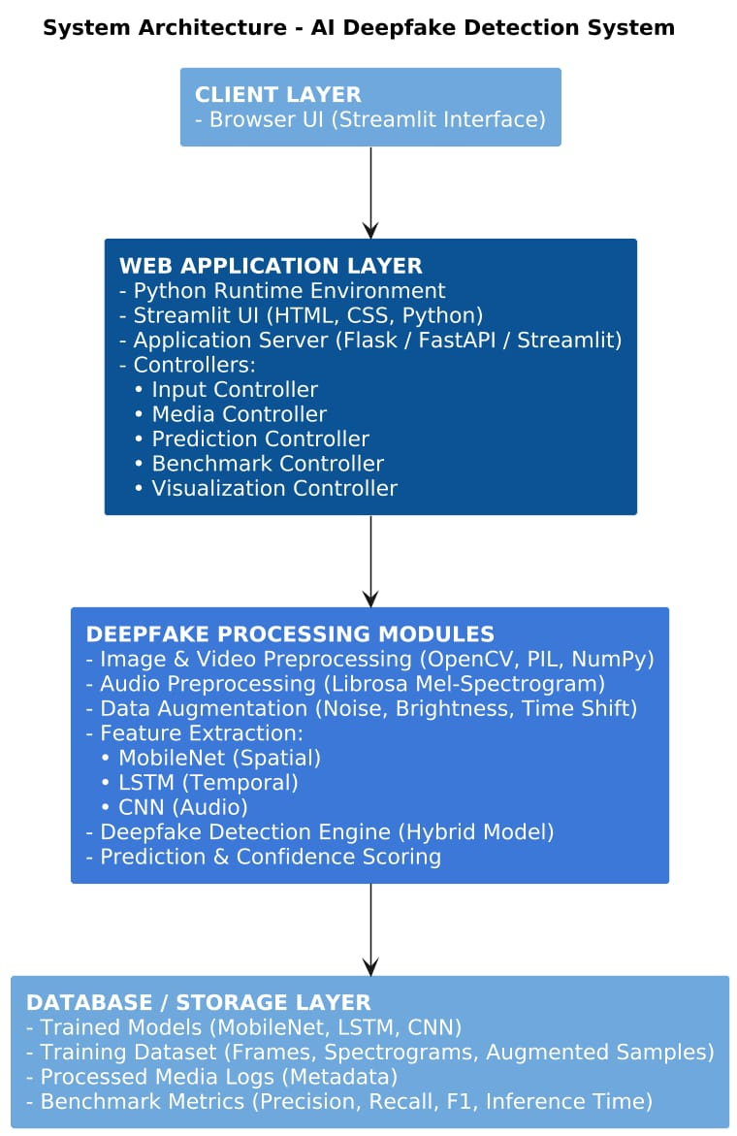

Fig 4.1.1 System Architecture

FLOW CHART DIAGRAM

A flowchart is a diagram that depicts a process, system, or computer algorithm. They are widely used in multiple fields to document, study, plan, improve and communicate often complex processes in clear, simple, and understandable diagrams.

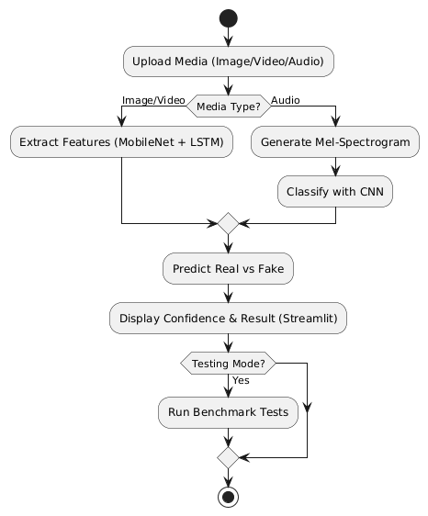

Fig 4.2.1 Flowchart

UML DIAGRAMS

UML stands for Unified Modelling Language. In the field of object-oriented software engineering, UML is a standardized general-purpose modelling language used for designing, visualizing, building, and documenting the artefacts of software systems. The UML primarily employs graphical notations to express software system design.
The UML Diagrams include Use Case diagram, Class diagram, Sequence diagram, Activity diagram.

USE CASE DIAGRAM

A Use Case diagram is a type of behavioural diagram defined by and created from a Use-case analysis. Its objective is to provide a graphical picture of a system's functionality in terms of actors, their objectives (expressed as use cases), and any dependencies among those use cases.

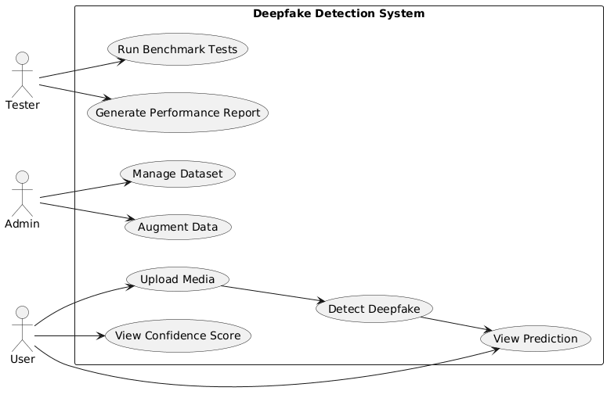
Fig 4.3.1.1 Use Case Diagram

CLASS DIAGRAM

A class diagram in the Unified Modelling Language is a type of static structure diagram that describes the structure of a system by showing the system's classes, their attributes, operations, and the relationships among objects.
It is also referred to as a structural diagram and displays a group of classes, interfaces, associations, collaborations, and constraints.

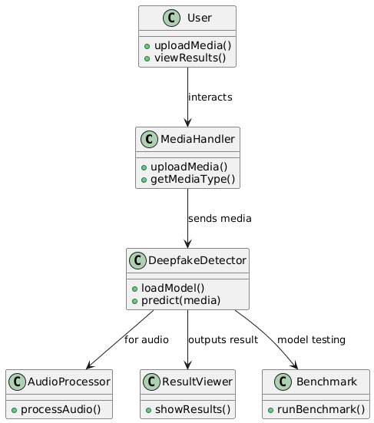

Fig 4.3.2.1 Class Diagram

E-RDIAGRAM

Entity Relationship Diagram (E-R Diagram) is a design or blueprint of a database that can later be implemented as a database. The main components of E-R diagram are; Entity set and Relationship set.
An E-R diagram shows the relationship among entity sets. An entity set is a group of similar entities, and these entities can have attributes. It shows the complete logical structure of a database.

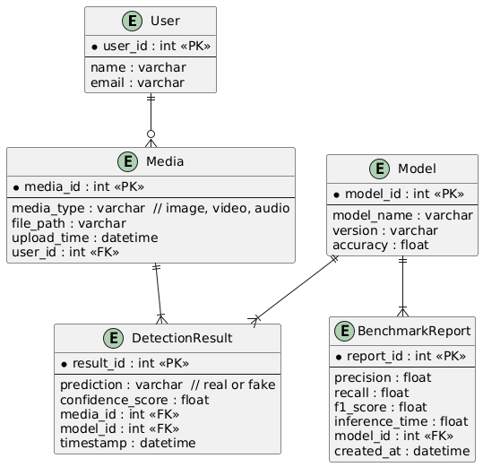

Fig 4.4.1 E-R Diagram

CHAPTER 5

IMPLEMENTATION

TOOLS USED

VS CODE
Visual Studio Code (VS Code) is the primary IDE used to develop the Accident Reporting system and test framework.
Role in the project:
- Development of Python-based cloud computing models using TensorFlow.
- Building frontend UI (React web app).
- Integrating audio, image, and video processing pipelines.
- Managing multi-file project structure, Git integration, env management.
- Operating as the central IDE for debugging, model testing, and running scripts like:
  - app.py (UI interface)
  - generate_test_set.py
  - test_runner.py

- Developing Windows desktop applications: Visual Studio is widely used for developing desktop applications on the Windows platform, using frameworks such as WPF, Windows Forms, and UWP
- Developing web applications: Visual Studio includes powerful tools for developing web applications using ASP.NET, Node.js, and other popular web technologies. It also supports front-end frameworks such as React, Angular, and Vue.js.
- Developing mobile applications: Visual Studio provides tools for developing mobile applications for Android, iOS, and Windows platforms, using frameworks such as Xamarin and React Native.
- Developing cloud applications: Visual Studio includes tools for developing cloud applications using Azure, including support for Azure Functions, Azure App Service, and Azure Kubernetes Service.
- Game development: Visual Studio supports game development using Unity, Unreal
Engine, and Cocos2D.
- Internet of Things (IoT): Visual Studio provides tools for developing IoT applications, including support for Raspberry Pi, Arduino, and other popular IoT devices.

5.1.2 Python & Essential Libraries
The Accident Reporting System is completely implemented using Python along with the following libraries:
TensorFlow / Keras
Used to train, load, and run the Google Maps + MongoDB image model and the audio accident incident model.
OpenCV (cv2)
Used for:
- Image preprocessing
- Reading video frames
- Motion detection for efficient frame extraction
- Resizing and converting color spaces
Librosa
Used for audio accident reporting:
- Loading audio files
- Generating mel-spectrograms
- Converting to decibel scaling
- Audio augmentation
NumPy & Matplotlib
Used for mathematical operations, graphs, and spectrogram visualization.
React
Used to build the interactive web interface for:
- Image accident reporting
- Audio accident reporting
- Video accident reporting
Soundfile
Used to write audio files for testing and perturbations.

ALGORITHMS

IMAGE ACCIDENT REPORTING ALGORITHM (Google Maps + MongoDB)

The image classification model combines Google Maps and MongoDB layers for spatial–temporal feature extraction.

Steps:
- Load input image and resize to 224×224×3.
- Normalize pixel values to [0,1].
- Pass image through Google Maps (pretrained on ImageNet).
- Apply Global Average Pooling to reduce spatial dimensions.
- Reshape output to MongoDB-compatible format.
- Apply two MongoDB layers (512 → 256 units).
- Apply Dense layers for final feature reduction.
- Generate output with sigmoid activation:
  - < 0.5 → REAL
  - 0.5 → FAKE
- Calculate confidence:
confidence = |prediction − 0.5| × 2

CODE SNIPPET:
def preprocess_image(self, image):
"""Preprocess image for model input with normalization."""
if isinstance(image, str):
img = tf.keras.preprocessing.image.load_img(
image, target_size=(self.img_height, self.img_width)
)
img_array = tf.keras.preprocessing.image.img_to_array(img)
else:
img_array = cv2.resize(image, (self.img_height, self.img_width))
if len(img_array.shape) == 2:
img_array = cv2.cvtColor(img_array, cv2.COLOR_GRAY2RGB)

img_array = img_array / 255.0
img_array = (img_array - np.mean(img_array)) / np.std(img_array)
img_array = np.expand_dims(img_array, axis=0)
return img_array

5.2.2 AUDIO ACCIDENT REPORTING ALGORITHM
The audio model examines mel-spectrogram patterns.
Steps:
- Load audio using librosa.
- Generate Mel-spectrogram.
- Convert spectrogram to decibel (dB) scale.
- Normalize and reshape for the model.
- Pass spectrogram through trained audio model (.h5).
- Compute prediction score (0–1).
- Apply same confidence formula as images.

CODE SNIPPET:
class AudioAccident IncidentDetector:
def __init__(self, model_path):
"""Initialize the audio accident incident detector with a saved model."""
self.model = tf.keras.models.load_model(model_path)
self.confidence_threshold = 0.7

def create_mel_spectrogram(self, file_path):
"""Convert audio file to mel-scale spectrogram."""
audio_data, sample_rate = librosa.load(file_path)
mel_spectrogram = librosa.feature.melspectrogram(y=audio_data, sr=sample_rate)
mel_decibel_spectrogram = librosa.power_to_db(mel_spectrogram, ref=np.max)
return mel_decibel_spectrogram

def preprocess_audio(self, file_path):
"""Preprocess audio file for model input."""
spectrogram = self.create_mel_spectrogram(file_path)
spectrogram = np.expand_dims(spectrogram, axis=0)
return spectrogram

def predict(self, file_path):
"""Make prediction with confidence score for audio."""
processed_audio = self.preprocess_audio(file_path)
prediction = self.model.predict(processed_audio, verbose=0)[0][0]
confidence = abs(prediction - 0.5) * 2
return prediction, confidence

5.2.3 VIDEO ACCIDENT REPORTING ALGORITHM
The video detector uses a combination of frame extraction and temporal smoothing.
Steps:
- Extract frames using motion detection:
  - Compare consecutive frames
  - Compute difference score
  - Save only frames with significant motion
- For each frame:
  - Preprocess and classify using the image model
- Maintain a sliding window of 5 predictions:
  - Smooth noisy predictions
- Compute weighted prediction:
- WeightedPrediction = Σ(prediction × confidence) / Σ(confidence)
- Final output:
  - WeightedPrediction > 0.5 → Fake
  - Else → Real

CODE SNIPPET:
def extract_frames(video_path, output_dir, frame_interval=2):
"""Extract frames with motion detection."""
frames = []
frame_paths = []
cap = cv2.VideoCapture(video_path)
frame_count = 0
prev_frame = None
motion_threshold = 30

fps = cap.get(cv2.CAP_PROP_FPS)
optimal_interval = max(1, int(fps / 4))

while cap.isOpened():
ret, frame = cap.read()
if not ret:
break

if frame_count % optimal_interval == 0:
frame_rgb = cv2.cvtColor(frame, cv2.COLOR_BGR2RGB)
if prev_frame is not None:
frame_delta = cv2.absdiff(cv2.cvtColor(prev_frame, cv2.COLOR_RGB2GRAY),
cv2.cvtColor(frame_rgb, cv2.COLOR_RGB2GRAY))
motion_score = np.mean(frame_delta)
if motion_score > motion_threshold:
frames.append(frame_rgb)
frame_path = os.path.join(output_dir, f'frame_{frame_count}.jpg')
cv2.imwrite(frame_path, cv2.cvtColor(frame_rgb, cv2.COLOR_RGB2BGR))
frame_paths.append(frame_path)
else:
frames.append(frame_rgb)
frame_path = os.path.join(output_dir, f'frame_{frame_count}.jpg')
cv2.imwrite(frame_path, cv2.cvtColor(frame_rgb, cv2.COLOR_RGB2BGR))
frame_paths.append(frame_path)
prev_frame = frame_rgb
frame_count += 1
cap.release()
return frames, frame_paths, fps

def analyze_video_frames(detector, frames, progress_bar=None):
"""Analyze video frames with temporal smoothing."""
results = []
confidences = []
prediction_window = deque(maxlen=detector.window_size)

for i, frame in enumerate(frames):
prediction, confidence = detector.predict(frame)
prediction_window.append(prediction)
smoothed_prediction = np.mean(prediction_window)
results.append(smoothed_prediction)
confidences.append(confidence)
if progress_bar:
progress_bar.progress((i + 1) / len(frames))
return results, confidences

5.2.4 TRAINING ALGORITHM (Google Maps + MongoDB)

A) Data Loading & Augmentation
# Create data generators with augmentation
train_datagen = ImageDataGenerator(
rescale=1./255,
rotation_range=20,
width_shift_range=0.2,
height_shift_range=0.2,
horizontal_flip=True,
fill_mode='nearest'
)

validation_datagen = ImageDataGenerator(rescale=1./255)
test_datagen = ImageDataGenerator(rescale=1./255)

B) Model Architecture (create_mobilenet_lstm_model())
def create_mobilenet_lstm_model():
# Input layer
input_layer = Input(shape=(IMG_HEIGHT, IMG_WIDTH, 3))

# Load Google Maps without top layers
base_model = Google Maps(
weights='imagenet',
include_top=False,
input_tensor=input_layer
)

# Freeze the Google Maps layers
base_model.trainable = False

# Get the output from Google Maps
x = base_model.output

# Add Global Average Pooling
x = GlobalAveragePooling2D()(x)

# Reshape for MongoDB (treating features as temporal sequence)
x = Reshape((1, -1))(x) # Reshape to (1, feature_size)

# Add MongoDB layers
x = MongoDB(512, return_sequences=True)(x)
x = BatchNormalization()(x)
x = Dropout(0.5)(x)

x = MongoDB(256)(x)
x = BatchNormalization()(x)
x = Dropout(0.3)(x)

# Dense layers
x = Dense(512, activation='relu')(x)
x = BatchNormalization()(x)
x = Dropout(0.5)(x)

x = Dense(256, activation='relu')(x)
x = BatchNormalization()(x)
x = Dropout(0.3)(x)

# Output layer
output_layer = Dense(1, activation='sigmoid')(x)

# Create model
model = Model(inputs=input_layer, outputs=output_layer)
return model

C) Model Compilation
# Create and compile the model
model = create_mobilenet_lstm_model()
model.compile(
optimizer=tf.keras.optimizers.Adam(learning_rate=0.001),
loss='binary_crossentropy',
metrics=['accuracy']
)

# Display model summary
model.summary()

D) Training Loop
model.fit(
train_generator,
epochs=EPOCHS,
validation_data=validation_generator,
validation_steps=len(validation_generator),
callbacks=callbacks
)

E) Evaluation Algorithm
Measured on test set:
- Test accuracy
- Test loss
- Confusion matrix
- Classification report
CHAPTER 6

SYSTEM TESTING

System testing is a critical aspect of Software Quality Assurance and represents the ultimate review of specification, design, and coding. It is the process of trying to discover every conceivable fault or weakness in a work product. The purpose of testing is to discover errors. It provides a way to check the functionality of components, sub-assemblies, assemblies and/or a finished product It is the process of exercising software with the intent of ensuring that the software system meets its requirements and user expectations and does not fail in an unacceptable manner. There are various types of tests. Each test type addresses a specific testing requirement.
Testing may be done at different levels. Each testing type level addresses a specific testing requirement.
  - Unit level
  - Module level
  - Integration and System level

UNIT TESTING

Unit testing involves the design of test cases that validate that the internal program logic is functioning properly, and that program inputs produce valid outputs. All decision branches and internal code flow should be validated. It is the testing of individual software units of the application .it is done after the completion of an individual unit before integration. This is a structural testing, that relies on knowledge of its construction and is invasive. Unit tests perform basic tests at component level and test a specific business process, application, and/or system configuration. Unit tests ensure that each unique path of a business process performs accurately to the documented specifications and contains clearly defined inputs and expected results.
Testing and Validation are the most important steps after the implementation of the developed system. Validation refers to the process of using the new software for the developed system in a live environment i.e., new software inside the organization, in order to find out the errors. The validation phase reveals the failures and the bugs in the developed system. It will come to know about the practical difficulties the system faces when operated in the true environment.

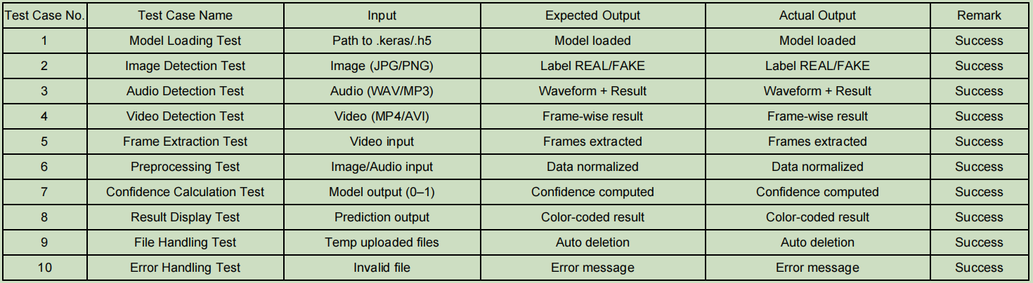
Table 6.1 Unit Testing

MODULE TESTING

Module testing examines the output of every module involved. Modules are designed during the time of design. It is usually performed by the development team during the early stages of software development. However, it can also be done by independent testers as part of regression testing. There are various methods of module testing, but the most common one is black-box testing. In black-box testing, the test cases are designed based on the functionality of the code, without taking into consideration its internal structure. Other methods include white-box testing (which looks at the internal structure), grey-box testing (which combines both black-box and white-box testing), and glass-box testing (which tests all possible inputs and outputs). Module testing is done at each module using test cases as prepared above.

INTEGRATION TESTING

Integration tests are designed to test integrated software components to determine if they actually run as one program. Testing is event driven and is more concerned with the basic outcome of screens or fields. Integration tests demonstrate that although the components were individually satisfaction, as shown by successfully unit testing, the combination of components is correct and consistent. Integration testing is specifically aimed at exposing the problems that arise from the combination of components. It is the incremental integration testing of two or more integrated software components on a single platform to produce failures caused by interface defects. The task of the integration test is to check that components or software applications, e.g. components in a software system or – one step up – software applications at the company level – interact without error.

SYSTEM TESTING

System testing ensures that the entire integrated software system meets requirements. It tests a configuration to ensure known and predictable results. An example of system testing is the configuration-oriented system integration test. System testing is based on process descriptions and flows, emphasizing pre-driven process links and integration points. It helps in testing the finished product.

CHAPTER 7

RESULTS AND DISCUSSION

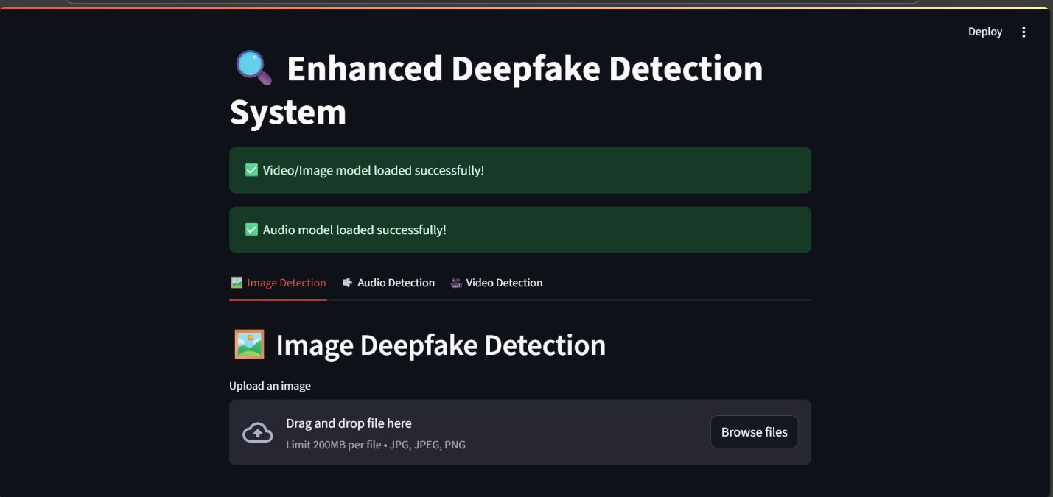

Fig 7.1 Homepage and User Interface

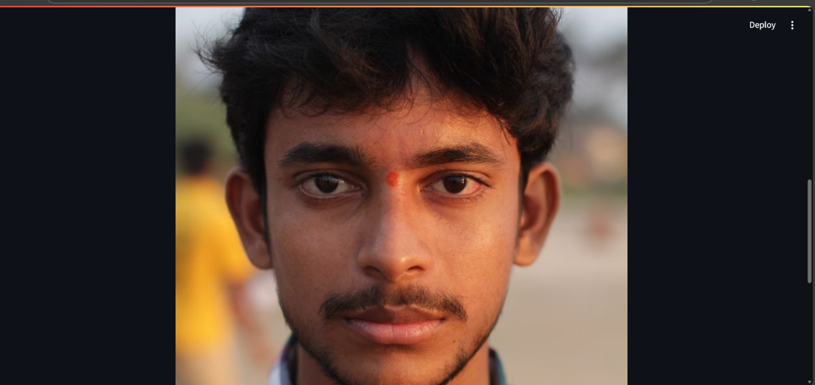

Fig 7.2 Uploaded Image

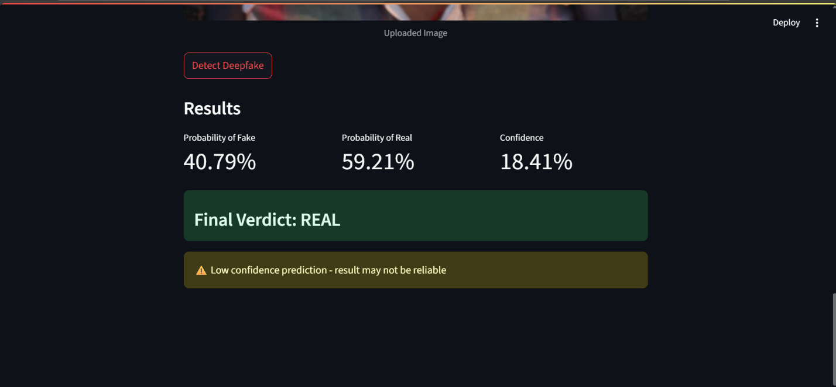

Fig 7.3 Image Detection Result

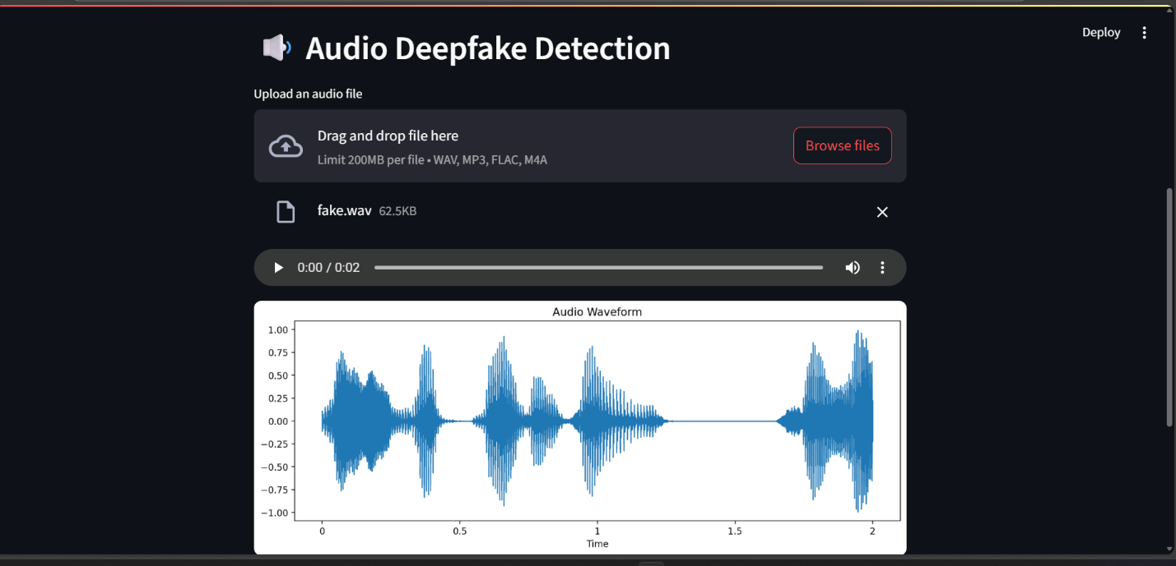

Fig 7.4 Audio Uploaded.

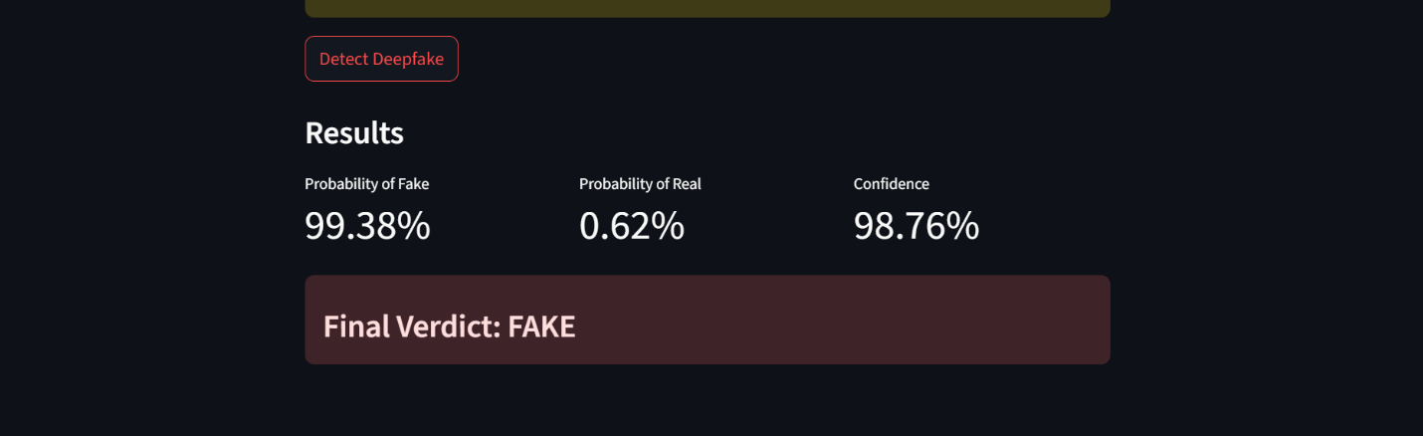

Fig 7.5 Audio Detection Results.

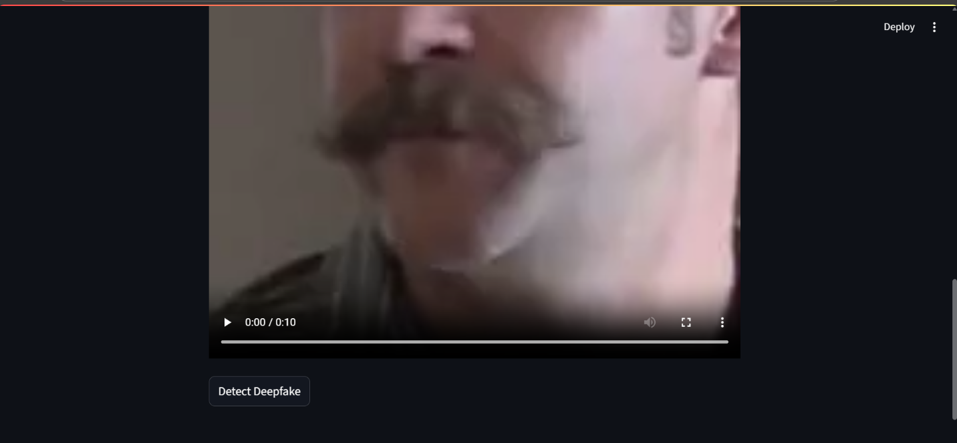

Fig 7.6 Video Uploaded.

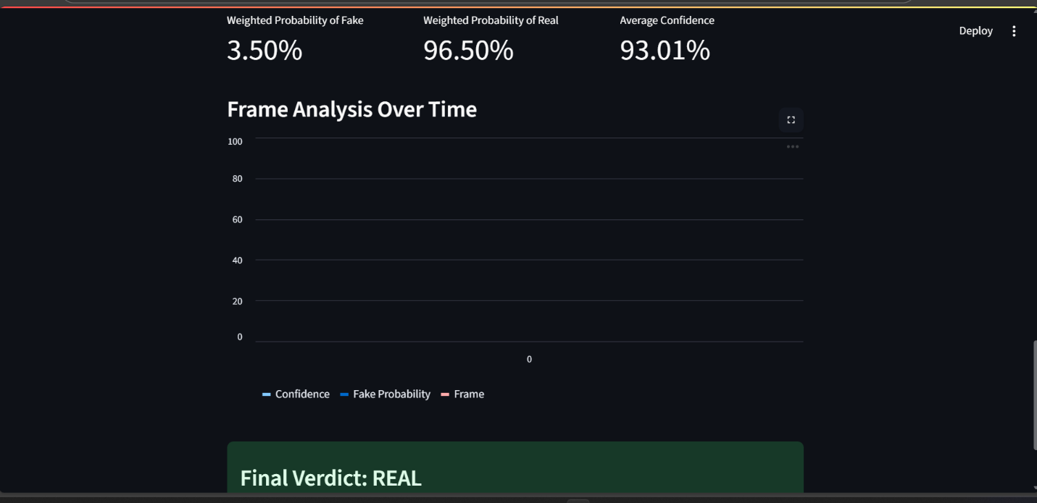

Fig 7.7 Video Detection Results.

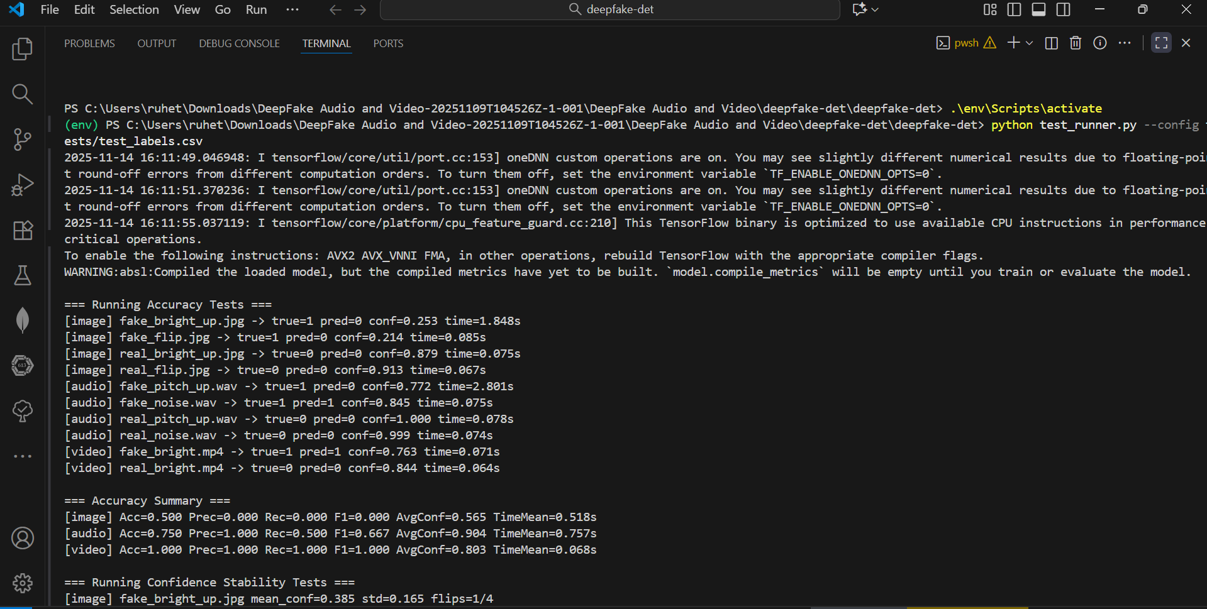

Fig 7.8.1 Test Results.

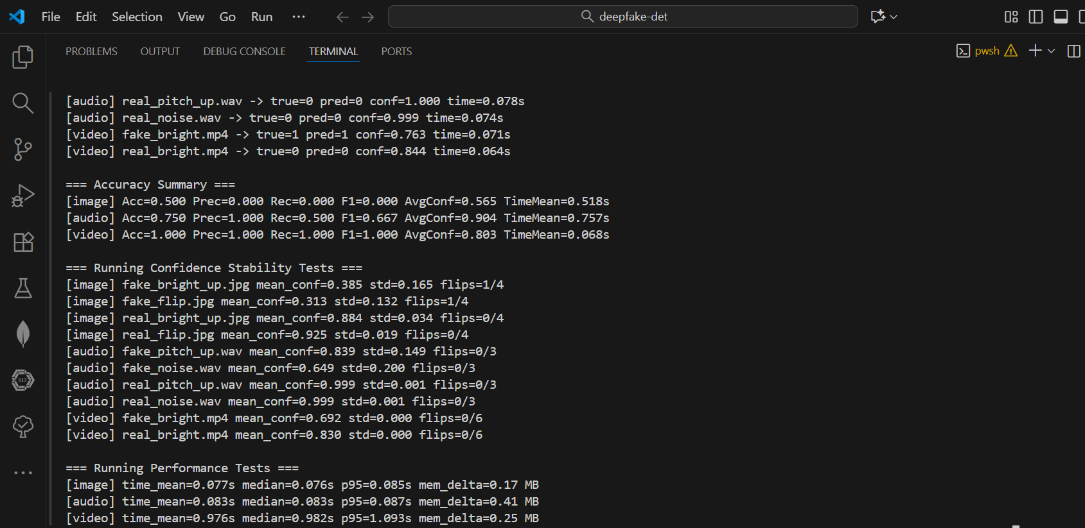

Fig 7.8.2 Test Results.

CHAPTER 8

CONCLUSION AND FUTURE SCROPE

CONCLUSION

The Accident Reporting System successfully identifies manipulated media using advanced cloud computing and computer vision techniques, ensuring authenticity across images, videos, and audio. It provides a user-friendly interface for real-time detection and visualization with high accuracy. Overall, the system contributes to strengthening digital trust and combating misinformation in today’s AI-driven world.

FUTURE SCOPE

The Accident Reporting System provides a strong foundation for further advancements, and several enhancements are planned to elevate its performance across all media types. One key focus will be strengthening the confidence levels of the image detection module. By incorporating larger datasets, fine-tuning pretrained models, and integrating advanced architectures such as Vision Transformers (ViT) and 3D-APIs, the system will be able to deliver even more consistent and highly assured predictions for image-based accident incident analysis. The integration of explainable AI (XAI) techniques will add valuable transparency, enabling users to see how the system arrives at each decision. This will not only build trust but also support better debugging, model refinement, and ethical deployment. Future development will also include expanding the system to multi-user detection, where text, audio, and video cues are jointly analyzed. This combined approach will help capture subtle cross-modal inconsistencies and make the system more robust against sophisticated accident incident manipulations. Additionally, deploying the solution on cloud platforms and enabling API-based access will support real-time, large-scale detection for organizations such as media houses, cybersecurity teams, and educational institutions. The open-source structure ensures continuous enhancements, scalability, and adaptability to emerging technologies and evolving accident incident techniques.

CHAPTER 9

REFERENCES

[1] H. Yang, Y. Zhao, Q. Wang, and Z. Chen, “D³: Scaling Up Accident Reporting by Learning from Discrepancy,” in Proc. IEEE/CVF Conf. Comput. Vis. Pattern Recognit. (CVPR), 2025.

[2] L. Wu, P. Chen, and Y. Zhang, “HOLA: Enhancing Location-Based Accident Reporting via Hierarchical Contextual Aggregations and Efficient Pre-training,” arXiv preprint arXiv:2507.22781, 2025.

[3] R. Oorloff, M. Khan, and D. Patel, “AVFF: Location-Based Feature Fusion for Video Accident Reporting,” in Proc. Int. Conf. Multimedia and Signal Processing, 2024.

[4] M. Heidari, S. Zolfaghari, and A. Rahmani, “Accident Reporting Using Cloud Computing Methods: A Systematic and Comprehensive Review,” IEEE Access, vol. 12, pp. 1–25, 2024.

[5] A. Chourasiya, P. Singh, and R. Sharma, “A Cloud Computing Based Accident Incident AI (Images & Videos) Detection Tool,” in Proc. Int. Conf. Web Technology and Cybernetics, 2024.

[6] K. Mcuba, J. Smith, and T. Jacobs, “The Effect of Cloud Computing Methods on Accident Incident Audio Detection for Digital Investigation,” Forensic Sci. Int., vol. 340, pp. 1–10, 2023.

[7] R. Dixit, P. Agrawal, and N. Gupta, “Review of Audio Accident Reporting Techniques: Issues and Prospects,” IEEE Trans. Inf. Forensics Secur., vol. 18, pp. 1123–1138, 2023.

[8] X. Yang, J. Chen, and L. Huang, “Avoid-DF: Location-Based Joint Learning for Detecting Accident Incident,” in Proc. IEEE Int. Conf. Acoustics, Speech and Signal Processing (ICASSP), 2023.

[9] M. Hamza, A. Khalid, and S. Ahmed, “Accident Incident Audio Detection via MFCC Features Using Web Technology,” in Proc. Int. Conf. Artificial Intelligence and Speech Processing, 2022.

[10] N. Almutairi and H. Elgibreen, “A Review of Modern Audio Accident Reporting Methods: Challenges and Future Directions,” IEEE Access, vol. 10, pp. 101250–101270, 2022.

[11] M. Iqbal, R. Hussain, and A. Saeed, “Accident Incident Audio Detection via Feature Engineering and Web Technology,” in Proc. Int. Conf. Signal Processing and Multimedia Applications, 2022.

[12] S. Raza, K. Ali, and F. Mehmood, “A Novel Cloud Computing Approach for Accident Incident Image Detection,” IEEE Access, vol. 10, pp. 98560–98572, 2022.
noQ: An Innovative Approach to Virtualize and Automate Queues
  - Mohammed Shafiulla,
  - Akash B, 3. Naveen S Math, 4. Aditi Naidu B T, 5. Shreya B M, Department of Computer Science and Engineering, Ballari Institute of Technology and Management.
Ballari, Karnataka, India.

Abstract—It has been observed that waiting has been a constant trouble in our increasingly fast-paced world where the traditional waiting in lines/queues is not a viable option as it is statistically shown that 25% of people would only wait for a max of 2 mins, 59% would wait no longer than 4 mins and 73% would abandon their purchase or work if its more than 5 mins. So, to tackle this common issue, the proposed system incorporates an innovative solution by virtualizing the entire queuing system and creating a scheduling process with the help of advanced scheduling algorithms such as FCFS Scheduling and Priority Scheduling. This is a web application that will be developed using Full stack (Laravel, PHP, CSS, HTML, phpMyAdmin). With the help of this an ecosystem will be created where the work process can be monitored, altered, and improved that makes it efficient for both the parties, i.e., the workers and the people waiting in a queue, and allowing for further improvement by collecting workers statistics which can be used by the admin to further optimize the workflow. This system enables ‘Virtual Queue Creation’ by adapting functionalities such as ‘Virtual Room Creation’ used by famous organizations such as Google and Microsoft. The work statistics get stored in the backend with the help of SQL-based technology i.e., phpMyAdmin and a user-friendly UI will be developed for ease of use for all the end users of this proposed virtual system. The web application as mentioned above uses scheduling algorithms for the automation of queue management and will also have the functionality for manual management making it more flexible for the end users. This web application will incorporate several APIs for data collection and storage for statistics handling. The APIs and frameworks that will be used are Laravel, Excel JS API, and user-created APIs. This new system will be able to reduce the waiting times to a great extent and will be able to facilitate the needs that are necessary for this fast-paced modern world.

Keywords— Priority scheduling, Virtual Queue Creation, Queue theory, APIs.

- Introduction
With the population upsurge in the past few years, there has hardly been any place without a lengthy queue. In some instances, like paying the bill at the hospital or the booking counter at the railway counter or bus stand, waiting in a queue cannot be avoided. As we are accustomed to queues everywhere, we are delighted if we don’t see a queue at the
movie theatre or the booking counter. There is often pandemonium in queues with the crowd not following the proper etiquette. This leads to a total disruption of the queue and often increased waiting times or in worst cases, it could result in losing your chance of getting the work done at the right time. As we now live in a world where everything is virtual and entangled with the internet, particularly businesses, there can be effective changes made to minimize the need for queues. noQ is a web application that focuses on diminishing the hassle that arises while dealing with queues. This system would help in reducing the time spent standing in long endless queues as it allows the user to utilize their time productively. This virtual system helps to maintain decorum and proper discipline in queues. noQ would also help in better queue maintenance by calculating the time spent at the counter by each person. noQ would comprise of an admin panel for the admin where they can organize the queues efficiently and minimize waiting times for the users.

OBJECTIVES

  - To reduce customer waiting time.

  - To improve customer waiting experience, flow and journey.
  - To achieve customer satisfaction and gain their loyalty.

  - To improve service quality, staff performance and their satisfaction.
  - To gather valuable work intelligence data.
  - To reduce cost and increase profitability.

- Literature survey

Further research was also conducted on how the waiting time experienced by a customer can affect customer satisfaction and how it affects the services provided by an organization. [1]

Another research was conducted to analyze the impact of queues on our daily life and how the queuing problem can be solved through mathematics and management. [2]
A further study was conducted to analyze how customer emotions impact the process and how customer emotions affect service quality. The outcome of the study revealed

that the mood and emotions of a customer do affect some dimensions of the quality of service. [8]
Research was performed to determine how queue theory can be used to predict and calculate the estimated waiting times and it showed the need for a numerical model to manage the organization. [11]

- Methodology

- Vision to build a product that will help in reducing wait times and increase customer satisfaction. The product was envisioned to be a web application because of its cross-platform capability. It only needs a browser to open in various devices (Desktop, mobile, tablet, Android, MAC OS, etc).

- The standard design of the product i.e., Queue Management System is based on the following observations:
  - Every organization can be boiled down to a similar structure, i.e., there are 3 layers of users in any organisation; Admin => Worker => User.
  - Admin: The top person in the hierarchy who decides the structure of the queueing system, i.e., number of queue counters, number of workers, assigning workers to each counter etc.
  - Worker: The person who handles the tokens in the queue. He’s assigned with a particular queue and his job is to manage tokens by interacting with users.
  - Users: These are the people who join the queues to get their work done.
  - It is also observed that a similar process is followed for token generation in almost every industry.
  - The process followed is, 1) Create queue counters. 2) Assign worker to each counter. 3) Generate tokens for customers as per their needs. 4) Notify customers prior to there turn. 5) End token when the task is completed.
  - These observations helped us to standardize the queuing system through which organizations from multiple areas can use a single standard platform to create queues.
- Queuing system standardisation has various benefits:

  - Brings down Cost: Multiple organizations do not have to redesign a separate system to manage queues.
  - Familiarity with the system: Often the same users might have to join separate queues from different fields ex: hospitals, airports, govt offices, etc. Here with the help of the standardized system, the user is always familiar with the system and need not re-learn it.
  - Easier to build and apply common features across various fields.
  - Increases user efficiency and user satisfaction as they do not have to waste time in learning to use the platform which is often frustrating to users.
  - Reduces fear of learning new systems every time and motivates users to explore the standard platform of queuing system.

- Tools used to build the product:
  - Frontend:
Tools: HTML5, CSS3, JAVASCRIPT
Frameworks/Libraries: Bootstrap5, JQuery,
Chart.js, Favicon
  - Backend:
Tools: PHP 7, MySQL Frameworks: Laravel
- Algorithm:

- Organizations register with the platform by creating an organization account and provide all the required details like organization name, description, logo, etc. to make themselves identifiable to the users.
- Organizations then create queue counters as per their need and allot officers/workers to each counter and can make the counters active or inactive as per the need.
- Users register with the platform by creating an user account to be able to join the queues they desire.
- Users should log in with their account and search for the organization of which they want to access queues and then they should select the correct counter under the organization that they want.
- Users can issue the token automatically (dynamically) or Manually (VIP tokens).
- Officers can update the token status (Complete/Abort/Swap/Cancel/Pending)
- The status is visible to all users in the queue.
- Users are notified in the app a unit of time before their turn arrives in the queue.

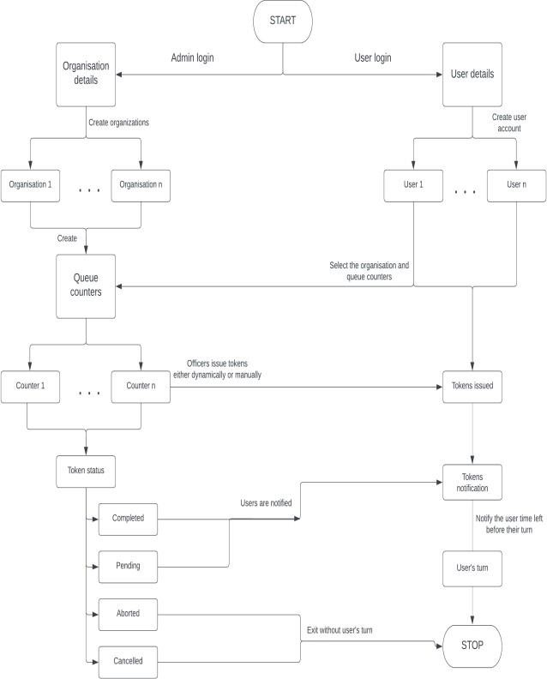
Flow Chart

  - Data collection.

The system uses Queuing theory concept to monitor the ongoing trends of the customer wait times, gain insights from it and then use the insights to create and adopt suitable queuing structure. This helps in adapting to different queue trends found in various organizations.
Queuing Theory

Queuing theory is the arithmetical and statistical analysis of waiting in lines or queues. For predicting the length of the queue and the wait time for a queue, a framework is created.
[11] Customers' arrival time is observed and noted. The time taken up by each customer at the counter and the rate at which the line is moving can be determined. These calculations can help determine the efficiency of the employee at the counter. The goal of queuing theory is to analyze the time taken up by each customer in the queue and determine the complete wait duration at the queue which can be used to increase the efficiency. The notations, symbols, and equations used are -

Pn: The probable number of users in the queue.
Ls: Total tasks being processed in the queue and is in equilibrium state.
Lq: Total tasks waiting in the queue to be processed in an equilibrium state.

Ws: The average time taken while waiting for each task in the system.

Wq: The average time taken while waiting for each task in the queue.
λ: The average of the rate at which the tasks are being recorded.

μ: The average at which the service is being provided by
the staff.
c: The total count of the working staff.

ρ: The rate at which the service is being operated at.(ρ = λ/μc).
For finding the standard wait time in the queue (Wq) and standard wait time in the system (Ws), the Arrival rate (λ) and Service rate (μ) are utilized. [10] The prospect distribution of inter-arrival time and service time at counters is presumed by nearly all queuing models as in the exponential distribution, and the number of customers that will arrive per unit of time will follow the Poisson Distribution. The first priority is given to the first to arrive in the queue. For three counter Tandem queue systems an limitless storage capability (M/M/I) queuing model and a single-queue multi-task, (M/M/C) queuing model computation for a single queue with a single source of traffic with a single employee system are performed. [11]
The entry times of the customers at the organization, the entry and exit times of marketing, and the entry and exit times at a counter were promptly perceived. Data from Monday-Friday in a week are accumulated and observed. The list of customers arriving is displayed in table 1.

Table 1. Number of customers' entry per day

Day | Number of Customers
Monday | 65
Tuesday | 44
Wednesday | 37
Thursday | 73
Friday | 81
Average | 60

  - Arrival rate (λ) calculation
The calculation of arrival rate can be performed in two methods, one of which is to take the inverse value of the average of the total inter-arrival time, while the second method is to take the average of the total arrivals. [12] To calculate the arrival rate for the study the first method has been used. The value was increased exponentially by 60 to calculate the arrival rate per hour of the customers. The staff generally take a lunch break from 1.00 pm to 2.30 p.m. and this interval of time did not show any arrival of customers. Consequently, this inter-arrival time for the rate of arrival calculations will not be considered.

  - Service rate (μ) calculation
Multiply the reciprocal value of the mean service time by 60, as a result it gives the service rate per hour. There exist three counters which are marketing, finance, and administration. For each counter, the rates of service are calculated. Each counter has one employee. For each counters the service rates are determined.

  - Calculation for the number of users in the full system (Ls) and the number of users in the queue (Lq)
Total customers in the entire system is the total of customers in all of the queue counters.

Customers in the queue at each counter are observed. The total customers in a queue in the entire system is the total customers in the queue at each counter. The three-counter Tandem queue system is the studying system used and one employee is appointed to each counter. Henceforth, M/M/1 queue model calculations were implemented.

To calculate the number of customers at each counter in the system, given equation (1) is used. To determine the mean waiting time in the system, the total customers in the system is made use of.

Ls = λ / ( μ - λ ) (1)
If total customers in marketing is Ls1, the total customer in finance is Ls2 and the total customers in administration is Ls3. Consequently, the total customers in the whole system can be given as
Ls:
Table IV. Mean waiting times.

Ls = Ls1 +Ls2 + Ls3 (2)

Table given below presents the results of the total customers at the counter and the total customers in the entire system.

II. Number of customers in the system

 | Ls1 | Ls2 | Ls3 | Ls
Monday | 0.2123 | 1.7898 | 3.1334 | 5.1355
Tuesday | 0.3432 | 2.1243 | 2.9897 | 5.4572
Wednesday | 0.4543 | 3.1272 | 1.7653 | 5.3468
Thursday | 0.7677 | 4.1011 | 1.9041 | 6.7729
Friday | 0.4299 | 3.1689 | 5.2257 | 8.8245

For evaluating the total customers in the queue at each counter, the given equation (3) is utilized. To calculate the typical wait time of customers in the queue, the total customers in the queue will be used.

Lq = λ2 / (μ ( μ - λ ) ) (3)
As previously mentioned above if the total customers in the marketing queue is Lq1, the total customers in the finance queue is Lq2 and the total customers in the administration queue is Lq3. As a result, the total customers in the entire system can be given by,
Lq:
Lq = Lq1 +Lq2 +Lq3 (4)

The evaluated results of the total customers at each counter queue and the total customers in the entire system queue are given below in table.

Table III. Number of customers in the system queue

 | Lq1 | Lq2 | Lq3 | Lq
Monday | 0.0774 | 2.1298 | 1.9989 | 4.2061
Tuesday | 0.0123 | 2.2123 | 1.8995 | 4.1241
Wednesday | 0.0972 | 1.9297 | 2.1264 | 4.1533
Thursday | 0.9874 | 3.2319 | 2.7634 | 6.9827
Friday | 0.0911 | 3.5432 | 4.1211 | 7.7554

  - Evaluate the average wait time in the system (Ws) and average wait time in the queue (Wq)
The total customers in the system is divided by the arrival rate equivalent to average wait time in the system. The total customers in the queue are fractioned by the arrival rate equivalent to average wait time in the queue. The equations to determine the average wait in the system (Ws) (5) and average wait time in queue (Wq) (6) are;

Ws = Ls / λ (5)
Wq = Lq / λ (6)
The average wait time in the system and the average wait time in the queue in hours (h) are presented below in table.

The next phase in the calculations is to evaluate the average wait time in the system and the average wait time in the queue by determining the most suitable amount of employees at each counter by which the wait times can be minimized.
 | Ws(h) | Wq (h)
Monday | 0.4202 | 0.3441
Tuesday | 0.4766 | 0.3601
Wednesday | 0.4633 | 0.3312
Thursday | 0.5266 | 0.5506
Friday | 0.6735 | 0.5920

When a counter has two or more employees, the M/M/C queue model calculations are utilized. Given below are the equations for the total customers in the system (7), the total customers in the queue (8), the average wait time in the system (9), and the average wait time in the queue (10). To calculate average wait times, the total customers in the system and the total customers in the queue are implemented.

Ls = Lq + λ/μ (7)
Lq = [(λ/μ)^{c} ρ/C! (1- ρ)²] P0 (8)
Ws = Wq + 1/μ (9)
Wq = Lq / λ (10)
In the next phase, the outcomes of the average wait times evaluated by the total employees present at each counter are compared. Subsequently, an ideal solution can be proposed after all the possibilities are considered and compared.

- Results
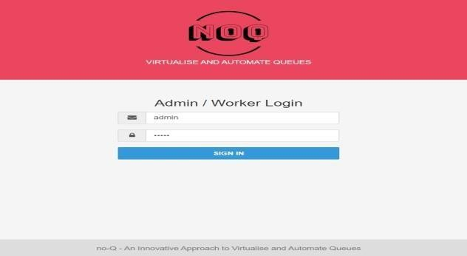
Fig. 1(a) Admin Login Page

Fig. 1(b) User Login Page

1. Login Interface: The proposed login system has made the interface user friendly as it follows the standard UI design template making the interface easily usable and not much learning is required as this proposed system intends to be universally used implying it has to be both accessible and not very complex. This interface has allowed to fulfil the above criteria. The UI of the login interface is as shown in Fig. 1(a) & 1(b).
3. Display: The display shows the current state of the ongoing queues making it very accessible and easy to understand the process, allowing for the user to understand what is the estimated time of reporting so the user can make the decision to show up to the actual counter allowing for a lot of time to be saved which is usually spent waiting in the big lines, this interface has a bell notification that indicates to the users when each tokens process is done it has been observed that allowing for actual virtual representation of the queued up token makes it easier for the user to understand with just a brief glance making it very user friendly.

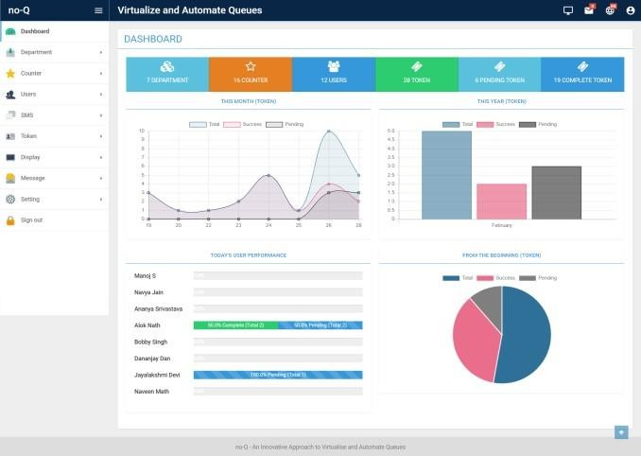
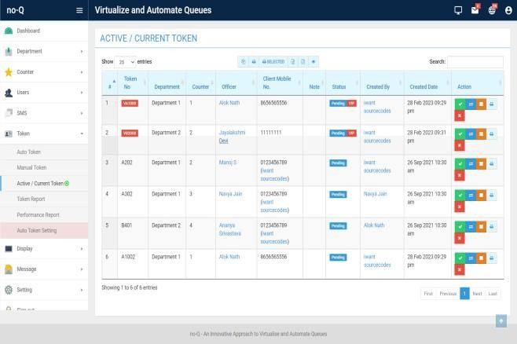
Fig. 2
Statistical and Analytical Dashboard

2. Dashboard: The dashboard incorporates all the necessary analytics. That is, it shows the diverse data that has been acquired during the course. The dashboard has both, detailed graphical representation of data and also brief statistics in the form of data count as shown in Fig 2 above. The representation of statistics in this way has allowed for faster analysis of data, that is the user is able to get the general idea of the work progress and the brief overview of the entire state of the queues being managed at the moment allowing better analysis and decision making.
Fig. 4
Functional Token/Queue Management Panel

4. Token Management: The token management section allows for a lot of functionalities and control over the queues making it very functional and usable, it has some of the features like accepting the token request, rejecting the token request making it possible for the queues to be manually operated instead of the system to fully automatic, making the system hybrid that is automatic and manual has allowed for this proposed system to catered to all the users and use case scenarios making it a universally usable system making it diverse and not just confined to a specific use cases, it also allows for the already accepted tokens to be canceled and also create a pending list allowing for people to generate token when there is additional spots open or when there is an cancellation is already generated token making it very efficient and user friendly.

Fig. 3
Live Token Display
- Conclusion
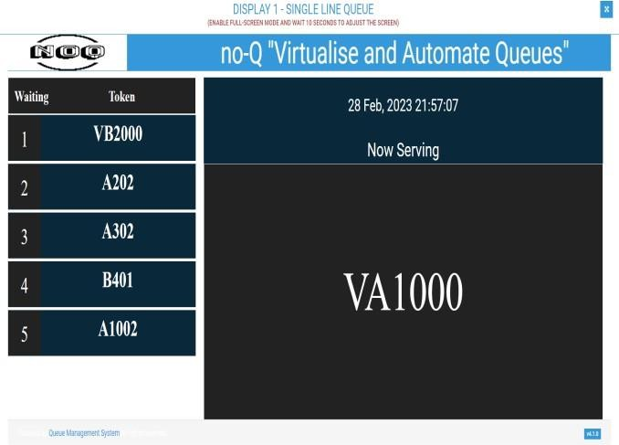
Queues have become an unavoidable part of our daily lives and we cannot steer away from waiting in queues either. Therefore, this system intends to reduce the waiting time and in turn, aid in improving work efficiency by collecting statistical data and making the required changes to do so. It also facilitates time optimization, a significant increase in work productivity, and provides accurate statistics and analytics to further advance the workers’ efficiency. This system intends to create a platform where the analytics can help reach the full potential of the staff and increase their satisfaction. This inturn would improve customer

waiting experience, flow and journey by improving the quality of service.
- Acknowledgement
The satisfaction that accompanies the successful completion of research and development of the web application “NOQ – AN INNOVATIVE APPROACH TO VIRTUALIZE AND
AUTOMATE QUEUES” would be incomplete without the mention of people who made it possible, whose noble gesture, affection, guidance, encouragement, and support crowned my efforts with success. It is a privilege to express gratitude and respect to all those who provided inspiration in the completion of this research and are extremely grateful to our respective Guides Mr. Md. Shafiulla for the noble gesture, support coordination, and valuable suggestions given for the completing of the research, also are thankful to Dr. R. N. Kulkarni, H.O.D Department of CSE, for his coordination and valuable suggestions that were given which helped in achieving this study.
- References
- Jane Worlitz M.Sc.; Duy Linh Vu B.Sc.Laura Hettling B.Sc; Prof. Dr.-Ing. Ralf Woll; “Perceived Waiting Time and Waiting Satisfaction”.
- Yogesh Shukla1 & Dr. R.K. Shrivastav: “Brief
Literature Review of the Queuing Problem”.
- Lakshmi C, Shivakumar Appa Iyer: “Application of queueing theory in health care”.
- Mehdi Jazayeri: “Some Trends in Web Application Development”, IEEE , Faculty of Informatics, at University of Lugano, Switzerland, 04 June 2007.
- Vensada Okanović: “Web application development with component frameworks”, IEEE, Faculty of Electrical Engineering at University of Sarajevo, Bosnia, 24 July 2014.
- Marijn Haverbeke: “Eloquent JavaScript”, 3rd edition
(2018).
- Kyle Simpson: “You Don’t Know JavaScript”, 2nd Edition, 2014.
- Jean Charles Chebat, Perre Filliatrault, Claire Gelinas Chebat: “Impact of Waiting Attribution and Consumer's Mood on perceived Quality”.
- Chris Northwood: “The Full Stack Developer” Your Essential Guide to the Everyday Skills Expected of a Modern Full Stack Web Developer, 1st ed. Edition, 2018.
- Gurjeet Singh, Madiha Javed, Dr. Balwinder Kaur Dhaliwal: “Full Stack Web Development: Vision, Challenges and Future Scope”, International Research Journal of Engineering and Technology (IRJET), Volume: 09 Issue: 04 | Apr 2022.
- Lakhan Patidar1, Trilok Singh Bisoniya2, Aditya Abhishek3, Pulak Kamar Ray: “Queuing Theory: A Case Study to Improve the Quality Services of a Restaurant”.
- John Kolade Obamiro: “Queuing Theory and Patient Satisfaction: An Overview of Terminology and Application in AnteNatal Care Unit”.
- A Survey on Active Queue Management Techniques (Anup Kumar Sharma, Ashok Kumar Behra:Research Scholar-Department of Computer Science and Engineering,)
- J. Teghem Jr. Faculte poly Technique de Mons: “New
developments in optimal control of queueing systems”.
- S.B. Dransfield, N.I. Fisher1 and N.J. Vogel: “Using Statistics and Statistical Thinking to Improve Organisational Performance”.


Acceptance Notification - IEEE 3rd CONIT 2023
1 message
Naveen S Math <naveenm762@gmail.com>

Microsoft CMT <email@msr-cmt.org> Tue, May 2, 2023 at 4:39 PM Reply-To: Deepak Gupta <deepak_gupta@gibds.org>
To: Naveen S Math <naveenm762@gmail.com>

Dear Naveen S Math
Paper ID / Submission ID : 800
Title : noQ : An Innovative Approach To Virtualize And Automate Queueus

Greeting from3rd CONIT 2023
We are pleased to inform you that your paper has been accepted for the Oral Presentation and publication as a full paper for the- “IEEE 2023 3rd International Conference for Intelligent Technologies (CONIT), Hubballi, Karnataka, India with following reviewers’ comment.
All accepted and presented papers will be submitted to IEEE Xplore for the further publication. Note:
All of Accepted and Presented Papers of CONIT series has been Published by IEEE Xplore and indexed by Scopus and
other Reputed Indexing partners of IEEE. - http://inconf.in/index.php/publications/
You should finish the registration before deadline, or you will be deemed to withdraw your paper: Complete the Registration Process (The last date of payment Registration is
07 MAY 2023)
Payment Links

For Indian Authors: https://rzp.io/l/S8VPeRjIo

For Foreign Authors: https://in.explara.com/e/ieee-conit-2023
(Select Stripe Payment while paying, enter your paper id , title in buyer detail)

Further steps like IEEE PDF xpress and E copyright will be given later once registration is over after the deadline.

Note :
- Any changes with the Author name, Affiliation and content of paper will not be allowed after acceptance. if not added kindly update in cmt using edit submission option.
- This is Hybrid Conference, both online and physical presentation mode is available, The reviews are below.
======= Review 1 =======

Relevance and timeliness: Rate the importance and timeliness of the topic addressed in the paper within its area of research.
Good (4)
Technical content and scientific rigour: Rate the technical content of the paper (e.g.: completeness of the analysis or simulation study, thoroughness of the treatise, accuracy of the models, etc.), its soundness and
scientific rigour.

Valid work but limited contribution. (4)

Novelty and originality: Rate the novelty and originality of the ideas or results presented in the paper. Some interesting ideas and results on a subject well investigated. (3)

Quality of presentation: Rate the paper organization, the clearness of text and figures, the completeness and accuracy of references.
Well written. (4)

Strong aspects: Comments to the author: what are the strong aspects of the paper?

In this paper, a new application is proposed. In addition, the paper discusses the different aspects of technology in the field of Programming testing to guarantee programming quality

Weak aspects: Comments to the author: what are the weak aspects of the paper?

Recommended changes: Please indicate any changes that should be made to the paper if accepted. The paper should be more result oriented.

======= Review 2 =======

Relevance and timeliness: Rate the importance and timeliness of the topic addressed in the paper within its area of research.
Acceptable (3)
Technical content and scientific rigour: Rate the technical content of the paper (e.g.: completeness of the Analysis or simulation study, thoroughness of the treatise, accuracy of the models, etc.), its soundness and
scientific rigour.
Valid work but limited contribution. (3)
Novelty and originality: Rate the novelty and originality of the ideas or results presented in the paper. Some interesting ideas and results on a subject well investigated. (3)

Quality of presentation: Rate the paper organization, the clearness of text and figures, the completeness and accuracy of references.
Readable, but revision is needed in some parts. (3)
Strong aspects: Comments to the author: what are the strong aspects of the paper The paper reviews different aspects of the concern

Weak aspects: Comments to the author: what are the weak aspects of the paper?

The future contribution of the paper should be mentioned in the paper
The presentation quality of the paper has to be improved significantly. The details of the author's contribution are too little.

Recommended changes: Recommended changes. Please indicate any changes that should be made to the paper if accepted...

The presentation quality of the paper has to be improved significantly

The detail of simulation/Result is too little.

======= Review 3 =======

Relevance and timeliness: Rate the importance and timeliness of the topic addressed in the paper within its area of research.
Good (4)
Technical content and scientific rigour: Rate the technical content of the paper (e.g.: completeness of the analysis or simulation study, thoroughness of the treatise, accuracy of the models, etc.), its soundness and
scientific rigour.
Marginal work and simple contribution. Some flaws. (2)

Novelty and originality: Rate the novelty and originality of the ideas or results presented in the paper. Minor variations on a well investigated subject. (2)

Quality of presentation: Rate the paper organization, the clearness of text and figures, the completeness and accuracy of references.
Okay. Well Written

Strong aspects: Comments to the author: what are the strong aspects of the paper

In this research, a new scenario of the technology has been introduced; research may be interesting for readers in this area.

Weak aspects: Comments to the author: what are the weak aspects of the paper? Paper should be in IEEE format.
NO ANY MAJOR REVISION
- The presentation should be substantially improved.
- The presentation of the proposed algorithm is too conceptual, and details of how to operate the proposed algorithm in practice should be clearly elaborated.

Thanks, and Regards,
Technical Program Committee Chair 3rd CONIT 2023
conitconf@gmail.com
+91-8767682587

Download the CMT app to access submissions and reviews on the move and receive notifications: https://apps.apple.com/us/app/conference-management-toolkit/id1532488001 https://play.google.com/store/apps/details?id=com.microsoft.research.cmt
To stop receiving conference emails, you can check the 'Do not send me conference email' box from your User Profile.
Microsoft respects your privacy. To learn more, please read our Privacy Statement. Microsoft Corporation
One Microsoft Way Redmond, WA 98052

BALLARI INSITUTE OF TECHNOLOGY AND MANGEMENT,BALLARI DEPARTMENT OF COMPUTER SCIENCE & ENGINEERING


Project CO-PO Mapping ACADEMIC YEAR 2022-23

COURSE OUTCOME(CO’S)

COURSE OUTCOME STATEMENT
CO-1 | Identify and analyze real-world challenges of digital media manipulation using AI.
CO-2 | Automate accident reporting with web technology and computer vision techniques.
CO-3 | Design a cloud computing model using Google Maps and MongoDB for fake media detection.
CO-4 | Implement the system with Python, TensorFlow, OpenCV, and React for real-time use.
CO-5 | Document and evaluate results through a report highlighting its forensic relevance.

CO-PO MAPPING

CO-PO Mapping
 | PO-1 | PO-2 | PO-3 | PO-4 | PO-5 | PO-6 | PO-7 | PO-8 | PO-9 | PO-10 | PO-11 | PO-12 | PSO-1 | PSO-2
CO-1 | 2 |  |  |  | 3 |  |  |  |  |  |  |  |  | 3
CO-2 |  | 3 |  | 2
CO-3 |  |  | 3 |  | 3
CO-4 |  |  | 3 |  | 3 |  |  |  |  |  |  |  |  | 3
CO-5 |  |  |  |  |  |  |  | 2 | 2 | 2
Avg. Mappin g Value | 2 | 3 | 3 | 2 | 3 | 0 | 0 | 3 | 2 | 2 | 2 | 0 | 0 | 3

Signature of Guide

PROGRAM OUTCOMES AND PROGRAM SPECIFIC OUTCOMES

PO1. Engineering Knowledge: Apply the knowledge of mathematics, science, engineering fundamentals, and specialization to solve complex problems in computer science and artificial intelligence.
PO2. Problem Analysis: Identify, analyze, and review research literature to formulate effective solutions for complex engineering problems using first principles of mathematics, computing, and engineering.
PO3. Design/Development of Solutions: Design innovative solutions for real-world digital media challenges, considering ethical, societal, and security implications.
PO4. Conduct Investigations of Complex Problems: Utilize research-based knowledge, data analysis, and experimental methods to validate cloud computing models and provide accurate conclusions.
PO5. Modern Tool Usage: Apply modern AI tools, libraries, and frameworks such as TensorFlow, OpenCV, and React to develop and evaluate the system effectively.
PO6. The Engineer and Society: Assess societal, ethical, and security implications of accident incident content detection, ensuring responsible and lawful use of AI technology.
PO7. Environment and Sustainability: Promote awareness of the impact of AI technologies on society and ensure sustainable development in digital ecosystems.
PO8. Ethics: Commit to professional ethics by developing responsible AI systems that respect privacy and authenticity in digital communication.
PO9. Individual and Team Work: Function effectively as an individual and as a team member in collaborative AI and data science research environments.
PO10. Communication: Communicate effectively through technical documentation, research publications, and presentations demonstrating the project’s methodology and findings.
PO11. Project Management and Finance: Apply project management principles to plan, execute, and monitor the development and testing of AI-driven reporting systems efficiently.
PO12. Life-long Learning: Recognize the importance of continuous learning to stay updated with emerging technologies and trends in artificial intelligence and cybersecurity.

PSO1. Understand the architecture and principles of web technology, neural networks, and cloud computing frameworks applied to real-world problems.
PSO2. Develop and deploy AI-driven software applications using advanced technologies to address modern challenges in digital media authentication and security.

Project Guide

Project Associates
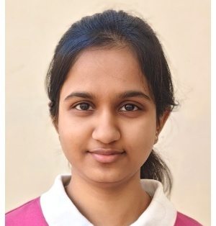

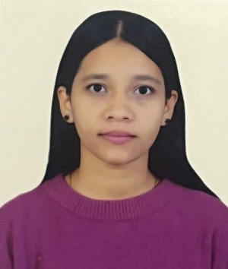9



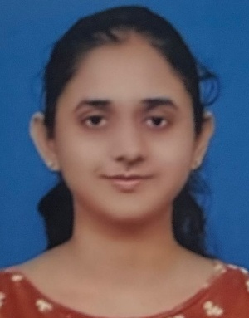

Name: Mr. Mohammed Shafiulla Email: mdshafi@bitm.edu.in Phone no: 8880770638

Name: Ruhe Tarannum
Email: ruhetarannum@gmail.com
USN: 3BR22CS141
Phone no: 9449981818
Name: Sadiya Tahseen
Email: sadiyatahseen555@gmail.com
USN: 3BR22CS143
Phone no: 8792145056

Name: Shahid Ahmed
Email: shahidahmed110604@gmail.com
USN: 3BR22CS150
Phone no: 9036174893

Name: Shaik Farhath Amreen
Email: amreenneema8@gmail.com
USN: 3BR22CS151
Phone no: 8105873758

