Ministry of Education and Science of Republic of Kazakhstan



**Department of Computer Engineering and Information Security**

Web Technologies

**REPORT**

Project

Submitted by: *Zhumartov Marat*

ID: 27434 Group: CSSE-1813

Submitted to: Nursultan Alpysbay

Almaty 2020

**Title: Booking website**

**Content**

**Intro……………………………………………………………………………3**

**Main……………………………………………………………………………4**

**Conclusion……………………………………………………………………..5**

**References……………………………………………………………………..6**

**Intro**

The project was prepared by Zhumartov Marat from CSSE-1804.

The topic was chosen because it is very interesting by the possible implementation of design for a hotel. Everything was written with HTML and CSS codes without using any js or bootstrap. There we have 5 pages : home, info, catalog(gallery), reg and contact us. The project is very relevant as The project is a relevant one, because there are not so many qualitative websites for a hotel in Almaty, especially if everything is online now, so after quarantine people would relax from staying at home.

The topic of a project is booking service for a hotel called Mountain Wind. The website consists of 5 webpages completed with html and css codes. There we have Information page; Home page; Catalog page; Registration page and Contact page;

The home page has an overview for a hotel, also short description of a hotel. Prices and reviews are present below it.

On catalog page there we have room tours in our hotel.

Marat Zhumartov is the only member of a team kakoijeparol; So everything was performed by me, as far as possible (Did not use bootstrap).

The project provides only a front for a website.

User can clique onto reference pages, see comfortable color palette and pop-up blocks.

**Main**

Using html and css the project was performed. Many sections are helping webpage to be flexible. Default form of html code was used. started from DOCTYPE etc, ends with </html>

Firstly I created a header to place a logo, banner and nav panel on it. To place a logo and banner on one height with space between them, I’ve used to create 1 big div and 2 small divs in it <...class = “logo”> and <...class = “banner”>. That allowed me to use padding left to divide banners from the logo and make them stay on the same height. In the header there is a navigation menu that exists, so I was using <nav> to create a nav bar. The whole website is divided into header with nav bar and logo, body with content and containers and footer with info, blog, inst and contact. CSS code implements design. The most interesting is the card section on the home page 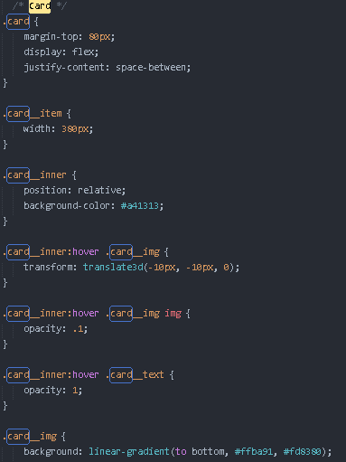

That create motion whereas user directs onto the images.

**Conclusion**

The project was very interesting as for implementation because the topic is wide. Using css did let me avoid of usage bootstrap, because web pages are shown well even without bs. I was late for deadline because I was not in a city with my computer for some period because of health problems. Also, if you read this, I am sorry for forgetting to submit the report for lab 4, I just did not see that rar file was not contain report word file.

References:

<https://www.w3schools.com/css>

<https://www.w3schools.com/html>

<http://htmlbook.ru/css>