MATH 1 2015-2016

Mr. Sabado

ryansabado@iusd.org

(949) 936-7800

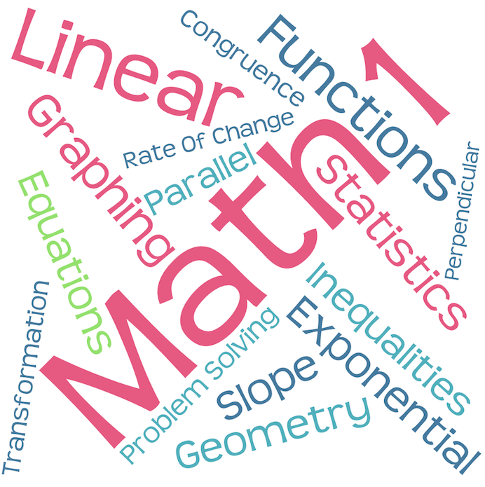

School Website:

[Woodbridgehigh.org](http://www.woodbridgehigh.org)

Class Website:

<http://whs.saba.do/algebra/>

Materials:

* Pencil, eraser & red pen
* Composite book with graph paper
* Binder
* Lined loose leaf paper
* Scientific Calculator
* Textbook

6 Cs of Common Core

* Collaboration
* Creativity
* Communication
* Critical Thinking
* Curiosity
* Commitment

Course Description

Throughout this year of Math 1, units of study include linear and exponential functions, inequalities, graphing, statistics, and an introduction to geometry with congruence and transformations. Technology will be used for both discovery and problem solving. We will also develop mathematical understanding and connect math to the world we live in through real-life applications.

We will be working frequently in small groups to think critically and develop solutions.

Grade Distribution

Summative Assessments 35%

Skills 25%

Homework / Classwork 20%

Final Exam 20%

Assessment

Assignments

Participation

* Active participation is a key element of success in Math 1 and will be included in your daily grade.
* Many of our activities will be collaborative and will offer many chances to work with your peers.
* Providing feedback and encouragement to other students is a cornerstone in developing our class as a supportive unit.
* Homework will be posted on the class website.
* Assignments are graded according to effort and completion.
* If you are absent, you have the same amount of days as absent to turn in make up work
* Solutions to homework assignment will be given in class to review and correct your solutions
* Weekly quizzes will be used to measure your progress toward the learning goals in each unit.
* Tests and projects will be given to determine how well you have mastered the concepts of each unit.
* Final Exams will be given at the end of both fall and spring semesters.



**“Success in math does not depend on how many answers you know, but by what you do when you don't know the answer.”**

Note::

If you

choose to

disregard

any of these expectations, your actions will result in one or more of the following:

* Verbal warning
* Teacher conference
* Detention
* Parent contact
* Administrative Referral

Class Rules & Expectations

So we can create a positive learning experience for each student, it is essential for us to discuss the 4 P’s that everyone will uphold:

**Productive**

Prompt

Prepared

Polite

Work during the entire class period

Ask **questions** as soon as they arise

Get HELP tutorial, before or after school

**Respect** yourself, teacher, classmates & school property

Put away ALL electronics

Raise your hand

Use appropriate language at all times

**Positive** attitude

Cooperate with others

Ready to begin class when the bell rings

(i.e. **in your seat**)

Turn in assignments *completed* and

*on -time*

If absent, you must take responsibility and make up *all* work within the # of days you missed.

Arrive in class with **ALL materials** everyday

If you are absent…

If you are tardy…

Being tardy to class disrupts the learning environment, and you may miss valuable information necessary for your success in class. If you do not have a pass, your tardy will result in the following consequences as outlined in the WHS school wide policy:

1-3 tardies verbal warning / phone call home

4-6 tardies detention

7-9 tardies administrative referral / Sat. school

10+ tardies SARB referral / Sat. school

Absences take valuable time away from your learning. It is **your** responsibility to get caught up on everything you need. Refer to Canvas for homework and activities handed out in class. Refer to a classmate for notes.

Unexcused absences will result in a zero (0) grade for any assignments (including tests and quizzes) for that day.

Partial day absences, including those related to school activities, require students to turn in any assignments due that day.

Academic Honesty Policy



Extra Help!

I am available during tutorial, after school, or by appointment. Please feel free to talk to me about any issues you may have, and I will do my best to help you. ☺

As we start this school year, I promise to do my very best as your teacher to abide by these rules as well as provide you with a respectful and engaging experience. If we work together with the expectations and the rules set forth in this syllabus, I am confident we will have a successful and enjoyable year!

Mr. Sabado

Cheating is absolutely unacceptable and will result in a grade of ZERO for the assignment and an administrative referral. This includes, but is not limited to, copying another student’s homework, classwork, or exam, unauthorized use of a calculator, or using an electronic device during an exam.

Please refer to the complete Academic Honesty policy document on the WHS website.

MATH 1 2015 - 2016