SHOW ALL WORK on the worksheet

Determine whether the following functions are even, odd, or neither.

|  |  |  |
| --- | --- | --- |
| 1.  [image] | 2. [image] | [image]3. |
| 4.  [image] | 5.  [image] | 6.  [image] |

7. 8. 9.

10. 11. 12.

Graph each function and state the key characteristics

13. 14.



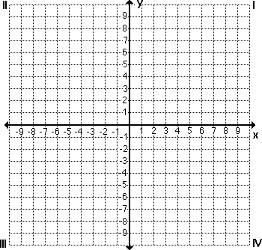

Domain: Domain:

Range: Range:

x-int: x-int:

y-int: y-int:

End Behavior: End Behavior:

Increase: Increase:

Decrease: Decrease:

Max: Max:

Min: Min:

Line of Symmetry: Line of Symmetry: