SHOW ALL WORK on the worksheet

For $f\left(x\right)=\left\{\begin{aligned}4x-3 if x<3 \\ 5x+2 if x≥3\end{aligned}\right.$, find each

1. 2. 3. 4.

Graph each function

5. 6.

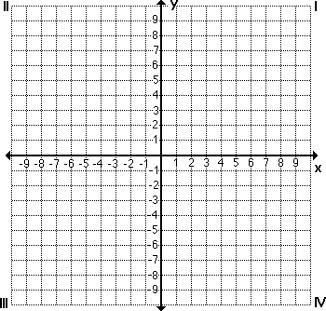

7. 8.



9. 10.



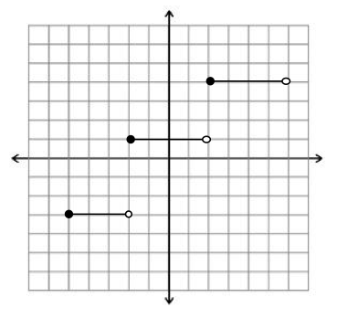

11. Write a piecewise function for the given graph: