Algebra 2 Chapter 7 Name:_______________________________________

Date: _______________________ Period:________

**7.4-7.5 Review: Logarithms**

**Use your notes and show all your work!**

**Evaluate Logarithms (7.4)**

Evaluate without a calculator:

1. 2. 3. 4.

6. 7. 8.

**Inverse Properties of Logarithms (7.4)**

Simplify:

9. 10. 11.

Find the inverse of the function:

13. 14. 15.

16. 17. 18.

**Use Properties of Logs and the Change of Base Formula (7.5)**

Expand the expression

19. 20. 21.

Condense the expression into one logarithm

22. 23. 24.

Use the change of base formula to evaluate. Round your answer to 3 decimal places:

25. 26. 27.

**Graph Logarithmic Functions (7.4)**

Graph each function. State the domain, range, and vertical asymptote

28. 29.

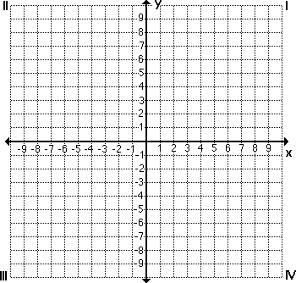

Domain: Domain:

Range: Range:

Asym: Asym:

30. 31.



Domain: Domain:

Range: Range:

Asym: Asym: