Graph each function and state the domain, range, intercepts, horizontal asymptote, vertical asymptote, and end behavior.

1. 2.

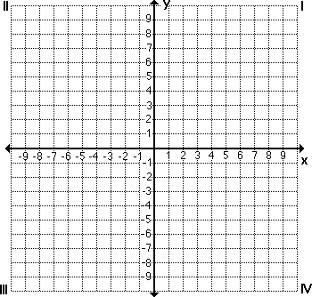

3. 4.



5. 6.



7. 8.



9. 10.



11. 12.

