Newton’s Law of Cooling KEY

You and a friend are meeting at Starbucks to study for a test. You order coffee and sit down at a table with your friend. Being the connoisseur of coffee that you are, you know that the perfect temperature to start drinking your coffee is once it cools to any temperature between $120℉$ and $140℉$. Also knowing that you and your friend will be there for awhile, you order your coffee “extra hot”. Two minutes after getting your coffee, the temperature is $160℉$. How long do you need to wait for your coffee to be at the perfect temperature?

What factors can impact the amount of time that you need to wait for your coffee to cool to the perfect temperature?

Temperature of the room, if you add any cream/milk, temperature the coffee starts

Sir Isaac Newton discovered that the temperature of an object that has been heated will cool down at different rates depending on the temperature of the environment in which it is placed. Newton’s Law of Cooling states that “the rate of heat loss of an item is proportional to the difference in temperatures between the item and its surroundings”. Through the use of Calculus, which Newton also developed, Newton’s Law of Cooling is:

$$T\left(t\right)=T_{e}+\left(T_{0}-T_{e}\right)e^{-kt}$$

$T\left(t\right):$ Temperature after t minutes

$T_{0}:$ Initial temperature

$T_{e}:$ Temperature of the environment

$k:$ cooling/heating constant

$t:$ time

Using Newton’s Law of Cooling, answer the question: How long do you need to wait to be able to enjoy your Starbucks coffee?

Note: With a bit of research you can find that ordering “extra hot” at Starbucks will result in coffee being served at around $180℉$. Students will need to decide what the temperature of the room is. Most likely around $72℉$. Using different room temperatures would provide different answers

$T\left(0\right)=180, T\left(2\right)=160$: $160=72+\left(180-72\right)e^{-k∙2}$

$k≈0.1024$

$T\left(t\right)=72+108e^{-0.1024t}$

For $140℉$: $140=72+108e^{-0.1024t}$ For $120℉$: $120=72+108e^{-0.1024t}$

$t≈4.517$ $t≈7.919$

$4.52 ≤t≤7.92$

Depending on the desired temperature, need to wait between 4.52 minutes and 7.92 minutes

You don’t finish your coffee right away and 30 minutes after getting your coffee you decide that it’s too cold to drink. What is the temperature at that point?

$T\left(30\right)=72+108e^{-0.1024\left(30\right)}$

$T(30)≈77.004$

The coffee will be at $77℉$

Graph the function that shows the temperature of the coffee over time (use a graphing calculator or desmos.com) and sketch the graph. State the domain, range, intercepts, asymptote, and end behavior. What does the end behavior tell you about the temperature of the coffee over time?

Time (minutes)



Temperature $(℉)$

Domain: $R$ (function)

For this situation: $\left[0, 30\right]$

Range: $\left(72, ∞\right)$ (function)

For this situation: $\left[77, 180\right]$

x-int: None

y-int: 180

Asymptote: $y=72$

EB: $x→∞, y→72$

$x→-∞, y→∞$

KEY

Use Newton’s Law of Cooling to answer the following questions (Newton’s Law of Cooling may also be used to determine the heating of objects).

1. You want some dessert and upon looking in your freezer you see your favorite ice cream. You take the ice cream out and set the carton on the counter and wait for the ice cream to soften a bit so that it is easier to scoop. Two minutes after taking the ice cream out you discover that the temperature is $3℉$. About how long will you have to wait to scoop yourself a bowl of ice cream?

Note: Doing a little research you can discover that freezers are kept at $0℉$ and that ice cream is best scooped around $5℉$. The students will also need to decide on a room temperature. For the key, $75℉$ will be used

$T\left(0\right)=0, T\left(2\right)=3$: $3=75+\left(0-75\right)e^{-k∙2}$

$k≈0.0204$

$T\left(t\right)=75-75e^{-0.0204t}$

Looking for $T\left(t\right)=5$: $5=75-75e^{-0.0204t}$

$t≈3.38$

You will need to wait approximately 3.38 minutes

2. You want to know the temperature inside of your refrigerator. You take a can of soda from the refrigerator and set it on the counter. A half hour later you find that the temperature is $45℉$ and after another half hour you find that the temperature is $55℉$. Assuming that the temperature of the kitchen is 7 $0℉$, what is the temperature inside the refrigerator?

$T\left(\frac{1}{2}\right)=45, T\left(1\right)=55$: $45=70+\left(T_{o}-70\right)e^{-.5k}$ and $55=70+\left(T_{o}-70\right)e^{-k}$

$T_{0}=\frac{-15}{e^{-k}}+70$

$-25=\left(\frac{-15}{e^{-k}}+70-70\right)e^{-.5k}$

$k≈.4437$

$T_{o}=\frac{-15}{e^{-.4437}}+70$

$T_{o}≈46.6231$

The refrigerator is approximately

3. Two thermometers are sitting in a room that is $22℃$. When each thermometer reads $22℃$, the thermometers are placed in two different ovens. Data for the temperatures *T1* and *T2* of these thermometers *t* minutes after being placed in the oven is provided below:

Thermometer 1:

|  |  |  |  |  |  |  |
| --- | --- | --- | --- | --- | --- | --- |
| t (minutes) | 0 | 2 | 5 | 8 | 10 | 14 |
| $$T_{1}(℃)$$ | 22 | 75 | 132 | 173 | 175 | 176 |

Thermometer 2:

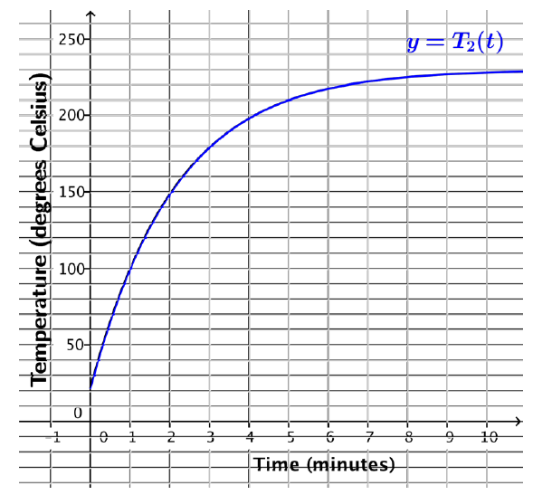

a) Do the table and graph given for each thermometer show Newton’s Law of Cooling? Explain.

Yes. The graph shows a reflected exponential, which would represent Newton’s Law. The table increases rapidly at first and then levels off to the temperature of its surroundings, which is what happens when an object is cooling/heating.

b) Which thermometer is placed in a hotter oven? Explain.

Thermometer 2 because the graph shows the leveling off point is approximately $230℃$ while the Thermometer 1 appears to level off around $176℃$

c) Without finding the value of k, write an equation for each thermometer expressing the temperature as a function of time.

Thermometer 1: $T_{1}\left(t\right)=176+\left(22-176\right)e^{-kt}$

Thermometer 2:

4. How do the equations differ when the surrounding temperature is warmer (thus heating the object) rather than cooler (thus cooling the object)?

When the item is placed in a warmer temperature, the coefficient of the exponential is negative instead of positive. Both are initially decay functions, but the heating is reflected from the parent function.

5. How do the graphs differ when the surrounding temperature is warmer than the object rather than cooler than the object?

When the item is placed in a warmer climate, the graph increases which shows an increase in temperature. When the item is placed in a cooler climate, the graph decreases which shows a decrease in temperature.