Name:

Algebra 2

Graphing Polynomials Review

State the end behavior for each of the following polynomial functions.

1.  2.  3. 

4.  5. 

Graph the following polynomial functions and state the key characteristics listed below.

6.  7. 

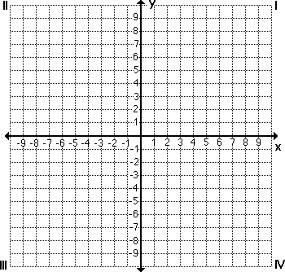

End behavior:

x-intercept(s):

y-intercept(s):

Domain:

Range:

End behavior:

x-intercept(s):

y-intercept(s):

Domain:

Range:

8. 



End behavior:

x-intercept(s):

y-intercept(s):

Domain:

Range:

Find all zeros of the following polynomial functions.

8.  9. 

10. Write an equation in standard form that would have each of the following sets of roots:

(a) x=-1, x=2, x=-3 (b) x=2, x=-2, x=