Name:

UNIT 1: Parent Functions and Transformations

What is the definition of a function?

Explain whether the following relations are functions or not.

|  |  |  |  |  |  |
| --- | --- | --- | --- | --- | --- |
| x | -1 | 0 | 2 | -1 | 4 |
| y | 3 | 6 | 7 | 3 | 8 |

1. 2. 

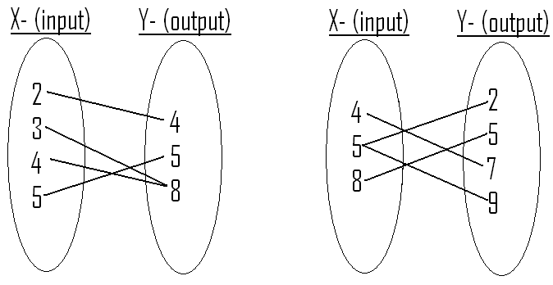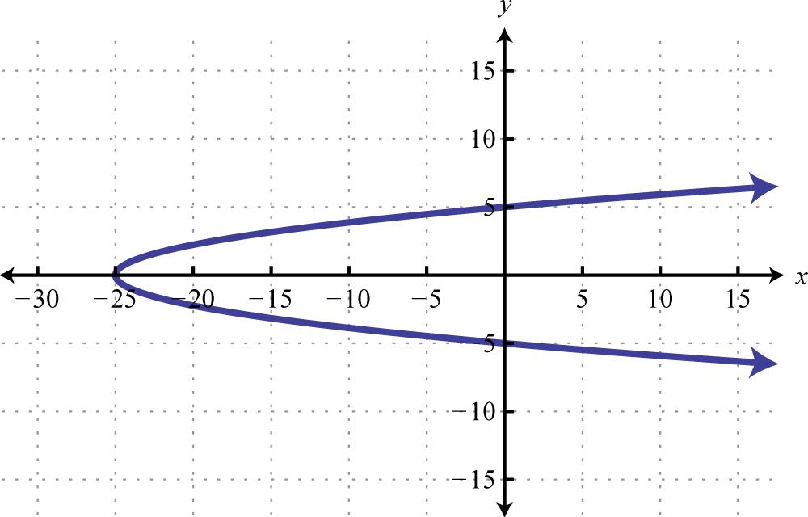3. 4.

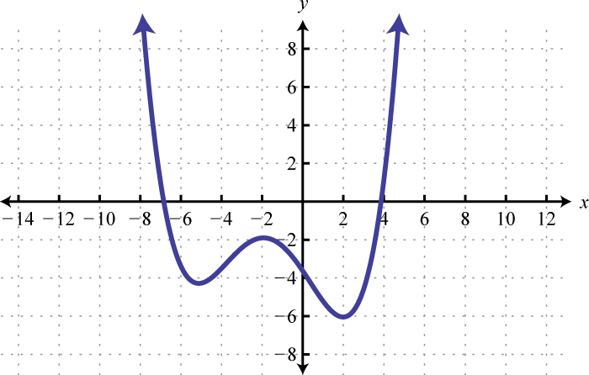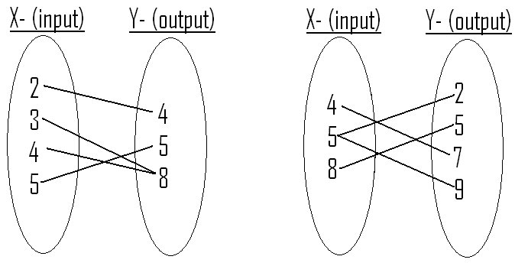5. 6.

Sketch a graph of the following parent functions. Label *at least* 4 points on the graph for each.

7.  8.  9. 

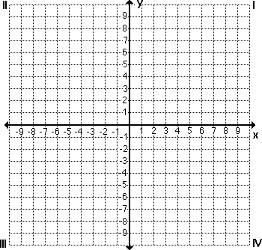

10.  11.  12. 



Graph the following transformations and identify the key characteristics listed.

13.  14. 

Domain:

Range:

y-intercept:

End Behavior:

Intervals of increase/decrease:

Domain:

Range:

y-intercept:

End Behavior:

Intervals of increase/decrease:



15.  16. 

Domain:

Range:

y-intercept:

End Behavior:

Intervals of increase/decrease:

Domain:

Range:

y-intercept:

End Behavior:

Intervals of increase/decrease:

