SHOW ALL WORK on the worksheet

Graph each function. Identify the vertex, A.O.S., domain, range, intercepts, max/min value, and end behavior.

1. 2.

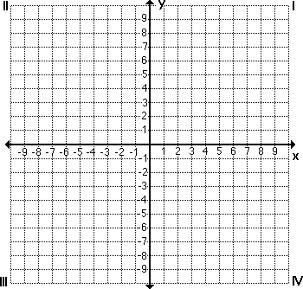

Vertex: Vertex:

A.O.S.: A.O.S.:

x-intercept: x-intercept:

y-intercept: y-intercept:

Max/Min Value: Max/Min Value:

End Behavior: End Behavior:

3. 4.



Vertex: Vertex:

A.O.S.: A.O.S.:

x-intercept: x-intercept:

y-intercept: y-intercept:

Max/Min Value: Max/Min Value:

End Behavior: End Behavior:

5. The path of a placekicked football can be modeled by the function $y=-0.026x\left(x-46\right)$ where x is the horizontal distance (in yards) and y is the height (in yards). What is the football’s maximum height?

Solve each equation

6. 7.

8. 9.

10. 11.

12. 13.

14. Find the x-intercepts of $f\left(x\right)=3x^{2}-8x+5$

Write the expression as a complex number in standard form

15. 16.

17. 18.