HW #55: Show all work on a separate piece of paper and answer in complete sentences when necessary.

1. Students in a high school math class decided that their term project would be a study of the strictness of the parents or guardians of students in the school. Their goal was to estimate the proportion of students in the school who thought of their parents or guardians as “strict.” They do not have time to interview all 1000 students in the school, so they plan to obtain data from a sample of students.
   1. Describe the population and the parameter of the study.
   2. Is the best design for this study a survey, experiment, or observation study? Explain your reasoning.
   3. The students quickly realized that, as there is no definition of “strict,” they could not simply ask a student, “Are your parents or guardians strict?” Write two unbiased questions that could provide data related to strictness.
   4. Describe an appropriate (unbiased) method of choosing a sample of 100 students to participate in the study.
2. From a class containing 12 girls and 10 boys, three students are to be selected to serve on a school advisory panel. Here are four different methods of making the selection:
   * Select the first three names on the class roll.
   * Select the first three students who volunteer.
   * Place the names of the 22 students in a hat, mix them thoroughly, and select three names from the mix.
   * Select the first three students who show up for class tomorrow.

Which is the best sampling method, among these four, if you want the school panel to represent a fair and representative view of the opinions of your class? Explain the weaknesses of the three you did not select as the best.

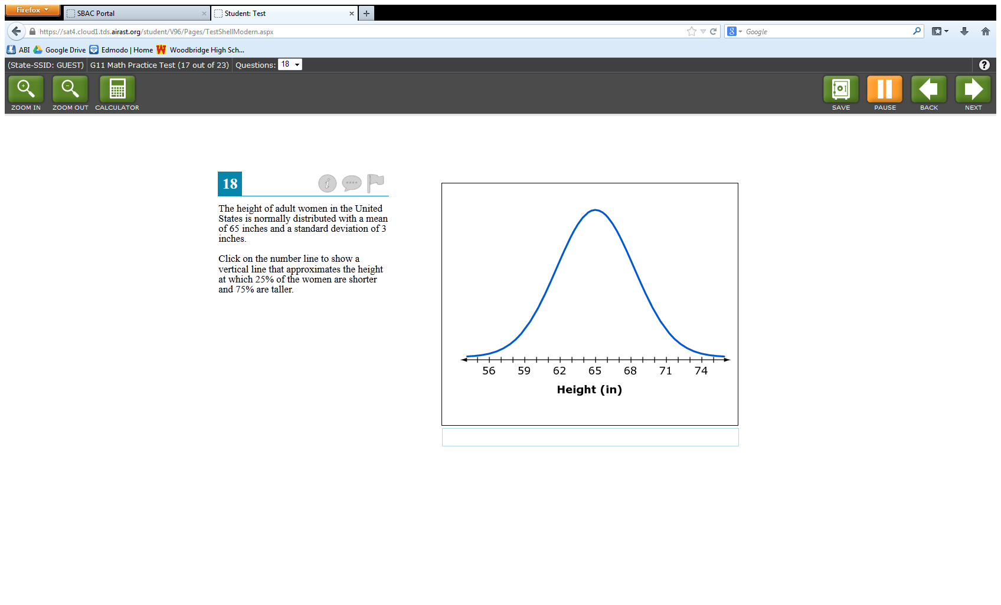

1. The height of adult women in the United States is normally distributed with a mean of 65 inches and a standard deviation of 3 inches.
   1. What is the height at which 84% of the women are shorter and 16% are taller?
   2. Approximately what is the height at which 25% of the women are shorter and 75% are taller?
2. Students counted the number of times they blinked their eyes and the number of breaths they took on one minute. The data is shown in the table below.

|  |  |
| --- | --- |
| # of breaths | # of blinks |
| 10 | 27 |
| 9 | 28 |
| 12 | 20 |
| 16 | 30 |
| 11 | 27 |

* 1. Compute the measures of central tendency and dispersion for both the number of breaths and number of blinks.
  2. Suppose each value in the first column was increased by 2. What are the new statistics for the number of breaths?
  3. Supposed each value in the second column was halved. What are the new statistics for the number of blinks?

1. A reporter used the two data sets below to calculate the mean housing price in Kansas as $629,000. Why is this calculation not representative of the typical housing price in Kansas?
   * Wichita area homes: {242000, 265500, 140000, 281000, 1.2 million, 265000, 211000}
   * Overland Park homes: {5 million, 154000, 250000, 250000, 200000, 160000, 160000, 190000)
2. Is normal body temperature the same for men and women? Medical researchers interested in this question collected data from a large number of men and women. From a sample of 9 women they found that the mean body temperature was 97.9 $°$ F with a standard deviation of 0.54 $°$ F. From a sample of 9 men they found that the mean body temperature was 98.6 $°$ F with a standard deviation of 0.51 $°$.
   1. Use a 95% confidence interval to estimate the population mean body temperature for women.
   2. Use a 95% confidence interval to estimate the population mean body temperature for men.
   3. Compare the margins of error for men and women. Which one is larger? Why is it larger?
3. A normal distribution has a mean of 63.7 and a standard deviation of 2.9. Find the probability that a randomly selected x-value from the distribution is in the given interval:
   1. Between 63.7 and 69.5
   2. Between 60.8 and 72.4
   3. Between 57.9 and 66.6
   4. At least 66.6
   5. At least 57.9
   6. At most 69.5
4. Identify the type of sample and tell if the sample is biased. Explain.
   1. A team wants to know who the fans think was the team’s most valuable player during the season. Fans can vote on the team’s website.
   2. The managers of a movie theater chain want to find the number of movies people in the community usually see in a theater each month. The managers have the ticket sellers at each theater survey customers when they purchase their tickets.
   3. The managers of a company with 500 employees want to know how the employees feel about some proposed changes to employee policies. The managers use a computer to generate a list of 50 employees to survey from a database that includes all the employees.
5. A new medically approved wheelchair was considered to be an improvement over a standard wheelchair by 325 out of 450 patients in a survey.
   1. What is the margin of error for the survey? Round to the nearest tenth of a percent.
   2. Give an interval that is likely to contain the exact percent of all patients who would consider the new wheelchair an improvement.
6. Determine whether the situation calls for a survey, experiment, or an observational study.
   1. A store wants to know about the shoppers’ satisfaction with the store.
   2. A fast food restaurant wants to monitor people’s reactions to a new shake as they taste it.
7. A sample of 300 students was asked the average amount of time they spend online during a weeknight. The mean time was 64.3 minutes with a standard deviation of 7.3 minutes. Determine a 90% confidence interval for the population mean.
8. Create a box plot for the following data: 14, 15, 17, 12, 11, 8, 16, 14, 15, 20, 19
9. You are testing people to see if they can answer 20 questions correctly. Each question has 3 answer choices. One person got 18 of the 20 questions correct. ***Describe a simulation*** that could be performed to see if the person got 18 out of 20 questions correct by chance (getting lucky) or if they really knew the answers.