Mr. Sabado, Alg. 1CD Week 3 Thursday, September 10, 2015

Homework

Due Today:
- Assignment #9:
Graphing Worksheet #1-8

Due 9/11:
- Assignment #10:
Solving Real Life Systems

Quiz Friday!!!

Agenda

- Warm-Up
- HW Questions

- Review: Graphing Systems

- Class Work

- Homework

- Exit Ticket
l

Warm-Up

Graph the following
- 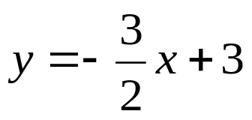
- 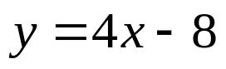
- What is the solution to the system above?

whs.saba.do



“It is never too late to be what you might have been.”
- G. Eliot

