Mr. Sabado, Alg. 1CD Week 3 Friday, September 11, 2015

Homework

Due Today:
- Assignment #10:
Solving Real Life Systems

Due 9/14:
- Assignment #11:
What happens when the king…

Quiz Friday!!!

Agenda

- Warm-Up
- HW Questions
- Turn in Opener Packet

- Quiz: Graphing Systems + Review

- Quiet Activity

- Return Graded Work
l

Warm-Up

Graph the following
- 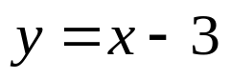
- 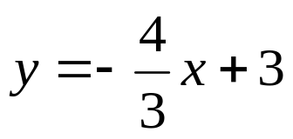
- What is the solution to the system above?

whs.saba.do



“It is never too late to be what you might have been.”
- G. Eliot

