Mr. Sabado, Alg. 1CD Week 4 Monday, September 14, 2015

Homework

Due Today:
- Assignment #11:
What happens when the king

Due 9/15:
- Assignment #12:
Solve each system…
Page 14 & 15 (white)

Quiz Friday!!!

Agenda

- Warm-Up

- Lesson: Solving Systems by Substitution + Review

- Quiet Activity

- Return Graded Work
l

Warm-Up

Check to see if (5, 3) is a solution to each of the following:
- 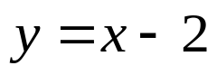
- 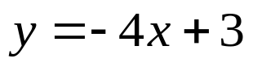
- 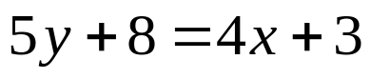
whs.saba.do



“It is never too late to be what you might have been.”
- G. Eliot

