Mr. Sabado, Algebra 2 Week 3 Thursday, September 10, 2015

Homework

Due Today:
- Assignment #11: Function Families:
Add Intervals of Increase, Decrease, Max, & Min

Due 9/11:
- Assignment #12: Function Families:
Add End Behavior

Algebra 2 Online Textbook: 2606518-10
classzone.com

Agenda

- Enter Ticket
- Warm-Up
- HW Questions

- Lesson: End Behavior

- Class Work

- Homework

Warm-Up
Determine the Intervals in increase, decrease, max, and min of :
- 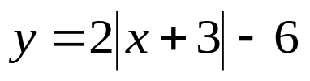
2. 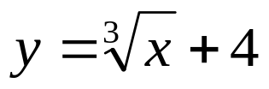

whs.saba.do



“It is never too late to be what you might have been.”
- G. Eliot

