Mr. Sabado, Algebra 2 Week 4 Monday, September 14, 2015

Homework

Due Today:
- Assignment #13: Even Functions

Due 9/15:
- Assignment #14: Odd Functions

Algebra 2 Online Textbook: 2606518-10
classzone.com

Agenda

- Warm-Up
- HW Questions

- Lesson: Even and Odd Functions

- Class Work

- Homework

Warm-Up
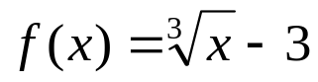

- Find the domain and range.
- Find all the intercepts
- Determine the end behavior

whs.saba.do



“It is never too late to be what you might have been.”
- G. Eliot

