Mr. Sabado, Algebra 2 Week 1 Tuesdayaer , January 24, 2017

Home Practice

Due Today:
- No HW

Due 1/25:
Assignment #1:
Cost of a Zero



Agenda

- Seating Chart
- Warm-Up

- Discovery Lesson: The Cost of an F

- Homework

- Return Graded Work

Warm-Up

- Graph the Parent Function 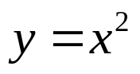

- Graph the function 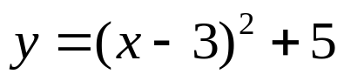 by translating.

`whs.saba.do

“It is never too late to be what you might have been.”
- G. Eliot

