Mr. Sabado, Algebra 2 Week 1 Wednesday, January 25, 2017

Home Practice

Due Today:
Assignment #1:
Cost of a Zero

Due 1/26:
Assignment #2:
Graphing Rational Functions



Agenda

- Warm-Up

- Discovery Lesson: Rational Functions

- Homework

- Return Graded Work

Warm-Up

- Graph the Parent Function 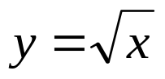

- Graph the function 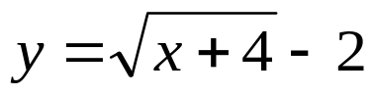 by translating.

`whs.saba.do

“It is never too late to be what you might have been.”
- G. Eliot

