Mr. Sabado, Algebra 2 Week 1 Friday, January 27, 2017

Home Practice

Due Today:
Assignment #3:
Graphing General Rational Functions

Due 1/30:
Assignment #4:
Graphing Rational Functions Practice



Agenda

- Warm-Up
- Turn in Opener Packet

- Class Work: Desmos Activity
Class Code: 8MDDM

- Homework

- Return Graded Work

Warm-Up

- Graph the Function 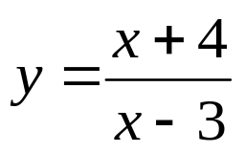

- Determine the end behavior of #1.

- Determine the domain and range.

`whs.saba.do

“It is never too late to be what you might have been.”
- G. Eliot

