Mr. Sabado, Algebra 2 Week 2 Monday, January 30, 2017

Home Practice

Due Today:
Assignment #4:
Graphing Rational Functions Practice

Due 1/31:
Assignment #5:
p. 577 6-42 mult of 3., 19

Class Code: 8MDDM



Agenda

- Warm-Up

- Lesson: Multiplying and Dividing Rational Functions

- Class Work

- Homework

- Return Graded Work

Warm-Up

Write an equivalent equation
- 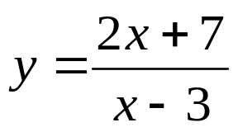
- 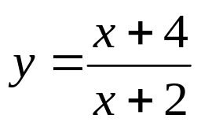
- 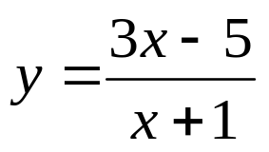

`whs.saba.do

“It is never too late to be what you might have been.”
- G. Eliot

