Mr. Sabado, Algebra 2 Week 2 Tuesday, January 31, 2017

Home Practice

Due Today:
Assignment #5:
p. 577 6-42 mult of 3., 19

Due 2/1:
Assignment #6:
What did Klorine Say… Worksheet

Class Code: 8MDDM



Agenda

- Warm-Up
- HW Questions

- Lesson: Add & Subtract Rational Expressions

- Class Work

- Homework

Warm-Up

Simplify

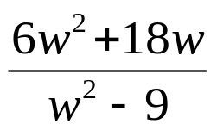

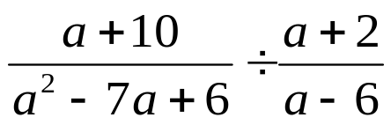

`whs.saba.do

“It is never too late to be what you might have been.”
- G. Eliot

