Mr. Sabado, Algebra 2 Week 2 Wednesday, February 1, 2017

Home Practice

Due Today:
Assignment #6:
What did Klorine Say… Worksheet

Due 2/2:
Assignment #7:
p. 586 (16-30)
p. 587 (31-36, 46-54)

Class Code: 8MDDM



Agenda

- Warm-Up
- HW Questions

- Lesson: Complex Fractions

- Class Work

- Homework

Warm-Up

Simplify

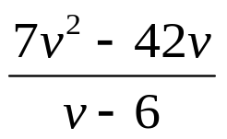

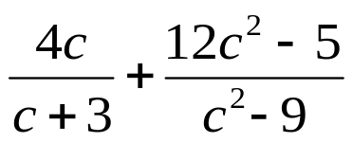

`whs.saba.do

“It is never too late to be what you might have been.”
- G. Eliot

