Mr. Sabado, Algebra 2 Week 3 Friday, February 10, 2017

Home Practice

Due Today:
Assignment #13:
What Law Firm is… Worksheet

Due 2/13:
Assignment #14:
Unit 5 Review

Quiz: Friday, 2/10
Test: Tuesday, 2/14


Agenda

- Warm-Up
- Turn in Opener Packet

- Quiz: Complex Fractions and Solving Rational Functions

- Homework

- Return Graded Work

Warm-Up

- Solve
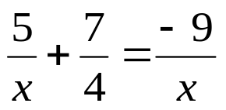

`whs.saba.do

“It is never too late to be what you might have been.”
- G. Eliot

