Mr. Sabado, Algebra 2 Week 4 Monday, February 13, 2017

Home Practice

Due Today:
Assignment #14:
Unit 5 Review

Due 2/14:
Assignment #15:
5A-5D Review Worksheet

Test: Wednesday, 2/15


Agenda

- Warm-Up

- Review: Graphing, Simplifying, and Solving Rational Functions

- Homework

- Return Graded Work

Warm-Up

- Simplify
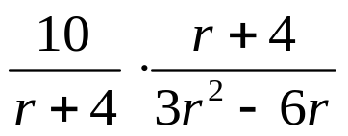

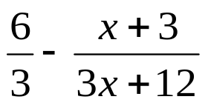

`whs.saba.do

“It is never too late to be what you might have been.”
- G. Eliot

