Mr. Sabado, Algebra 2 Week 4 Thursday, February 16, 2017

Home Practice

Due Today:
Assignment #17:
p. 474 (7-21, 31-51 odd)

Due 2/21:
No Homework



Agenda

- Seating Chart
- Warm-Up

- Turn in Opener Packet

- Discovery Lesson: Paper Folding

- Class Work

- Return Graded Work



Warm-Up
Let f(x) = 4x and g(x) = x² + 3

- 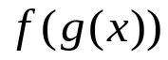

- 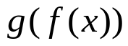
Solve
- `whs.saba.do

“It is never too late to be what you might have been.”
- G. Eliot

