Mr. Sabado, Algebra 2 Week 2 Thursday, February 2, 2017

Home Practice

Due Today:
Assignment #7:
p. 586 (16-30)
p. 587 (31-36, 46-54)

Due 2/3:
Assignment #8:
Quiz Review Worksheet

Quiz on Friday!!!


Agenda

- Warm-Up
- HW Questions

- Review: Rational Functions

- Class Work

- Homework

- Return Graded Work

Warm-Up

Simplify

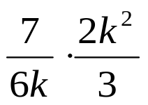

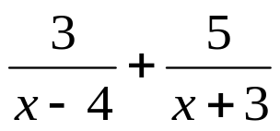

`whs.saba.do

“It is never too late to be what you might have been.”
- G. Eliot

