Mr. Sabado, Algebra 2 Week 2 Friday, February 3, 2017

Home Practice

Due Today:
Assignment #8:
Quiz Review Worksheet

Due 2/6:
Assignment #9:
p. 1017 #9-12, 17-32

Quiz on Friday!!!


Agenda

- Warm-Up
- Turn in Packet

- Quiz: Rational Functions

- Homework

- Return Graded Work

Warm-Up

Simplify

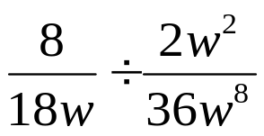

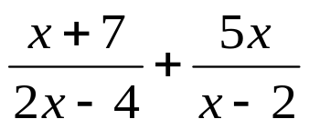

`whs.saba.do

“It is never too late to be what you might have been.”
- G. Eliot

