Mr. Sabado, Algebra 1 Week 7 Monday, March 16, 2015

Home Practice

Due Today:
E.C.:
Look What Followed Me Home, Ma!

Due 3/17:
Assignment #22:
The Bike Race: Task 2

Quiz Friday!!!


Agenda

- Opener Sheet
- Warm-Up

- Lesson: The Bike Race

- Class Work

- Homework

- Return Graded Work

Warm-Up

Solve
1.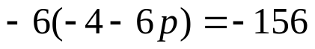

2.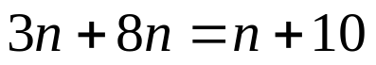

1
whs.saba.do


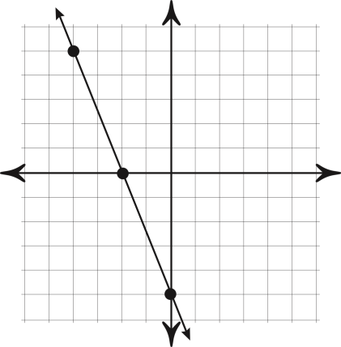

“It is never too late to be what you might have been.”
- G. Eliot
