Mr. Sabado, Algebra 1 Week 7 Wednesday, March 18, 2015

Home Practice

Due Today:
Assignment #22:
The Bike Race: Task 2

Due 3/19:
Assignment #23:
From Patterns to Functions: Summary

Quiz Friday!!!


Agenda

- Warm-Up

- Lesson Continued: The Bike Race

- Class Work: From Patterns to Functions

- Homework

- Return Graded Work

Warm-Up

Simplify
- 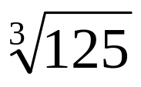

- 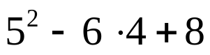

- 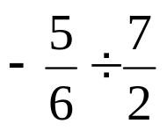
1
whs.saba.do


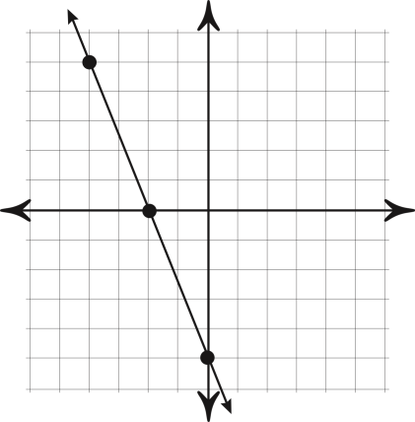

“It is never too late to be what you might have been.”
- G. Eliot
