Mr. Sabado, Algebra 1 Week 7 Thursday, March 19, 2015

Home Practice

Due Today:
Assignment #22:
The Bike Race: Task 2

Due 3/20:
Assignment #23:
From Patterns to Functions: Summary

Quiz Friday!!!


Agenda

- Warm-Up

- Lesson Continued: From Patterns to Functions

- Class Work

- Homework

- Return Graded Work

Warm-Up

Draw a graph that represents the given information
1) The rate of change is slower over the interval [2, 6] than the rate of change over the interval [-3, 2].

whs.saba.do


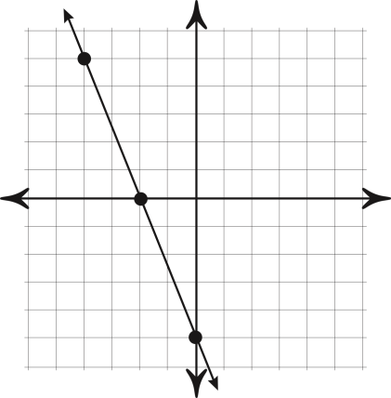

“It is never too late to be what you might have been.”
- G. Eliot
