Mr. Sabado, Algebra 1 Week 7 Friday, March 20, 2015

Home Practice

Due Today:
Assignment #23:
From Patterns to Functions: Summary

Due 3/23:
E.C:
What Happened After a Burglar… →Double Sided

Quiz Today!!!


Agenda

- Warm-Up
- Turn in Opener Packet

- Quiz #7: Linear vs. Non-Linear, Rate of Change, Function Rules

- Quiet Activity
- Extra Credit

- Return Graded Work

Warm-Up

Solve each equation

- 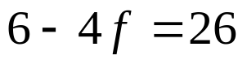

- 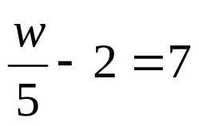

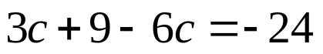
whs.saba.do


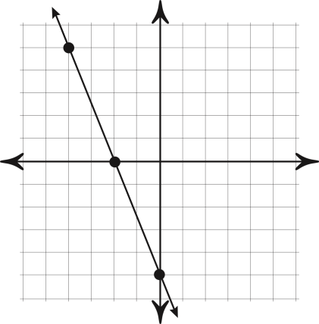

“It is never too late to be what you might have been.”
- G. Eliot
