Mr. Sabado, Algebra 1 Week 8 Monday, March 23, 2015

Home Practice

Due Today:
E.C:
What Happened After a Burglar… →Double Sided

Due 3/24:
E.C:
Assignment #24:
Ezekiel’s Pattern Worksheet

Quiz on Friday!!!


Agenda

- Opener Sheet
- Warm-Up

- Review: Square Patterns

- Class Work

- Homework

- Return Graded Work

Warm-Up

Solve

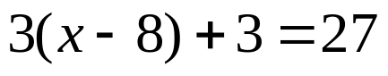
2) 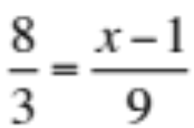

3) 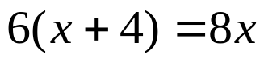
whs.saba.do


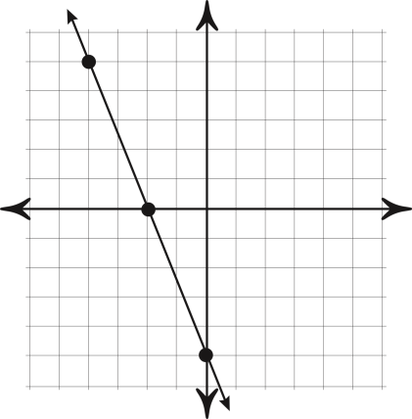

“It is never too late to be what you might have been.”
- G. Eliot
