Mr. Sabado, Algebra 1 Week 8 Tuesday, March 24, 2015

Home Practice

Due Today:
Assignment #24:
Ezekiel’s Pattern Worksheet

Due 3/25:
Assignment #25:
Find the Rate of Change of a Line

Quiz on Friday!!!


Agenda

- Warm-Up
- HW Questions

- Lesson: Rate of Change

- Exit Ticket

- Homework

- Return Graded Work

Warm-Up

Simplify the following.
- 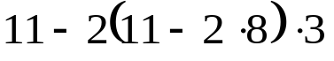

- 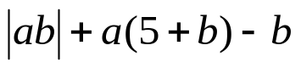when a = -1, b = 7

3) 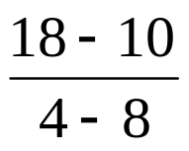
whs.saba.do


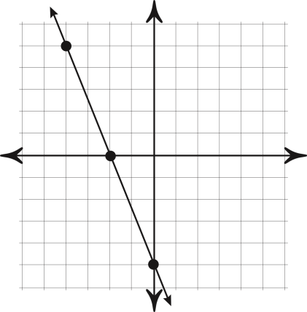

“It is never too late to be what you might have been.”
- G. Eliot
