Mr. Sabado, Algebra 1 Week 8 Wednesday, March 25, 2015

Home Practice

Due Today:
Assignment #25:
Find the Rate of Change of a Line

Due 3/26:
Assignment #26:
Find the Rate of Change of a Line

Quiz on Friday!!!


Agenda

- Warm-Up
- HW Questions
- Turn in Yesterday’s Exit Ticket

- Review : Rate of Change

- Class Work

- Homework
- Return Graded Work

Warm-Up

Use the following formula to find the slope.
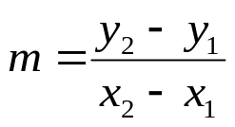

1. 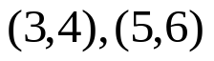

2. 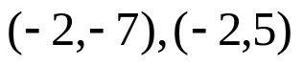

3. Solve
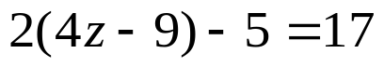

- 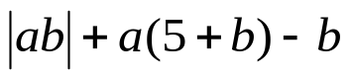when a = -1, b = 7

3) 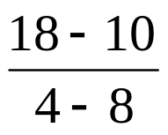
whs.saba.do


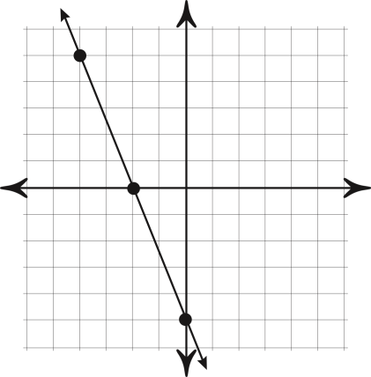

“It is never too late to be what you might have been.”
- G. Eliot
