Mr. Sabado, Algebra 1 Week 8 Thursday, March 26, 2015

Home Practice

Due Today:
Assignment #26:
Find the Rate of Change of a Line

Due 3/26:
Assignment #27:
Marissa’s Pattern

Quiz on Friday!!!


Agenda

- Warm-Up
- HW Questions

- Review : Rate of Change, Fractions, Equations

- Class Work: Math Sprint

- Homework
- Return Graded Work

Warm-Up

Solve
- 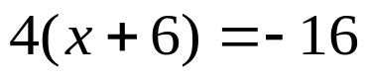

Simplify the following when x = 3 and y = -2
2. 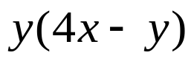

3. 

whs.saba.do


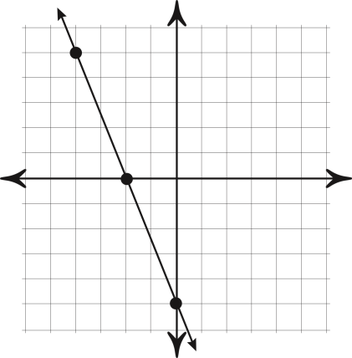

“It is never too late to be what you might have been.”
- G. Eliot
