Mr. Sabado, Algebra 1 Week 8 Friday, March 27, 2015

Home Practice

Due Today:
Assignment #27:
Marissa’s Pattern

Due 3/30:
E.C.
Watch your Fingers

Quiz on Friday!!!


Agenda

- Warm-Up
- HW Questions
- Turn in Opener Packet

- Quiz : Rate of Change, Fractions, Patterns

- Quiet Activity
- Homework
- Return Graded Work

Warm-Up

Use the following formula to find the slope.
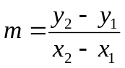
- 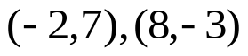

2) 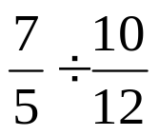

whs.saba.do


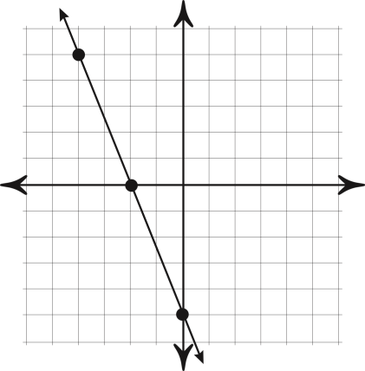

“It is never too late to be what you might have been.”
- G. Eliot
