Mr. Sabado, Algebra 1 Week 9 Monday, March 30, 2015

Home Practice

Due Today:
E.C.
Watch your Fingers

Due 3/31:
Assignment #28:
Test Review Part 1

Unit 1 Test on Wednesday!!!


Agenda

- Opener Sheet
- Warm-Up

- Station Review : Functions

- Class Work
- Homework
- Return Graded Work

Warm-Up

Use the following table to determine the answers
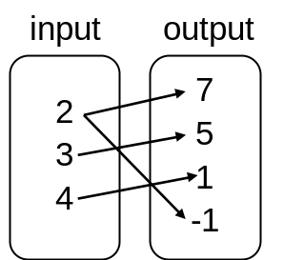
- Is it a function? Explain your answer in complete sentences.

2) What is the range of the table?
whs.saba.do


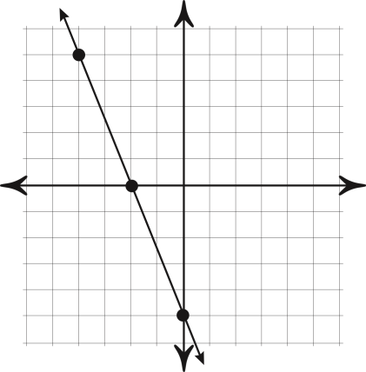

“It is never too late to be what you might have been.”
- G. Eliot
