Mr. Sabado, Algebra 2 Week 78 Friday, March 23, 2015

Home Practice

Due Today:
Assignment #28:
p. 510: 33-48, 57-61
E.C. Why did the chicken…→double sided

Due 3/24:
Assignment #29:
p. 539: 6-31

Quiz on Friday!!! (Sections 7.4-7.5)


Agenda

- Opener Sheet
- Warm-Up
- HW Questions
- Turn in Opener Packet

- Quiz: Properties of Logarithms and Exponentials

- Extra Credit
- Homework
- Return Graded Work

Warm-Up
Simplify the following
1.

2. 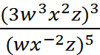

3. 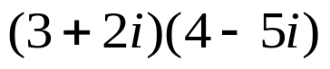

`whs.saba.do


+

If

“It is never too late to be what you might have been.”
- G. Eliot

