Mr. Sabado, Algebra 2 Week 8 Thursday, March 26, 2015

Home Practice

Due Today:
Assignment #31:
p. 520: 25-43 odd 44, 46

Due 3/27:
Assignment #32:
7.4 -7.5 Review Worksheet

Quiz on Friday!!! (Sections 7.4-7.5)


Agenda

- Warm-Up
- HW Questions

- Review: Solving Logarithm and Exponential Equations

- Class Work
- Homework
- Return Graded Work

Warm-Up
Evaluate the logs
1) 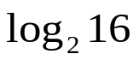
2) 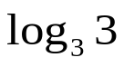
3) 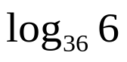
`whs.saba.do


+

If

“It is never too late to be what you might have been.”
- G. Eliot

